The 3D Pronunciation Model

Introduction

Most Syllables in putonghua (Mandarin) are composed of initials , finals and tones . A small number of syllables, however, have only finals and tones , but not initials. There are as many as 1200 syllables in putonghua.
Initials The phonetic symbols of putonghua comprises 21 initials that are consonants beginning a syllable.
Finals The phonetic symbols of putonghua comprises 39 finals that are composed of vowels followed by nasal consonants.
Tones There are 4 basic tones in putonghua.

The 3D pronunciation model illustrates the essentials of initials and finals pronunciation, e.g. how to pronounce the sound of u

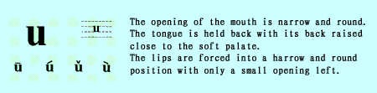

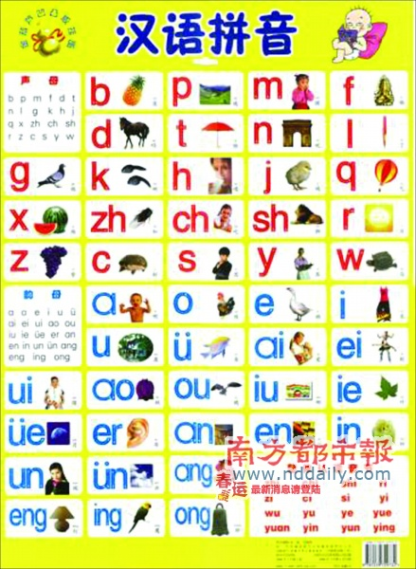
Reference: http://www.jsedu.net/szty/xpy/lesson1.htm

