PRESENTATION and NAVIGATION of CONTEMPORARY ART in 3D DIGITAL DOSSIERS
Chris van Riel, Yiwen Wang, Olaf van Zon, Tim Verweij and Anton Eliëns
Vrije Universiteit Amsterdam, De Boelelaan 1081A, 1081 HV Amsterdam, The Netherlands
{cvriel, ywang, ovzon, tverweij, eliens@few.vu.nl}
Abstract. In this paper, we describe a case study of creating a digital dossier to present a collection of artworks of the Serbian-Dutch performance artist Marina Abramovic, together with the art related information for the preservation and re-installation of these artworks. For the presentation of information we choose a 3D environment which facilities the presentation of text, pictures and video as well as 3D models of artwork installations. For navigation we developed a concept graph that allows for choosing inter-related concepts, artwork-related information and media recordings of artworks in a unified intuitive fashion. The Abramovic dossier, developed as a collective student project based on a set of video recorded interviews with the artist. The outcome of these recordings can also be accessed by using the concept graph as a navigation paradigm.
1 INTRODUCTION
Digital archives for contemporary art that mimic a real-life museum in 3D space lack the ability for effective information retrieval when dealing with a large amount of highly inter-related information. From the perspective of entertainment these virtual museums can certainly amuse but the concept of copying a real life museum in a virtual environment is not very original anymore.
To cope with highly inter-related information structures, in such a way that is supports effective information retrieval and relationship detection in 3D space, we created a special kind of digital archive, further called digital dossier, for which we developed a new interface paradigm.
The case study is a project of a multimedia course at the Vrije Universiteit Amsterdam. The project's aim was the creation of a digital dossier for the Netherlands Institute for Cultural Heritage in the domain of contemporary art. The digital dossier was realized by a team of nine students with different educational backgrounds and skills.
The digital dossier presents itself as a digital archive in 3D space, containing information about the artworks of the performance artist Marina Abramovic by presenting media content and relational structures.
The idea of the digital dossier originates from the traditional medical dossier, which contains patient’s information of relevance for diagnosis and treatment. In this particular case, the digital dossier presents the artist Marina Abramovic s artworks, serving as an information source for the museum’s curators to conserve and install the artworks.
Our digital dossier introduces some innovative features with respect to navigation and presentation in 3D environments.
For navigation, we designed a concept graph that links multimedia elements in a structured hierarchy. The hierarchal structure is dynamic i.e. the selected information determines the presented hierarchy and visualizes parent-child relationships between information nodes.
For the presentation of media content, we designed a content gadget consisting of three windows positioned in a way that allows to deal with multiple media simultaneously.
The structure of this paper is as follows: In section 3, we give an example of using the digital dossier and in section 4 we explain our approach and implementation. In section 5, we discuss extensions to the digital dossier with respect to data representation and content management and in section 6 we discuss initial user experiences. Finally, in section 7, we draw our conclusions.
2 BACKGROUND and RELATED WORK
The digital dossier described in this case study was developed in close collaborations with the Netherlands Institute for Cultural Heritage (ICN). ICN is a leading, independent knowledge institute for the preservation and management of moveable cultural heritage. ICN is coordinator of International Network for the Conservation of Contemporary Art (INCCA).
The digital dossier for the artist Marina Abramovic had to satisfy the following requirements:
- It must serve as an information source for conservators and curators of contemporary art,
- It must present rich media recordings of all artworks, and,
- In addition, it must provide background information for the general public (non-expert users).

A common environment used to present art related information in 3D space is the virtual museum. A virtual museum is a navigation orientated environment where navigation and presentation of content are overlapping [2]. While navigating for content, representation of the artworks are constantly visible.
For quick navigation or searching in large information collections, this could lead to confusion and disorientation. Many different visualizations have already been proposed to navigate hierarchical information structures [4]. These visualizations can be in 2D or 3D and are needed to interpret the intended hierarchy of a particular information collection.
Such diagrams are aimed at reducing the cognitiveload for the user.A well-known example of a 3D information visualization is the 3D cone tree [3] (see figure 1). The 3D cone tree visualizes hierarchical structures and consists of cone objects. The motivation of sing 3D over 2D cone trees is that 3D visualizations make optimal use of screen space and provides the opportunity to visualize larger hierarchical structures.
With respect to usability, we observe that the cone tree presents all information at once. In case of a large amount of highly inter-related information structures this could lead to an informationoverflow.

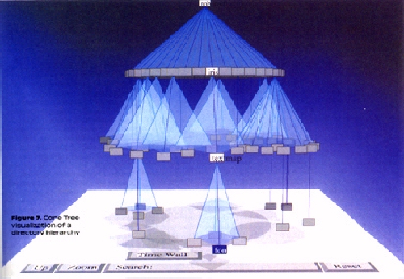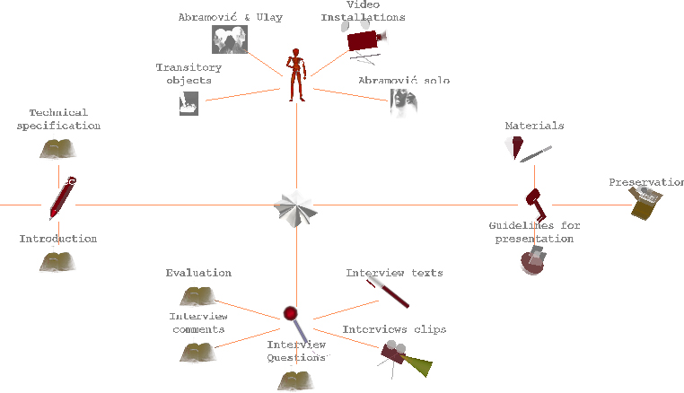 Fig. 1. Cone tree visualizing hierarchy Fig. 2. Concept graph visualizing hierarchy
3 A SENARIO of USING the DIGITAL DOSSIER
In this section, we give an example of using the digital dossier illustrating how to find information related to the artwork ‘China Ring’.
When starting the dossier, it loads the concept graph that is used to navigate through the available information (see figure 2). In the center of the concept graph, a shining star is shown to illustrate the root of the information hierarchy, and is used as the start object. When clicked, a star structure spreads and child objects appear surrounding the center star object (see figure 3).

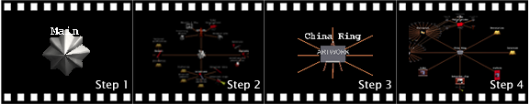 Fig. 3. initialization hierarchic structure. Fig. 4. related objects ‘China Ring’.

Clicking on the information node Artworks and then on China Ring will bring the node for China Ring into focus. Alternatively, using the keyword search function, the artwork China Ring can be easily found without concept graph navigation.
The tree depicted in figure 4, step 4, shows China Ring' as the center node surrounded by all its children nodes which present information in text, picture and video format.
When clicking on the current center node China Ring , the content presentation environment appears. It functions as a content gadget with three windows to present different types of information which are grouped into categories (text, pictures and video) listed below the windows. The information items can be dragged-and-dropped to any window for display. As we can see from figure 5, step 5, the picture of China Ring is presented in the left window, video in the middle window and text description in the right window. If desired, the user can focus on any window by using a zoom function (see figure 5, step 6).

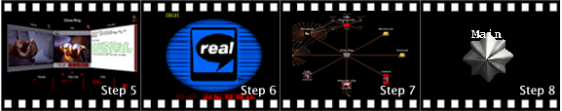
Fig. 5. presentation of media content.

When the presentation of media content is finished, clicking on the close button will result in going back to the concept graph. Alternatively, the home function of the tool bar may be used to return directly to where we started: the original shining star.
4 APPROACH and IMPLEMENTATION
In this section we will indicate what technology we used, and we will describe the realization of the concept graph in somewhat more detail. We will then discuss the way media content is presented and how 3D models of artworks may be incorporated.
4.1 TECHNOLOGY
The digital dossier was created with Virtual Reality Modeling Language (VRML). It allows creating virtual worlds connected via the Internet and hyperlinked with the World Wide Web to expose the digital dossier to a broader audience.
4.2 CONCEPT GRAPH for NAVIGATION
As a user interface for navigating the digital dossier, we created a concept graph that represents hierarchical information structures. The concept graph allows the user to detect relations and search for information. Unlike the 3D cone tree, where the complete hierarchical structure is presented, only a subset of the hierarchy is shown - three levels deep.
The concept graph is implemented as a starstructured-hierarchy diagram representing related information objects. By star-structured we mean that relations between information objects are visualized by lines, getting a parent-child relationships structure by showing a centered information object surrounded by related information objects.
This structure, originated by the parentchild relationships, is dynamically generated when selecting an information object. The selected object will be translated to the center of the screen, involving movement in the X and Y direction. It then becomes a parent node showing its children around it. So, the presentation is dynamic and actually determined by the user’s choice. To compensate for the lack of an instant overview, where all information is shown at once, the user can, as already indicated in the previous section, also use keyword search instead of navigation.
In summary, there are two ways of finding information in the digital dossier:
- Concept navigation – through information object selection, center nodes and their relation to other nodes are visualized.
- Keyword search – the search fucntionality enables the user to located information based on textual input.

Information objects shown in the concept graph are represented by 3D icons. These 3D icons isualize a certain type of information. The icons tell he user what information s/he can expect when licking on it. We distinguish between two nformation types:
- Conceptual information types– 3d models that represent categories
- Content information types – 3d modles that represent types of content

The content information type itself consists of different media types. These are:
- Text content type – 3d models that represent textual information
- Picture content type – 3d models that represent static visual information
- Video content type – 3d models that represent motion based information
4.3 PRESENTATION of MEDIA CONTENT
Presentation of media content is supported by different visualization facilities. Presentation is an essential part of the digital dossier but is separated from navigation. The presentation facilities are deployed when media content is selected for view. The digital dossier contains different presentation facilities for 2D and 3D content.
For 2D media content a visualization facility is needed that is able to present video, images or textual information. This facility is implemented as a content gadget with three windows. In each of the three windows the user can view 2D media content. These windows are positioned in such a way that the user can inspect the information simultaneously (see figure 6). In our experience, three images can be presented at the same time without much visual distortion.

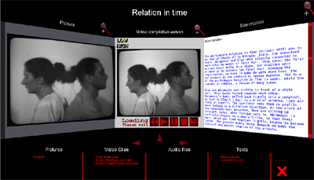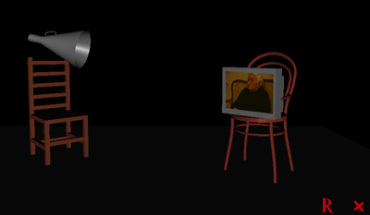
Fig. 6. presentation gadget with 3 windows Fig. 7. 3D model artwork
Below the three windows a list of all content related to the selected information object is displayed. The content is categorized lists for each content type.
The user can control on which of the three windows content is displayed. By using drag-anddrop the user can view content on a window of choice. This functionality gives the user some freedom for customization instead of being bounded to a fixed display.
If necessary, the user can focus on a particular window with a zoom option, to avoid distraction from the other windows.
4.4 INCORPORATING 3D MODELS of ARTWORK INSTALLATIONS
Since we adopted 3D technology, we could easily accommodate a 3D model for one of the installation art works by Marina Abramovic.
We implemented a plain exhibition room, providing a 3D perspective of the installation Terra Degli Dea Madre (see figure 7) that allows the user to manipulate the position of the objects by a click-and-drag function.
The 3D environment demonstrates the interactive exploration of the installation of an artwork. By manipulating position and/or angle of objects, museum curators can get insight into how the artwork could be exhibited.
5 DATA REPRESENTATION ISSUES
To preserve the information stored in the digital dossier for future use, we must consider the data representation i.e. how the information is stored and structured. To use the information presented by the digital dossier, taking into account future developments in 3D technology or other application contexts, it has to be independent of formatting information. This means that the same information instance can be used for other presentations in a relatively easy way. In case of the digital dossier the presented information has to be VRML independent.
As an extension to the digital dossier we created a web-based content-management tool that generates XML (eXtendible Markup Language) structured data output from textual information input. XML is independent of formatting information and therefore suited for multiple presentation forms.
The tool has initially been created for non-expert VRML users that want to create a 3D digital dossier in a relatively quick and easy way, without programming or adjusting existing code.
By using style sheets, the generated XML output can be presented in various ways by giving it formatting information. In case of the 3D digital dossier a style sheet conversion is needed from XML to VRML format.
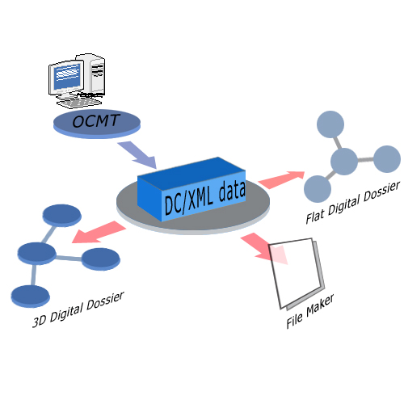
Fig. 8. OCMT generates XML output for various presentations
6 USABILITY EVALUATION
As a first review of the digital dossier we conducted a cooperative evaluation [1] with potential end-users. The cooperative evaluation is a variation of a think-aloud evaluation and has the following advantages:
- It's easy to conduct, and involves no extra costs
- It delivers test results in a relatively short time
- It encourages the user to criticize the application and the style of interaction

The actual evaluation sessions of the digital dossier were recorded on video.
6.1 EVALUATION
The evaluation was designed to assess domain related tasks where the user uses all functionality related available for navigation and presentation. It focused on the following aspects of the digital dossier:
- Navigational actions
- Interpretation of navigational results
- Interpretation and detection of relations between information
- Presentation of content
- Functionality of presentation gadget

In general, we were interested in explorative tasks, where the evaluator has a passive role.
6.2 EVALUATION ROLES
The test results give a first indication of the usability of the digital dossier:

Postive results:
- The concept graph makes it easy to detect relations between information
- Using a concept graph for navigation appeared to be intuitive for all users
- The close relation between the concept graph and presented media reduces dis-orientation

Negative results:
- The meaning of 3D icons was not well understood
- The users expressed the wish to customize the visual appearance of the concept graph and the icons used.

In general, we conclude that the concept graph supports both intuitive navigation and relationship detection. However improvement of the visual appearance of the digital dossier is definitely possible and desired.
7 CONCLUSION
We have argued that a concept graph implemented as a star-structured diagram, where the presentation of the structure is dynamic, as used in the digital dossier, may provide intuitive navigation when dealing with highly inter-related information structures in 3D space. Instead of presenting a complete view of the hierarchy, the concept graph shows only a subset of the information. Presentation of content is separated from navigation but the digital dossier indicates a strong relation between them.
So far, the results of the initial evaluation look very promising for using the concept graph as a navigation paradigm. Evaluation indicates that it is relatively easy to use and that it supports exploratory tasks rather well. As such, the digital dossier can be a solution for dealing with presenting highly interrelated information structures in 3D space. However, to get a more accurate view of the usability of the digital dossier, evaluations that are geared to obtain quantitative results need to be conducted. Also deploying the digital dossier in more real world applications may reveal new issues for its further development.
8 ACKNOWLEDGEMENTS
We gratefully acknowledge the contribution of the following people to the development of the digital dossier:
- Vrije Universiteit Amsterdam: Eric de Boer, Pascal Snijders Blok, Olaf van Zon
- Universiteit van Amsterdam: Abeer Mahdi, Jina Menke, Michela Negrini
- Technische Universiteit Delft: Jurgen Koster
- The Netherlands Institute for Cultural Heritage: Tatja Scholte, Ijsbrand Hummelen
- Montevideo: Bart Rutten, Gaby Wijers
9 REFERENCES
[1] Dix A, Finaly J, Abowd G, Beale R, Human Computer Interaction, second edition, 2001.
[2] Hoorn J., Eliens A., Huang Z., van Vugt H.C., Konijn E.A., Visser C.T., Agents with character: Evaluation of empathic agents in digital dossiers, Emphatic Agents, AAMAS 2004 New York 19 July - 23 July, 2004
3] Cone trees: animated 3D visualizations of hierarchical information, Proceedings of the SIGCHI conference on Human factors in computing systems: Reaching through technology, 189 194, New Orleans, Louisiana, United States, March 1991.
[4] Schonhage, B., van Ballegooij, A., Eliens, A. 3D gadgets for business process visualizations, Proceedings of the fifth symposium on Virtual reality modeling language (Web3D-VRML), 131 - 138, Monterey, California, United States, February 2000.

http://www.few.vu.nl/~dossier05
http://www.vu.nl
http://www.uva.nl
http://www.icn.nl and http://www.incca.org
http://www.montevideo.nl

