
Faculteit der Exacte Wetenschappen
Vrije Universiteit
Amsterdam

Creating the next generation interface paradigm in media-rich information spaces
Supporting efficient and effective information retrieval in Cultural Heritage

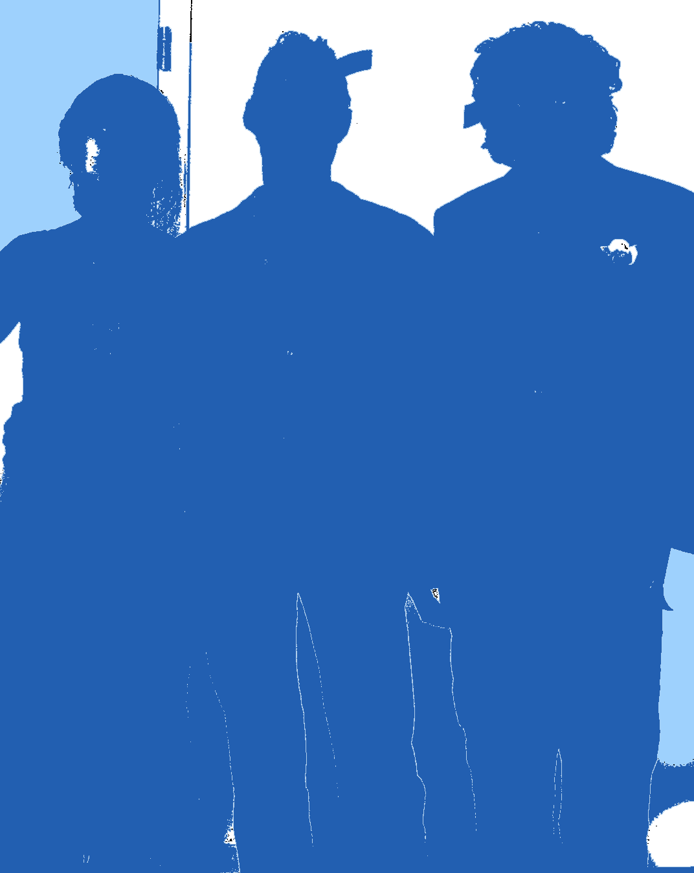

Amsterdam, June 2006

Chris van Riel

Master’s thesis Information sciences - Multimedia and Culture

Faculty of Sciences

Vrije Universiteit Amsterdam

Supervisor:

Vrije Universiteit – dr. A.. Eliëns
Foreword

The first visit I made to the 'Vrije Universiteit' was somewhere in the end of the summer in 2003. To be more exact, it was on the 3rd of September. After obtaining my bachelor degree in Business Informatics in July 2003, I spend a couple of months re-thinking about what I should do. Confused as I was, I soon came to the conclusion that I didn’t want my future to be in the cooperate business. I decided to continue studying and subscribed as a master student to the study Multimedia and Culture at the Vrije Universiteit. At that particular moment in time, I didn't foresee the changes that decision has had on my point of view on studying. It completely changed me as a student, I was becoming immersed in multimedia and culture and the scientific world in general.
In November 2004 I encountered for the first time the master course Multimedia Casus. This annual course turned out to be offering a mixture between theory and practice. As a student group of ten people, we collaborated with the Netherlands Institute for Cultural Heritage (ICN) - a leading, independent knowledge institute for the preservation and management of so-called moveable cultural heritage, to develop a digital dossier to facilitate the need for accessing 2D and 3D information related to artists, artworks and installations on contemporary art. I found the course very interesting and after successfully completing it, I decided to continue to work on the notion of digital dossier as a master graduation project. In that particular period starting at February 2005, I worked together with student Yiwen Wang, supervisor Anton Eliëns and client Tatja Scholte from ICN.
This thesis is the result of my contribution on the master project, specific literature research and on the Multimedia Casus 2005 as a student-assistant. For my master project on digital dossiers I did the following:
- Coordinate, presented and evaluate design aspects on digital dossiers
- Contribute to the development design content management
- Development and design of conceptual guided tours in digital dossiers
- A theoretical study of relevant scientific background
In addition, four papers on digital dossier have been accepted in conferences with regard to media-rich environments, digital dossiers, concept graphs and mapping. Two of these papers are included in the appendix.

I should like to take the opportunity of thanking Anton Eliëns and Yiwen Wang for a pleasurable collaboration, their professional attitude and expertise. I am also very grateful for giving me the opportunity to get experience in writing conference papers.

Furthermore, I want to express my appreciation to Tatja Scholte providing information and expertise about Cultural Heritage, and Olaf van Zon and Tim Verweij who I could consult for technical advise.

This thesis is dedicated to the memory of the "three that took a journey on digital dossiers" and to the next generation of multimedia cultural designers working on digital dossiers who are willing to explore their ideas beyond established paradigms.

Table of contents

PART I – Introduction

1 Introduction 5
1.1 Research context 5
1.2 Research issues and questions 5
1.3 Research approach 7
1.4 Structure of this thesis 7

PART II – Theoretical background

2 Purpose, expectations and influences on presentation 9
2.1 Outline chapter 9
2.2 Initiator: creator’s idea or user’s call 9
2.3 Purpose and expectations of presentation 10
2.3.1 Message of communication 10
2.3.1 Identifying user needs, expectations and desires 10
2.4 Influences on the completion of presentation 10
2.5 Experiencing the final presentation 18

3 Human information processing and user interface design 19
3.1 Outline chapter 19
3.2 Human information processing 19
3.2.1 Initial look at the perceptual and cognitive system 20
3.3 Using our memories for perception and cognition 21
3.4 Paying attention to perceive or use for cognitive processes 22
3.5 What can we perceive? 25
3.6 Using our cognitive abilities 28
3.7 Dealing with conceptual models, affordances and conventions 30
3.8 Considering design principles and patterns in UI design 30
3.8 Considering feelings of esthetics: the halo effect 32

4 Information visualization 33
4.1 Outline chapter 33
4.2 Dealing with information visualization 34
4.3 Display dimensions: 2D or 3D? 37
4.4 Interactive information visualizations: applications 39
4.5 Interactive information visualizations: metaphors 42

PART III – Analysis of existing digital dossiers

5 Looking at digital dossiers in Cultural Heritage 44
5.1 Outline chapter 44
5.2 Digital dossier: background, requirements and applications 44
5.3 Dossier Boezem: evaluation 47
5.3.1 Dossier Boezem: overall conclusion 50
5.4 Abramovic dossier: evaluation 51
5.4.1 Abramovic dossier: overall conclusion 56
5.5 Dossier Shaw: evaluation 57
5.5.1 Dossier Shaw: overall conclusion 63
5.6 Conclusion on analysis 64

PART IV – Design of the next generation digital dossier

6 Elaborating on next generation digital dossiers in Cultural Heritage 66
6.1 Outline chapter 66
6.2 Defining the design aspects 66
6.3 Concept next generation digital dossier 67

PART V – Conclusions

7 Conclusions 73

PART VI – Appendix

Conference paper 1 74
Accepted for Concept Mapping Conference, Costa Rica – San Jose, 5-7th September, 2006. 74
Conference paper 2 82
Accepted for: International Conference on Multidisciplinary Information sciences & Technologies, Spain – Mérdia, Oktober 25-28th, 2006. 82

PART VII – References

References 88

1 Introduction

1.1 Research context
This thesis focuses on identifying design aspects on interface design in Cultural Heritage that support efficient and effective information retrieval. An essential question for creating an information system is “How to present the information?”. When dealing with the presentation of information, you need to consider the way to access this presentation (navigational aspects) by reflecting on the purpose of presentation, expectations of the audience, properties of the audience, and complexity of the information. To accommodate initial user requirements imposed by the Netherlands Institute of Cultural Heritage (ICN), literature to investigate are chosen to match design issues on this.

Defining the purpose and expectations of, and influences on presentation (purpose of presentation, expectations of the audience)
The presentation of information depends on the goal of its creator. In other words, what is the message of communication that the presentation conveys? The goal of the creator could be to inform, influence or entertain the user. This needs to be determined by forehand and considered when realizing the presentation.
What the user desires and expects of the presented information are also important aspects to consider. As a creator, you can deal with this by defying the experience of presentation. An experience can be interpreted as 'a state of being in which one is trapped by the evidence of the senses and the awareness of the world as it is' [William Blake,1757-1827], and depends on the venue in which the creation is perceived, user interaction possibilities, internal and external influences [Sherman R.W., Craig B.A., 2003] and what appeals to our intuition [Norman, 2004].

Dealing with human characteristics (properties of the audience)
Designing for any user interface requires insight in the human cognitive and perceptual system. A discipline that considers this is Human Computer Interaction. Human computer interaction can be defined as the study of people, computer technology and the ways these influence each other [Dix A., Finlay J, Abowd G., Beale R., 2002].
Besides general knowledge about the human cognitive and perceptual system, we have to take into account individual differences by knowing the specific audience that will interact with the system. In any case, the general rule is to avoid pushing the user to their perceptual or cognitive limits [Dix A., Finlay J, Abowd G., Beale R., 2002].

Visualizing information (complexity of the information)
Visualizing information aims to reduce the cognitive load for the user. These visualizations can be used on scientific data and other complex information, as navigational paradigm and acts as an external memory, enhancing our ability for interpretation and problem solving [Irani P. Ware C., 2003].
Whether dealing with structured or unstructured information, a suited visualization can be selected based on the complexity of the information in combination with the desired presentation layout. The complexity of information can be defined as the amount of relational and detailed information structures. The presentation layout can determine the presentational aspects i.e. appearance of the visualization, and as like the complexity of the information, it can influences if visualizations are in two or in three dimensions and have static or dynamic views.

1.2 Research issues and questions
User Interface paradigms and principles for interaction
For the design of user interfaces, paradigms and principles of interaction are considered important aspects. Paradigms are interactive systems that are believed to enhance usability and are used for development of future products, and are based on the development of technology and creative applications [Dix A., Finlay J., Abowd G., Beale R., 2002]. The creation of a new paradigm is creative process and results in an innovative product. Besides these paradigms, principles for interaction are used to enhance user interface usability. In contrast to paradigms, principles are independent of technological development and relay on psychological, computational and sociological aspects of interaction [Dix A., Finlay J., Abowd G., Beale R., 2002]. To benefit from the creative and innovative aspect of paradigms and the theories of principles, a complementary approach can be used for user interface design where the paradigm is strengthened by principles.

Case studies: digital dossiers for Cultural Heritage
Digital dossiers can be interpreted as a digital archive which presents particular information about a specific topic in a specific way. The idea of the digital dossier originates from the traditional medical dossier and represents available information of an artist and related artworks. The digital dossier presents itself as a digital archive in 3D space and serves as an information source for the curators of a museum for conservation or installation of artworks. The 3D space allows for the implementation of 3D representation(s) of artworks. These representations allows to obtain new insights by manipulation of several parameters like angle, position, colour, light, aging, etc, in a relative quick and simple way. This could benefit, for instance, museum curators for artwork preservation, installations or exhibitions.
In several case-studies, conducted annually by students of a multimedia master course of the Vrije Universiteit Amsterdam (Multimedia Casus), digital dossiers where created for the Netherlands Institute for Cultural Heritage in the domain of contemporary art. In 2004 and 2005 I participated to two of these case studies. The case study of 2004, project contemporary artist Marina Abramovic, I started as a project member and functioned later as project leader. During the case study of 2005, project contemporary artist Jeffery Shaw, I participated as a student-assistant.
In this thesis I will discuss, with regards to the theoretical background, three case studies:
- Boezem atelier project (2003)
- Marina Abramovic project (2004)
- Jeffery Shaw project (2005)

Problem definition
The goal of this thesis is to find a suitable interface paradigm that presents complex inter-related information for efficient and effective information retrieval and interpretation in Cultural Heritage. I assume that this can be realized by studying the purpose and expectations of presentation, aspects of human computer interaction, the human cognitive and perceptual system, notations to visualize complex information and incorporating my personal experience regarding to information visualization in Cultural Heritage conducted in several case studies.

The problem definition for this thesis is:
How can one present and access media-rich highly related information with regard to Cultural Heritage so that the cost of information retrieval and interpretation is minimized?

To answer this research question, three sub questions should be answered first:
1. How does one experience information presentation and what aspects determine this experience?
2. What aspects determine effective and efficient information retrieval and interpretation?
3. How to present large amount of highly related information with regard to effective and efficient information retrieval and interpretation?

Hypothesis
I expect that a user interface paradigm for effective and efficient presentation and navigation has at least the following aspects:

- Aspects considering purpose and expectations:
  - Mental immersion of navigation and presentation (letting the user experience one environment)
  - Customization visualization of layout and metaphors
  - Customization level of detail (how detailed information will be presented)
  - Useful (functionality provided is satisfactory to execute user tasks)

- Aspects considering human characteristics:
  - Presentation of information match pre-attended visual system i.e. reducing cognitive workload for the user
  - Navigation match intuitive actions and considers human characteristics
  - Familiar, similar and coherent visualization of layout and metaphors
  - Familiar, similar and coherent actions to use functionality
  - Providing multiple ways to perform same tasks for different type of users (beginner - expert)
  - Considering overall usability (principles for usability)

- Aspects considering visualization of information:
  - Separation of navigation and presentation of content

Relevance
The outcome of this research is of interest for anyone how deals with visualizing large information in an environment considering navigation and presentation. By using an interface paradigm that copes with purpose and expectations of presentation, human characteristics, ways to visualize information combined with existing paradigms and principles, men can employ effective and efficient navigation and presentation of content in 2D or 3D space.

1.3 Research approach
The research approach to provide a user interface paradigm is based on the results of the several case studies and a literature study. This literature study can be roughly divided into 3 sections. These are:

- Communication goals and expectations of presentation
- Human characteristics and computer interaction
- Information visualizations

At first, theories about how communication works and how to translate communication goals into practice are introduced. After that, more detailed information is provided about what an experience is, how to create an experience, which aspects needs to be considered for it’s creation and how to implement this into an application.

Secondly, literature about human characteristics in relation to Human Computer Interaction are presented by focusing on theories on the human cognitive and perceptual system. This part must give detailed information about how humans think, reason, process information, sense, solve problems, what appeals to there intuition and aspects like the use of colors and motion. Further more, we look at design principles and patterns that could be used in the user interface design.

Next, we deal with visualizations of information. Looking at which possibilities are currently available for visualization (types), how they can be used for a user interface paradigm (behavioral properties – static / dynamic views), what there strengths and weaknesses are and how to present them (presentational properties – two / three dimensions).

After all the relevant theories relating to the problem definition are defined and explained, we look at the results of the cases studies concerning digital dossiers for Cultural Heritage.

In conclusion, we use the new insights and knowledge gained from the literature study, case studies to identify the next generation paradigm for information visualization for digital dossiers in Cultural Heritage.

1.4 Structure of this thesis
This thesis is structured as follows:

Theoretical background:
Chapter 2 deals with the aspects that influence the way information is presented by looking at human communication and user experience. In chapter 3, theories of human computer interaction are used to describe how users perceive and think, and interface paradigms and principles. This knowledge is used to reflect on interaction with a user interface. Chapter 4 explains the ways to visualize information effectively and efficiently.

Analysis of existing digital dossiers:
Chapter 5 evaluates the result of case studies on the creation of digital dossiers based on an evaluation framework.

Application of analysis:
Chapter 6 discusses the implications of evaluation of analysis on the design of a next generation digital dossier.

Conclusion:
In Chapter 7 conclusions are drawn based on the analysis of existing digital dossiers and its application on future design.

Chapter 8: Appendix
Chapter 9: References

2 Purpose, expectations and influences on presentation

2.1 Outline chapter
Purpose
This chapter deals with factors that influence how a presentation in general will be shaped, and as a consequence be experienced.
As shown in figure 1, I came across to two main factors that influence the determination of presentation: (1) purpose and expectations of presentation, and (2) influences on completion. Each factor contains sub-factors that need to be considered and dealt with by forehand when realizing the actual presentation.
Figure 1: overview factors that determine the final experience

Goal
The sub-research question that this chapter tries to answer is:

How does one experience information presentation and what aspects determine this experience?

Focus
The issues that are discussed are:
- Intentions of a presentation– section 2.2
- Purpose and expectations of presentation– section 2.3
- Influences on presentation - section 2.4
- Experience of presentation – section 2.5

2.2 Initiator: creator’s idea or user’s call
The progress of human society in various ways relies on the ability to communicate ideas among one other. The need to improve human life or life changes begins with an idea that is judged on its value and eventually be spread to others in a final or evolving form with different intensions. In this perspective, it should be stressed that the ideas that come into existence are related to experience factors [Sherman W.R. and Craig A.B., 2003] like emotional state, education, culture, abilities, etc, and are therefore closely related to its creator(s). How the idea is related to other people influences how to deal with the creators and user needs. For example, if a painter wishes to present his/her art in an exhibition, personal goals are (usually) more important then audience needs. By way of contrast, if that same painter has given an assignment to exhibit his/her art to a certain group of people with the purpose of satisfying their needs, the audience wishes are more important then his personal wishes.

2.3 Purpose and expectations of presentation

2.3.1 Message of communication
Defining the communication goal(s)
By communication through media, a creator of a presentation can realize different communication goals. A goal can be to persuade the user to perform some action, aiming to an attitude change, informing the user based on his needs and/or to entertain the user based on his desires. These communication goals can be defined as the message of communication and are aimed at a certain effect.
Research on the effect of media communication, has led to the identification of several type of effects and communication effect models. One of the many communication effect models is developed by Ladvidge and Steiner (1961).

Figure 2: Stair-step model of communication effects (Lavidge R. and Steiner G. A.)

As shown in Figure 2, Ladvidge and Steiner indicate three main effects that a creator of a presentation can realize: on the cognitive, affective and conative level. In short, if we look at the intended communication goals with regard to media, we can say that the cognitive deals with the purpose to inform, affective can aim at the purpose to entertain, and the conative is focusing on the purpose to persuade.
After the creator has defined its communication goal(s), they can be mapped to the user needs and used to define the shape/form presentation. Depending on the communication goal, the presentation of information can be shaped differently as to the visual appearance, textual content and style, and structure wise.

2.3.1 Identifying user needs, expectations and desires
In addition to the creators goals we need to define the user needs in a sense of his/her needs, expectations and desires of the interface. In the field of interface design a lot of methods are developed to identify user needs (also called user requirements modeling) and how these needs can be satisfactory incorporated in the design process. Examples of these methods are: socio-technical models, soft systems methodology, participatory design, cognitive models, linguistic models, etc [Dix A. et al, 2001].

2.4 Influences on the completion of presentation
Defining the type of communication
How communication works can be described in different ways. Depending on the type of communication one can make or use models to represent the communication process. These models are applied to organize data, predict, measure or used for heuristic purposes [Deutch, 1952] and give insight in the type of communication and interaction. Concerning communication between computer and human, we can use the mathematical theory of communication [Shannon and Weaver, 1949] to represent the communication process. This model is focused on technical communication with an emphasis on limited communication (see figure 3). In this model, the information source can be seen as the sender of information. In case of presenting information by a computer, the sender would be the creator of the presentation and the transmitter represents the program to create the presentation. The result of the transmitter is presented by the medium i.e. the computer screen and is received by the human eye called the receiver. Finally the presentation is interpreted by the human brain called the destination. Shannon and Weaver also incorporated noise source into the model to represent the need for redundancy. When the message is distorted by something that same message can be send again.

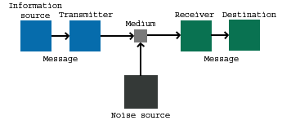
Figure 3: Shannon and Weaver’s
mathematical theory model of communication.

However, the mathematical theory of communication doesn’t represent the interaction between user and computer. It deals mainly with the transmission of a message, and disregards any form of feedback. As an alternative, the interaction framework [Dix A. et al, 2001] can be used to describe the same communication process in more detail by including feedback.

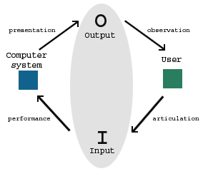
Figure 4: Abowd and Beale’s interaction framework

This model is an extension on the execution-evaluation cycle [Norman, 1990] which aims to understand human-computer interaction in a clear and intuitive way. The interaction framework model incorporates the system explicitly, making it more suited to present the communication process. As shown in figure 4, it consists of four main components: the computer system, the user, input and output. Interaction is represented by the arrows and gives insight in what type of actions are preformed by the user and computer.
By using a model that represents the communication process one can deal with the specific type of communication and interaction by defining and incorporating them into the model.
Proper communication between sender and receiver is essential for the processing, interpretation and understanding of information. Communication can be defined as a connection allowing access between persons or places [Wordnet Princeton University, online lexical reference system]. When dealing with the presentation of information, three types of communication can identified: one-way, two-way asymmetric or two-way symmetric [Grunig and Hunt, 1984].
In the first case, communication between computer and user can be seen as pure transmission: the computer transmits information to the user. The user just interoperates the information without providing any feedback to the computer and this type of communication can be compared with static automatic information display like in public spaces. This kind of dissemination of information focuses on one-way communication; from computer to user.
In case the user gives feedback, for example by keyboard and mouse input, to the computer, the communication between computer and user can be seen as asymmetrical: the computer transmits multimedia information to the user which can navigate through the information executing browsing functionality with keyboard and mouse. This kind of dissemination of information focuses on two-way asymmetrical communication and can be compared with switching channels on your television; browsing through broadcasted programs to find something of interest. What I would like to emphasize is that asymmetric indicates the presence of imbalanced effects caused by differences in communication by user and computer which are caused by the fact that communication from computer to user is much richer then from user to computer [Jacob R.J.K., 1991].
To engage two-way symmetric communication, where communication from computer to user and the other way around is somewhat equal, the type of computer output matches the type of user input. Figure 5 illustrates the different communication types.

Figure 5: difference in bandwidth with
communication between computer and user

Depending on how the user’s bandwidth in communication with the computer is increased, the use of two-way symmetric communication over two-way asymmetric and one-way communication can lead to greater expressive power, naturalness, and portability [Oviatt S., 1999].

Defining the type of interaction
As was said earlier, communication can be defined as the process of exchanging information, and in that respect, it is worth noting that interaction is (usually) part of communicating.
Interaction can be defined as a mutual or reciprocal action (Wordnet Princeton University, online lexical reference system). When dealing with communication between computer and user different types of interaction can be identified: one initiates other responds, both are initiating and responding.
In the first case, one initiate other responds, the computer can have a more passive role while the user can have a more active role by initiating interaction. For example, a user can browse through a website deciding which information s/he wants to see. However, this type of interaction also can be reversed where the computer initiates interaction or a type where interaction is distributed among participants. In the first case the user responds to what is presented; having a more passive role. For example, asking the user to choose between several options.
Usually this form of interaction is not very common. More often when looking at human-computer interaction, the computer and user are both initiating and responding. The number of times they are initiating and responding can differ: for example, the user can initiate interaction more often then a computer. As said above, there is a strong relation between interaction and communication. An indication how interaction is related to communication can be seen in Table A below.

Type of communication/ type of interaction | passive (responding) | active  (initiating)
one-way | - | user or computer
two-way asymmetric (interactive) | user or computer/  user and computer | user or computer /  user and computer
Two-way symmetric (interactive) | user or computer/  user and computer | user or computer /  user and computer
Table A: relation between type of communication and interaction.

With respect to the design of the user interface and consequently the presentation of information, the type of interaction can be of influence. One can imagine that if the user initiates interaction and the computer has a passive role, the user must be able to initiate according to what is presented and (hopefully) be satisfied with the result. This enables a different design approach then when the computer is the initiator: information will be presented to the user instead of searching or thinking for/about it.
However, in the end, the way how human-computer interacting takes place is of importance to successful interaction. Research on how interacting must take place indicates a focus on conceptual discrepancies in human-computer interaction. According to R.J. Beun and R.M. van Eijk. (2004) rich media interacting does not necessarily improve the communication process and therefore interaction itself. They argue that interaction designers can improve interaction by looking at human-human conversational skills. In other words, we are led to considering natural conversational skills in interface design to reach better cooperation. But how can this be realised?
R.J. Beun and R.M. van Eijk indicates that everyone needs and constructs a mental model to understand our complex world, and reacts in a cooperative manner to his/her dialogue partner in order to gain understanding. To reach cooperative understanding by dialogue between user and computer, the computer’s model, called ontology, must match the user’s mental model. An ontology can be defined as being a explicit and formal specification of a conceptualisation [Studer R. et al, 1998] that considers aspects of a domain of interest, and resembles the human’s mental model in the way that it enables a computer to reason about the domain.
Due to the fact that mental modals are often partial, unstable and subject to change [Dix A. et al, 2001] conceptual discrepancies with the computer’s ontology can occur often. By matching the user’s mental model with the computer’s ontology, conceptual discrepancies can be detected and feedback utterances in dialog can be generated to adjust the discrepancies. As example, this can be realized by the use of utterances - a simple language fragment – that the computer can interpret supporting cooperative reactions on communication between human and computer. R.J. Beun and R.M. van Eijk (2004) developed a computational framework that generates feedback utterances in order to repair the discrepancies between it’s ontology and user’s mental model. The computer interprets user language messages, and based on this, generates assumptions about the meaning of the message. These assumptions are compared with the system ontology and feedback is provided when discrepancies are detected.

Defining the perceptual bandwidth
To engage communication we can use different communication technologies as a means to exchange our knowledge, thoughts and ideas to others. The list below sums up some choices of communication technology/mediums/ways that can be used.

- Visual orientated -- communication by symbolic means.
  - Physical non verbal – like body gestures, facial expressions
  - Record of symbolic experiences – like Print, writing, imagery and pictures
- Auditory orientated -- communication by verbal means.
  - Telephone -- remote analogy communication
  - Telegraph -- remote narrow communication
  - Radio -- analogue broadcasting of sound
- Tactile orientated -- communication through or by the skin or external device
  - Interpersonal contact -- like handshakes, pat on the shoulder
  - Physical machine human contact -- Touch/point screens
- Multimodal orientated -- communicate symbolic experiences through multiple modalities
  - Television -- analogue A/V broadcasting combination of sound and vision
  - Internet -- multimedia communication by combined sound and vision
  - Virtual Reality – mixture of haptic, vision, sound in interaction and experience
(Gloria Davenport, read it from A. Eliens, introduction multimedia, 2002, categorized to modalities)

The communication technologies differ in how communication can proceed with regard to the intensity of using our senses (to engage communication) to perceive and sending sensory information. They each have different features and possibilities to being in contact with other persons. For example, one can communicate to a friend about experiencing an eclipse in Spain. This can proceed in many different ways: s/he could orally describe it by telephone, textually by email, textually and visually by a website, in a face-to-face conversation showing photographs and a video of the event, etcetera.
For using communication technology for expression, as noted above, it’s clear that the richness of different flows of information - a type of information flow or communication channel is called a modality and can contain different forms e.g. spoken text, written text, etcetera (Bongers, 2001) - is greater when using communication technology that provides for receiving and sending several types of sensory information. To return to an earlier point, it should be noted that the type of communication plays a role in increasing user’s bandwidth in communication with the computer. The way how this is increased depends on the number of modalities to be used. According to Oviatt, it should be stressed out that increasing user’s bandwidth in communication with the computer does not lead to more effective and efficient user interfaces, although it is assumed to. However, as stated in “defining the type of communication”, increasing the user’s bandwidth can lead to greater expressive power, naturalness, and portability [Oviatt S., 1999]. In this respect, it is worthwhile to consider it for the presentation of information in user interfaces.
Traditional interfaces support mouse and keyboard input as feedback to multimedia information. In the field of HCI, innovative and novel user interfaces are explored to accommodate multimodal interaction by focussing on some of the human senses. These interfaces support forms of user feedback, like eye-gaze, touch, speech, gesture, emotive feedback, but are not as widely commercialised as the traditional feedback possibilities but can be used to increase the bandwidth. The process of multi modal interaction is illustrated in Figure 6, and describes how communication and multimodal interaction between human and computer occurs.

Figure 6: interaction model based on
Abowd and Beale’s interaction framework

Keeping in mind the developed or explored interfaces that support other forms of user feedback or initiative input, we can take a look at the possibilities for incorporating human senses in human-computer interaction in general. In short, there are five main senses a human is capable of using. These are: seeing, hearing, feeling (e.g. temperature, pain, shapes, etcetera), tasting and smelling. With regard to communication between human and computer which senses can be used for user feedback and which stimuli can the computer produce? Furthermore, which senses and stimuli are appropriate to use related to effective and efficient interaction? Let’s start to give a possible answer to the first question by looking at computer output and later on at user feedback or initiative input.
The use of graphics and sound as computer generated stimuli to facilitate human perception is widely implemented and encompasses the most extensive literatures stating it to be the most fundamental forms of computer output.
In the case of vision, there are visual mechanics, color, brightness and contrast, objects and forms, depth, size, and movement that can be created and interpreted by humans [Reeves B. and Nass C., 2000]. These visual mechanics have proven to work very well for effective and efficient interaction. For example, the perception of motion, which tells us that things that move demand attention (which occurs unconsciously), can be used for issues that needs to be dealt with right away.
In case of hearing, the use of sound include the following: psychophysics issues like loudness, pitch, timbre and sound localization, physiological mechanisms considering auditory components of the ear and the neural activity, and perception of speech focusing on units of speech and word recognition [Reeves B. and Nass C., 2000]. These three possible components of sound can be used as computer generated stimuli and as user feedback to convey meaning. For example, perception of speech can be employed to facilitate speech-to-text functionality and speech-input-based-navigation, or computer generated speech, like Windows narrator, for people that are visually disabled.
As for stimuli that address to other human senses; feeling, tasting and smelling, there has been research conducted about their use in HCI. In case of feeling, there are different ways to stimulate such sense.
First, let’s make the distinction between using the sense of touch by physical and virtual objects. By using force feedback one can provide technology that allows for sensation of impact and vibration. For example using force feedback joysticks in computer games indicating danger or other kind of warning. This technology mainly focuses on the physical haptic feedback device (like the joystick with force feedback) itself. It doesn’t give the user any information about to discern on geometry and texture, but is does get the attention of the user to engage further action.
When dealing with creating a sensation of touching an object that doesn't physically exist (but virtually), researchers Ruspini D. C., Kolarov K. and Khatib O. created a haptic system that combines complex visual structures with the sense of touch. This does give the user information about geometry and texture, which enriches (more then only impact and vibration) interaction. However this doesn’t imply usage of haptic over force feedback. It just indicates the difference in information richness and its usage depends on the context where it would be appropriate.
The use of tasting and smelling are not very common in HCI (due to technical and chemical difficulties, issues of research focus and direction and esthetics), and as a consequence not explored or developed. Although they can be useful in incorporating them into an application to create atmosphere (immersion wise), or convey functional meaning (learning to cook). Figure 7 gives an overview of computer output that can be used for interaction.

Figure 7: computer generated stimuli

To continue on seeking an answer to the question of which senses can be used for user based action and which stimuli can the computer produce, I now consider the possibilities of user based action. In sum, besides the traditional input like mouse and keyboard, more types of user input can also be implemented.
In the field of attentive computing - where interaction between human and computer is based on the user’s attention - vision, sound, touch, movement, gesture, interaction pattern and emotion can be used to initiate for computer action, which enables multimodal interaction. But how can one identify, capture and use information about a user’s attention? Let’s first look at capturing the user’s visual focus for interaction. In general, four elements are used to construct attentive user interfaces [Vertegaal R., 2003]:
- Visual attention: where the user is attending on can be derived form its eye-gaze, where the user is looking at. This is considered the most important input technique.
- Turn-taking techniques: this technique allows devices to communicate with each other to optimise the interaction with the user.
- Modelling techniques: this technique allows for programs to ‘decide’ when and how to interrupt the user regarding turn taking and scheduling of interruptions.
- Focus context displays and visualisations: enhances or decreases the information density with regard to where the user is focused on.

By using an eye gaze tracker, one can track the user’s focus and eye movement. This type of tracker is also described and evaluated by Jacob J.K.R. [1991] and is enhanced by it includes identifying head movements as well making it more easier to use. It allows the user to freely move his head during an eye-gaze session without keeping his head steady in a certain position (and avoiding the risk of getting a sore neck). More research has been conducted by Zhai S. [2003], which investigated paying attention to the target object of interaction (by dwell time) before manipulating it by tracking the user focus. Moreover, he argues that eye gaze input must be accommodated by explicit user actions. In other words, the eye gaze of a user tends to provide the context within which actions take place and can be accommodated by the hands of the user which tends to act within the context of where the user looks. Although he argues that eye-tracking technology must be further developed for particle use, the results of the experiments conducted where eye gaze is accommodated by the hands, show the potential for using this novel technology.
More recent research on using eye-gaze in attentive computing has been conducted by Dickie C. et al (2005), where the attention is used in ubiquitous mobile computing. The research focused on making computers communicate with users consistent to social norms on turn taking in communication. Dealing with the turn taking social norms avoids the annoyance of being interrupted by mobile communication devices in situations unwanted for. A low cost eyeGAZE contact sensor (ECS) in a mobile media device is used to detect when a user looks at the mobile display. The information processed by the ECS about user attention is used to pause or continue video or text reading tasks by the mobile media device.
Another form of user’s attention that can be captured and used for interaction is speech. Speech technology for human-computer interaction is currently available and allows computers to process speech and respond on it in a reliable manner. Speech is also used in commercial application such as dictation systems and more. Researchers Tomko S. et al [2005] argue that speech technology supports natural interaction but needs to be redefined how natural the interaction must be. Based on the results of their experiments they conclude that a more structured natural language improves efficiency over natural language in human society in interaction despite that natural language is known to be an extremely efficient mode of communication for human-human interaction.
Dealing with touch as user input we see that it is often used with mobile devices. For instance, the use of a pen to point objects and activate functions in an interface is used with PDA’s (personal digital assistance) and for gaming devices like the PSP (play station portable). The usage of a pen proved to work very well with such mobile device because the interface screen is much smaller, in comparison with a personal computer at home, by which the smallest interface objects can be easily selected. Whether touch input is an enhancement for interaction with personal computer needs to be seen, as a mouse is currently widely used and satisfactory in select, point and click actions.
Body movement and gestures can also be used as user input. However this kind of communication can have numerous constrains like user fatigue and accuracy. Despite these constraints, gestures and body movement input can be used with (mobile) devices where the implementation of a classical keyboard is not possible or inconvenient. For instance, so called software keyboards instead of physical keyboards can be realised by using pen gestures (captured by a camera) or drawings (handwriting a single letter) as user input as a selection method for text input. These gestures or drawings can be symbolic or aim at a certain target which is linked to a symbol. Martin B. [2005] discusses a new form of software keyboard that is formed as hyperbolic geometry and can be operated by static pen gestures. This interesting software keyboard allows for unistroke pen gestures to reach a target (that is related to a letter) with a focus and context visual feedback using little space on screen. The results of evaluation show that its use is quite easily, faster and with more accuracy then other existing gestures keyboard. Whether this technology is useful for other then mobile devices depends on if it is able to be faster and more user friendly then the traditional keyboard for text input. Although it’s concept of navigation can be used for other purposes (like using it for navigation) rather then only text selection.
Dealing with user’s interaction pattern can give insight in user's preference and as a consequence determine how the computer (must) interact. By making the computer able to sense and reason about the user’s attention and therefore choosing a way to address the user given the content of information needed to be attended on, Horvitz E. et al introduced a system that makes decisions based on user preferences, interaction pattern and message content. This analysis of cost of interruption is matched to the gain of interruption (economic systems). To use this into an application other then an operating system one must define the use of such. One can apply user’s interaction pattern into attentive computing with the aim of efficient and effective information searching.
Also emotional expressions can be used as input. Emotions can be expressed by spoken or written language but also by non-verbal ways like facial expressions, intonation, body poses, etc. If the computer is able to process also these non-verbal acts, it could lead to providing more adequate and/or even more appropriate feedback to the user. For instance, by recognizing the emotion of anger that erupted from frustration of conceptual discrepancies between the user’s mental model and computer’s ontology, the computer can initiate actions (in a appropriate way) to repair the discrepancies (adequacy). Based on the assumption that incorporating non-verbal communication for emotion detection, Busso C. et al [2004] argue that capturing facial motion and the tone of the speech can be indicators to identify emotions. In human-human communication these types of expressions are easily detected and matched to an emotion even if they are very subtle. So, in order to match human-human communication in this respect as close as possible, the computer must be able to recognize very subtle expressions as well.
In the research done by Busso C. et al, focused on capturing four types of emotions namely sadness, anger, happiness, and a neutral state by recording and processing facial, acoustic expressions and an integration of both. They concluded that using more modalities for classifying emotion (facial and acoustic expressions) provide more accurate results in identifying happiness and sadness then only using one modal classifier like only acoustic expressions. However anger and the neutral state where more accurate detected by using only one modal classifier (facial expression). Given their conclusions, one can say that capturing emotions by non-verbal clues can certainly be used to enrich communication with the computer. Whether this leads to more effective and efficient communication and interaction remains to be seen. Figure 8 shows an overview of user output that can be used for interaction with the computer.

Figure 8: user sensory expressions

We have discussed which human expressions and computer generated stimuli (output) can be used for interaction. Now, we can look at the question of which senses and stimuli are appropriate to use related to effective and efficient interaction, as stated earlier in this chapter.
Looking at computer generated stimuli, see figure 5 above, one can argue that when dealing with the presentation of large amount of information considering likely complex relations, the use of a particular stimuli depends on the context of use. For example, if the aim of the creator is to strictly inform the user to fulfill his/her needs to know about a guitar, the use of smell and taste seems rather odd and superfluous, unless off course you want to know how the wood of an acoustic guitar smells like. I would be more adequate to present visual information about the appearance of guitar and parts, auditory information about the sound of different resonance boxes, force feedback to simulate the strings of the guitar and haptic information about the feel of holding a guitar and the shape. When looking at the human senses that can be used for input, as shown in figure 6, we can say that all is possible to enrich interaction. However, the way how some of the expressions can be realized is context related. For example, movement in sense of physical body movements is not really suited for an information system as input. It could be very important input for applications where this is helping the user realizing it needs in a particular way. Like in arcade halls where some kind of physical participation: dancing or snowboarding on an input device to enhance game skills and user experience. Besides using body movements, body presence and expressions can also be used as input in computer applications. For example, when dealing with Virtual Meeting Rooms (VMRs) [Reidsma D. et al, 2007], representation of recording of a real-life meeting in a 3D environment, real-time representation by remote participation can be realized. These VMRs are realized form observation, annotation to simulation instantly by computer based algorithms or manually.
As for user feedback and computer generated stimuli in general, it is important that all can be used (considering it’s usefulness for effective and efficient interaction). Besides this, it has been known to that users use multiple input modalities in different ways while interacting. For instance, an interesting experiment, about using a pen and speech as user input shows that pen and speech are used simultaneously and sequentially [Oviatt S. et al, 2003]. Despite the assumptions that multimodal input always involves simultaneous signals, as Oviatt S. explains in Ten Myths of Multimodal Interaction, experiments aimed to interaction patterns shows the contrary. It shows that multimodal input is used differently with users that are in a certain age group. Therefore, a user analysis needs to be conducted to indicate type of interaction, or designers deal with simultaneous as sequentially input for design.

2.5 Experiencing the final presentation
In a word, the final presentation is influenced by communicant goal(s), user needs, and the use of the medium like the communication and interaction type, and perceptual bandwidth. Looking at the final experience form the communicant's point of view, we can say that the communicant’s goal(s) and user needs define the domain or framework where the final experience must operate. Then, with the choice of a medium, the communicant can facilitate the creation of the final experience (bringing it to life), and can transmit its goals/ideas to the recipient. Considering the medium, Sherman W.R. and Craig A.B. [2003] stress out, also mentioned in earlier sections, that how one uses the possibilities of a medium can shape the final experience differently. Dealing with a computer as a medium used, the final experience can vary from more user participation to less user participation, from more immersive to less immersive, etc. In the end, how the medium is used is related to the initially defined domain or framework as illustrated in figure 9.
Looking at the final presentation from the recipient (user) point of view, the one that experiences, we can say that by way of comparison the recipient experience and communicant’s ideas are originated from experience factors (see: 2.2 Initiator: creators idea or users call). The mental reaction of the recipient on the presentation can therefore be various [Sherman W.R. and Craig A.B., 2003].
Figure 9: overview transmitting an idea to recipient, based on idea communication diagram Sherman R.W. and Craig B.A. [2003], and figure 1.

3 Human information processing and user interface design

3.1 Outline chapter
Purpose
This chapter examines the influence of the human perceptual and cognitive system, and the individual differences with respect to this on user interface design. Figure 10 illustrates these connections.
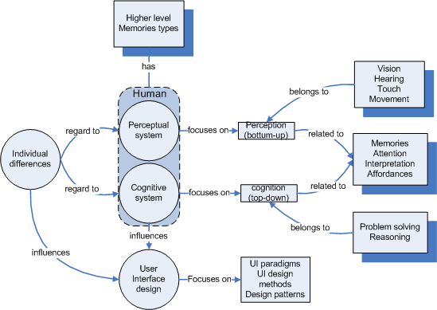
Figure 10: relations between human characteristics
and user interface design

Goal
The sub-research question that this chapter tries to answer is:

What aspects determine or influence effective and efficient information retrieval and interpretation?

Focus
The issues discussed are:
- Memory - section 3.3
- Attention - section 3.4
- Perception - section 3.5
- Cognition - section 3.6
- Affordances and conventions - section 3.7
- Design principles and patterns - section 3.8

3.2 Human information processing
There are two main theories of how perception works and therefore how humans process information. First, the theory of ecological perception by James Gibson tells us that our environment is rich enough to support direct information detection without any form of elaboration or intervention by our mental processes, like to notion of affordances. As a contrast and more widely accepted, the theory of indirect perception, which explains perception as an indirect process which allows for intervention of memories and representations. In this chapter, I use the latter as a basis to describe the information processing process [Micheals C.F, Carello C., 1981].
When dealing with information processing different stages can be distinguished. Figure 11 illustrates these stages and presents them in a certain order of activation. As shown, some stages, like the long-term memory or attentional resources, can activate or influence multiple stages. According to cognitive psychologists, there is no fixed starting point to initiate information processing, as indicated by the presence of a loop. Information processing may occur by some environmental stimuli or is voluntary initiated by, for example long-term memory. In the following chapter more detail is given about each of these information processing stages.

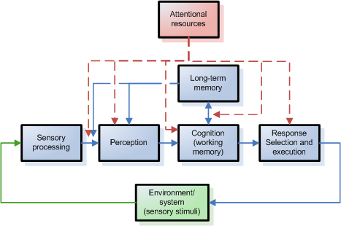
Figure 11: human information processing stages
(modified and obtained from Wickens C., Hollands J., 2000, page 11)

3.2.1 Initial look at the perceptual and cognitive system
Before all the stages of the information processing model are discussed, I like to clarify the notion of perception and cognition briefly.
As commonly known, we are aware of the world around us by using our senses. As described in the previous chapter, the human can perceive computer stimuli and react on it by sensory expressions. With respect to user interface design and more general to the field of human-computer interaction, researchers often make the explicit distinction between the perceptual and cognitive system, like Gillan J. Douglas states in his ‘The Psychology of Multimedia’ (1998). However, because of the existence of multiple definitions for perception and cognition, the distinction itself may come across confusing and can be considered even blurred. As an example, the following definitions for perception and cognition are selected:

Perception: "The act of perceiving; cognizance by the senses or intellect; apprehension by the bodily organs, or by the mind, of what is presented to them; discernment; apprehension; cognition."

Cognition: "The act of knowing; knowledge; perception."

Both definitions contain the defined word of each other. This gives the impression that they are somewhat the same, also when considering that perception and cognition both incorporate bottom-up (from sensory information to interpretation) and top-down (from memory to action/conclusion) processes to acquire knowledge [Wickens and Hollands, 2000). For example, when looking at perception, the environmental input can be accommodated by previous experiences which directs focus of attention. Having said this, is there a difference between perception and cognition, and if so, in what way do they differ?
According to psychologists like R. Gregory (1993), there is a real distinction between cognition and perception. They argue that cognition is part of perception and can both trigger each other, but, the difference between cognition itself and perception lies in the intensity or duration of using cognitive processes; where cognition requires more time, mental effort or attention. Furthermore, when considering the notion of ecological perception (pioneered by J.J. Gibson in 1972 which favours direct realism against the representational theory of perception) or gestalt theory of perceptual grouping, it may suggest that cognition is not part of perception at all; like knowing how an optical illusion works doesn’t make you experience the illusion on a perceptional level differently. Given these assumptions, the consequences for user interface design are the following:

- perception conceived as ecological or gestalt like, is worthwhile to consider when aiming to reduce the effort for instant information processing and directing which and how information is processed.

- cognition conceived as higher-level abstractions refers to solving problems, beliefs, desires and intentions, learning, thought and action, is worthwhile to consider when aiming to attain a maximal level of performance.

3.3 Using our memories for perception and cognition
Much of our daily activity relies on the use of our memory. It is generally agreed that we distinguish three types of memories: sensory memory, working memory and long-term memory.

What is memory?
Before discussing each different type of human memory, the following initial questions need to be answered: what is memory? What can it do for us? And most of interest, in what way can a user interface accommodate and use our memory most effectively and efficiently?

To start with the first question, in short, memory can be defined as:

"the ability of the brain to store, retain, and subsequently recall information" ~ (Wordnet Princeton University, online lexical reference system)

Or more generally said:

"the store of information" ~ [Wickens C., Hollands J., 2000].

Beside the abilities of our memories, there are some properties that need to be considered. Our memory tends to be:

- Limited - only a certain number of items can be retained in working memory
- Imperfect - due to wrong or limited understanding of a situation or system, information stored in memory is partial. This could lead to misinterpretation, confusion and inflexibility when confronted with domain related problems or tasks.
- Selective - due to our arousal, emotional state and interest's one focus his/her attention particularly.
- Subject to change - information loss due to forgetting, change of information due to false remembering or new insights in long term memory.

With regard to the property 'subject to change', psychologist Edmund Blair Bolles says:

"Remembering is an act of imagination"

He argues that remembering is recreating sensory experiences. By this recreating process memories can be changed by incorporating new information, believes or imagination.
To return to the second question, memories can help us to execute and plan actions by applying reasoning and problem solving. In human computer interaction, we have to retain information in our working memory in order to complete tasks. However, to overcome some problems with our memory in computer interaction, like limited storage or incorrect understandings by lack of insight or information, the challenge for every multimedia designer is to create an environment of sensory elements that is memorable, and moreover, one that indicates the correct meaning and location of information.

Using our sensory memories
As mentioned earlier, we can use our senses to acquire information about the world and ourselves. Our sensory ability enables us to retain stimuli for a brief period in sensory memory and if further processed, extract useful information from it. These sensory memories act as buffers. For each type of stimuli (or so called sensory data), a specific sensory memory is used to store it. In short, we can distinguish the following relations between a specific sensory memory and type of stimuli [Dix A., Finlay J., Abowd G., Beale R., 2002]:

- Iconic memory – visual stimuli
- Echoic memory – aural stimuli
- Haptic memory – haptic stimuli (touch)

Capabilities and limitations of our sensory memories
The retained stimuli in the sensory memories are dying out after a period of time. As a consequence, the time stimuli are retained is limited to the time between dying out and obtaining the stimuli. This retaining-time differs for each type of sensory memory [Wickens D., 2001]:

- Iconic memory – 0.5 seconds
- Echoic memory – 2 seconds
- Haptic memory – 0.8 seconds

Attended information in sensory memory is coded to short-term memory. Given this notion, paying attention is a key factor for user interface designers when controlling what and how information will be processed by the user. In chapter 3.2.2.1, I will consider the potential of creating an ‘attention space’ [Jean Trumbo, 1998] in design as a way to control user information processing.

Long-term and working memory
It has been generally agreed that besides our sensorial memories we have a working and a long-term memory.
The working memory can be considered as a temporarily scratch pad where information is retained by attention to think, reason, get new insights, solve problems, repeat, compare, calculate, transform, conclude, etcetera. and with repetition stored in long-term memory. Working memory uses knowledge or information from sensory memories and long-term memory and information not attended for will be lost in less then 20 seconds [Dix A., 2001]. So, for interface designers it's important to control which information from sensory memory, and perhaps, which information from long-term memory (the knowledge/information the user already has stored), is attended for or retrieved from. With other words, the attended sensory or retrieved stored information that is moved into the working memory can be directed by controlling user attention. Also, to avoid information overload, consider that the working memory can only retain 7 +/- 2 chunks of information at a time. As for controlling how to transfer information from long-term memory into working memory, designers can use recognition and recall. Although, psychologists believe that users need considerable less mental effort to recognize something then to recall it.
The long-term memory is considered an unlimited storage of information. Information from working memory may be stored in long-term memory by repetition or association. In our long-term memory we store factual, experiential knowledge, procedural rules, etc [Dix A. 2001].
Interesting for designers is that it is easier to remember words representing objects then words representing concepts, and sentences are easier to memorize.
But in what way is this higher level view of interest for a designer? Jean Trumbo argues that the interpretative memory is most critical in multimedia design to overcome technical limitations especially on the Word Wide Web. User can fill in missing details based on pervious knowledge and experiences.

3.4 Paying attention to perceive or use for cognitive processes
Whether humans choose to do something with the temporally stored sensory information depends to an extent on our arousal, interests, needs and/or previous knowledge [Dix A., Finlay J., Abowd G., Beale R., 2002]. In other words, not all information that comes to our senses is attended to: we capture only a small part of the stimuli at a given moment while ignoring other parts. Our attention is selective which is necessary to avoid overloading our senses. Furthermore, research directed to attention indicates that the choice of attending to sensory information can occur passively (as a reflex, consider the ‘cocktail party phenomenon’) or actively (voluntary).

In general, attention can be divided into three categories [Wickens C., Hollands J., 2000]:

- Selective attention: is a kind of attention where one intentionally paying attention to something, sometimes unwise, while ignoring other things. If selection is becoming too selective then desired, we speak of cognitive tunneling.
- Focused attention: is a kind of attention where one needs to focus on a particular communication channel. Problems occur when we are unintentionally distracted by other competing stimuli and, as a consequence, one could not focus on the desired information source.
- Divided attention: is a kind of attention where one needs to deal with multiple concurrent stimuli. Problems occur when we are unable to divide our attention and, as a consequence, fail in integrating multiple information sources.

Given these types of attention and possible problems, it is desired to address them correctly and overcome possible problems in human-computer interaction.
By dealing with user attention, the computer can anticipate on user actions, prioritize information presented and optimize information processing. For example, as mentioned in the previous chapter in section 2.4, attentive user interfaces are especially made for that purpose. An attentive user interface can be defined as:

“Computing interfaces that are sensitive to the user’s attention” [Vertegaal R., 2003]

But, there are many different types of attentive user interfaces like eye tracking or registration of user presence and orientation. These differences lie in the way how to deal with user attention and how they anticipate on user attention. In this perspective, user interface designers can consider three approaches:

- directing user attention, and/or,
- tracking user attention, and/or,
- Accommodating user attention.

Before the three approaches are discussed, I would like to emphasizes that the overall goal is to create a space of attention (a particular area on the screen or information), by considering the user attention span (the time and mental resources the user has to attend to something), that address the types of attentions, as mentioned above, correctly for efficient and effective information processing.

Directing attention
First let's look at directing user attention. There are several methods to direct the users focus and therefore guide the user through information processing. In current multimedia applications the most important stimuli is visual. This is obvious when considering that sight (and sound) dominate our perception [Reeves B. and Nass C., 2000]. Given this, the most studied and applied methods for directing user attention are [Kahn A. et all, 2005] : 1) animations, 2) motion cues, 3) graphical trials, and 4) sound.

- Animations: animations (gradual and progressive simulation of movement), as well other forms of motion, are easily detected by ganglion cells [Dix A. et al, 2001] located in our peripheral vision. This allows us to perceive animation, without having to focus vision on the source. In other words, this unintentional ability to perceive motion is well suited to direct attention immediately. For example, the use of guided tours can contribute to demonstration and explanation like by animations with regard to viewpoint or object position and/or rotation. Also other animations like using animated icons to support identification. Overall, these ten basic ways for animation can be considered useful in interface design.
According to Bay-Wei Chang and David Ungar (1995), cartoon-like animations in user interfaces are both cognitive and affective. They argue that cartoon-like animations support users to track objects and understand what is changing on the screen. These animations reduce some of the cognitive load associated with deciphering the interface status from higher cognitive mental processes to the periphery of the nervous system. Furthermore, applying cartoon-like animations instead of realistic animations has the advantage that animation engages users, keep them focused on the domain and concerned with the task, instead of the mechanics of the interface.
Other research, conducted by Khan A. et al (2005), applied spotlight animation on a presentational screen. This spotlight illuminates a part of the screen in a sized diameter and making the surrounding gradually darker. They showed that directing user attention by this spotlight, improved high performance to target acquisition tasks.
However, to avoid animations to be slow, distracting and/or annoying, each animation applied in a user interface must be understandable, engaging, and a pleasurable experience. One way to address this is to understand the interactive nature of interfaces, where the user has control and animations must be responsive: for example, if a user is ready to move to a next action, running animations needs to be stopped immediately. Although, like Bay-Wei Chang and David Ungar argue, any user interruption must be then facilitated with appropriate animations to keep the interface style coherent.

- Motion cues: Bartram L. (1997) states, based on research conducted by others, that humans can pre-attentively and simultaneously track up five distinct unrelated motion trajectories in the same visual field. In this perspective, motion can be used to direct focus and speed-up interpretation. It is assumed that motion reduces cognitive load of interpretation and allows for increasing information density given sensory buffer limits. Also, using relative simple motions can be interpreted as highly sophisticated behavior, which are computationally inexpensive and impose less screen space.
Research conducted by Baecker R. et al (1991) shows that dynamic icons are considered useful and helpful in situations where static icons failed to convey the proposed meaning. However, despite these positive results, they didn’t succeed to identify what makes an animated icon successful in terms of length, content, ordering and presentation.

- Graphical trails: In some computer games graphical trails(visualizations in user interfaces used as feedback, to inform, and/or to hold/get the attention of the user in order to help the user indicating future actions) appear to inform the user about some off-screen object of interest. For example, in the game world cup '98 an indicator tells the user that a current off-screen team member is in range to pass the ball, in the direction where an arrow is pointing. As for more 'serious' applications, Zellweger P.T. et al (2003) developed contextual views for off-screen information.
Currently, when browsing through highly inter-related information, indicators are used to track and show user history, answering the questions like "where was I before?", "where am I now?" and "what is currently available to me?", adding graphical trails can inform the user about future steps, answering questions like "show me, what can I do next?".
Also, with regard to limited screen space, where information is hidden/obscured form the user in particular stages, it is believed that graphical trails can point out this information to the user, and as a consequence, reducing cognitive load to search for the information himself. Whether this assistance occurs by pointing out all information available or just particular information based on user interest/profile remains to be investigated per application.

- Sound: getting and directing the user attention by sound is considered an appropriate alternative/supplement. Important to consider is the frequencies, amplitude and the properties and working of our echoic memory.
Mastoropoulou [2005] discovered that sound attracts attention away from visuals in user interfaces. Furthermore, related to animations, user experienced animations at different rates as equally smooth. This audiovisual combination could lead to better appreciation of animations and less demanding on computer resources.

Tracking user attention
There are different ways to track user attention. A goal would be to record and establish a user’s interaction pattern by which the computer system determines what, when and how information is presented. This interaction pattern recording could be done explicitly, by using the mouse pointer as focus of attention. For example, in most current WIMP (windows, icons, menus and pointers) applications, the user is responsible for prioritizing information to process. By using windows the user can determine (by minimizing or maximizing the windows) what information will be on the foreground, and it focused on, and what information will be on the background. Alternatively, we can track user attention more implicitly, by capturing eye focus or other bodily expressions. For example, the Magic Pointing System that uses eye and mouse input simultaneously [Zhai S., 2003].
When user attention is tracked successfully, the computer can perform actions triggered by the user attention. One can think off: deciding if a user needs to be instantly interrupted given the priority of a message and user attentional models [Horvitz E, 2003], initiate to direct the user to other information of interest given the user focus on particular information, etcetera.

Accommodating user attention
When the user has directed his/her attention, designers have to accommodate the attention span as effective as possible to assist the user's information processing. Attention span can be defined as:

"the length of time you can concentrate on some idea or activity" [Wordnet Princeton University, online lexical reference system]

The accommodation of this attention span, triggered by a type of attention, as mentioned above, like focused and/or divided attention, can be realized by dealing with how and when to present information.
In windows based applications, like the Windows OS, one can argue that the use of opaque windows facilitates focused attention – any distraction is minimized by placing it on the background. On the other hand, using transparent windows facilitates divided attention more effectively – multiple sources are visible at the same time. Given this, Harrison B.L et al (2003) states that task characteristics largely determine the attentional requirements. They experiment with dynamically evolving interfaces which changes visuals according to needed attention, like transparency properties. The results are very promising and show that designers can create new interaction and visualization techniques that support the attentional needs of the user and the tasks that need their attention.
Besides these implementations, I believe perception is fundamental to accommodating user attention. Therefore, human information processing theories related to human computer interaction can provide initial guidelines. In the next section, I will provide more detail on perception.

3.5 What can we perceive?
As mentioned in section 3.2.1, perception can be shortly defined as the active in which we select, organize and interpret sensory input. Next, I will briefly describe the effect of visual perception on information processing.

Visual perception
Visual perception can be considered the most important input channel to process information. Because of this, we need to consider limitations and opportunities to deal with or apply in interface design to make it as effective as possible. In short, we can perceive color, motion, size and depth, etc.

Visual perception: making use of color
When looking at color, it can provide means to make distinctions, group information, apply context, define relations, enhancing aesthetics, etc. But how can we apply color effectively to enhance perception? Colors used in so-called home made website, found scattered on the Internet, are often chosen based on personal preferences without understanding how it can be applied to solve problems with regard to perception. As a result, the websites can contain hardly readable words by bad contrast or improper combinations or colors leading to misinterpretations and errors.
Colors are considered to make up from hue (family), intensity (light) and saturation (amount of white). By color sensitive receptors located mainly in our fovea, we are able to detect blue, green and red color waves. Because these receptors are located mainly in our fovea, we are less capable to detect colors in our peripheral view, in contrast to the detection of motion. In other words, colors are best detected when focusing on it. Also consider that 8% and 1 % of all males and females are unable to discriminate between red and green. [Dix A., 2001]
Subin, Falck and Johnson (1996) have conducted a literature research in the use of colors in interface design. They conclude that each visual element must be created with respect to all other visual elements. Meaning that visuals created depend on other visuals used. For example, the use of lighter of darker backgrounds makes object larger or smaller which can cause confusion, errors or misbalance the intended interface schema.
In general, we need to ask ourselves the question: what is the problem to solve? And see if colors can fit in. When colors are applied consider the following rules:

- Contrast - to get maximal readability of text make sure that you use dark text on light backgrounds and light text on dark backgrounds.
- Consistency – ensure a common look and feel (and avoid a color highlight effect) in the interface by applying colors consistently creating a coherent visual overview.
- Context – use color to group information and distinct or discriminate between information.
- Mood – apply appropriate color schemes to convey the mood and emotions the application is intended to send out.

A useful aspect is that colors can be applied for any visual effect. For example, creating optical illusions or applying colors to enhance aesthetics or context. By using different intensity or saturation objects can appear more distant or more on foreground. Also giving the illusion of 3D objects by applying shadow effect on flat visuals.

Visual perception: size and depth
The perception of size occurs when the retinal image of object will be larger if the object is close to the eye, and smaller if it is further away [Wickens D., 2001]. Familiar and relative size monocular cue's can give the user information about the distance of an object or status object. For example, familiar sized icons and minimized version tells the user about the status of information: being active/passive, foreground/background or focus/out-of-focus.
The perception of depth can be defined as the ability to see in 3D and indicate how far an object is [Wickens D., 2001]. Seeing depth allows us to make efficient use of virtual screen space, facilitate attention, or convey additional information like functionality and usage. Depth perception can be divided into two main categories: visuals cues by characteristics of an object or the world we perceive (object-centered cues), and characteristics of human visual perception (observer-centered cues).

  - Some known object-centered cues [Wickens D., 2001]:
  - Linear perspective – two lines converging are seen as two parallel lines appearing in depth.
  - Interposition – when an object obscures another, the obscured object is seen as further away.
  - Height in plane – objects that are higher located in our vision are seen as further away.
  - Light and shadow – shadows indicates objects orientation and shapes with respect to our location.
  - Familiar size – if known objects of the same size are seen at different size, the relatively larger perceived object is seen as closer to us.
  - Textual gradients visuals – the texture of an object is less finer at greater distances.
  - Proximity-luminance covariance – objects are brighter and the intensity greater as they are closer to us.
  - Aerial perspective – distant objects appear less clearly by the atmospheric interference.
  - Motion parallax – objects that are closer to us tend to show greater relative motion. The same effect occurs when the background of objects is moved.
  - Light and shading – light is assumed to come from above and can detect shape edges that lead to textures that imply depth.

    - Known observer-centered cues [Wickens D., 2001]:
  - Binocular disparity – the combination images perceived from both eyes tell our brain the depth of the object based on the differences of information of both eyes.
  - Convergence – the shape of the eye lens tell our brains how far away an object is (the thicker it is the closer an object is).
  - Accommodation – the angle between the line of sight of the eyes tell our brains the distance of an object (the greater an angle is the closer an object is)

Visual perception: visual positions and distribution of forms
In constructing computer images or facilitating group perception, one can make use of principles of perceptual grouping by gestalt. Following the suggestion of Chang D. et al. (2002) and others, gestalt laws or principles can be used to improve information processing and thereby improve learning. Chang further argues that not enough gestalt principles are used; instead only a small number of principles are applied, and identified eleven principles that could be used in interface design. The principles most used by designers are according to Chang:

  - Law of proximity: objects that are placed near each other are perceived as grouped to together [Fisher and Smith-Gratto, 1998–99]. This can be used to draw user attention. As an example see figure 12.
  - Law of closure: we tend to see complete objects even when part of the information is missing [Fisher and Smith-Gratto, 1998–99]. This can be used to spare computer resources. As an example see figure 13.
  - Law of similarity: objects that are similar are perceived as belonging to the same group. [Fisher and Smith-Gratto, 1998–99]. This can be used to draw user attention. As example an see figure 14.
  - Law of good continuation: we tend to follow straight or curved flows and perceive them as an object. Fisher and Smith-Gratto, 1998–99]. This can be used to draw user attention. As an example see figure 15.


Figure 12: proximity Figure 13: closure Figure 14: similarity Figure 15: good continuation

The other identified gestalt principles for interface design by are:

- Law of focal point – point of attraction by dissimilarity.
- Law of figure ground – detection of fore- and background colors.
- Law of balance – objects are perceived incomplete when not symmetrical
- Law of Isomorphic Correspondence – we associate object with meaning by previous experiences
- Law of Unity/Harmony – objects placed in the same unity are perceived as related
- Law of Simplicity – we unconsciously tend to simplify visuals when perceived
- Law of Prägnanz (Good Form) – we tend to organize visuals as symmetrical as possible

The results of experiments by Chang et al. shows that all eleven principles aid users in information processing.

Visual perception: motion
As already discussed in the previous section, we are also able to detect motion in our peripheral view. Besides that we do not have to focus on the source to detect motion, and therefore someone else may use it to direct attention, we need to be very selective when to use motion in order to avoid distracting the user when not wished for.

Visual perception: object recognition
The recognition of objects can provide us with information about the identification of that object, possible actions to perform with or on the object, contextual information in the perceived situation, size, position and distance of the perceived object, etc.
There are two main theories about how humans recognize objects. These are:

  - Feature detection theory
  - Shape detection theory

The feature detection theory indicates that features of object are combined in order to make a recognition. Based on this theory Treisman (1986) developed a model that represents the feature detection theory. In a word, this model suggest that the features of an object is detected in early vision i.e. retinal perception. After that the features identified are accommodated by information about their nature (like color) and location. Then attentional recourses combine all features into a representation of the object perceived. Finally, the object is recognized or is conceived as new.
The shape detection theory indicates that a perceived object is matched against 3D components that represent parts of the object. Biederman, I. (1995) has identified several geons that are used as representational components of objects in general. Recognition occurs by matching the geons, represented in memory, against parts of the object perceived. These geons are considered 'unaccidental properties of an object' i.e. information that is unlikely accidental with regard to the its viewpoint.

3.6 Using our cognitive abilities
The two cognitive processes that will be discussed in this part are: 1) problem solving, and 2) reasoning. Knowing how humans solve problems and reason, can tell something about how information is processed and manipulated. At the end, mental models are discussed.

Reasoning
Reasoning can be defined as:

"the process by which we use the knowledge we have to draw conclusions or infer something new about the domain of interest" [Dix A., 2001]

It has been generally accepted that reasoning can be categorized in three types [Dix A., 2001]:

  - Deductive reasoning: a logical result from given premises. For example: if the sun shines my friend goes to the park. So, in the case the sun shines, the logical result of that will be that this friend will go to the park. Be aware that deductive reasoning doesn't have to be valid. It can be logical correct but not valid according to the truth.
  - Inductive reasoning: a generalization from things we know to say something about things we don't know but can infer to. For example, at universities in Amsterdam all master classes will be given in English, therefore I can assume that this is also the case in universities in Rotterdam.
  - Abductive reasoning: given a certain fact, the related action/state that caused it is identified. For example, suppose my tutor always dresses in black when he gives a presentation. When my tutor appears in black costume, we may infer that he is going to or just had a presentation.

All the reasoning types are not completely reliable or can be assumed to be true all the time (however we need to do this in order to be efficient with time and resources). This could lead to users reason about their encounter with a user interface incorrectly, leading to misunderstanding about the system and as result being confused. Being aware of this can help the designer to minimize any incorrect reasoning by being explicit. On the other hand, I believe that these types of reasoning can also be exploited by the interface designer by building the system according to the types of reasoning by being consistent. For example, every time a user activates a video an icon is shown inferring other related content. This is of course easier then in the real-world, where we don't control and know everything. A computer program can be made, respond and controlled in a way you like it to be.

Problem solving
Problem solving can be defined as:

"process of finding solution to unfamiliar tasks by using the knowledge that we have" [Dix A., 2001]

Dix et al describes three views how problem solving works. These are:

- Gestalt theory: This view focuses on the mixture between previous knowledge or experiences and new insights of the problem (productive reconstructing). A well known example is the Maier's `pendulum problem'. Where a problem couldn’t be solved by participant until a researcher set an object in motion as an initial clue. From this clue, the participants could reconstruct the solution of their problem.
- Problem space theory: this view focuses on ways to reduce the differences between the initial state to the defined goal state. This reduction is often realized by sub-goals. The domain which this theory is applied for has to be well-defined. The problem solver must have full understanding in the operator s/he can choose to accomplish the goal state. For example, in a game of chess, the goal would be to eliminate the king of the opponent. Well defined operators (game rules and pieces) are available to accomplish this goal.
- Analogy in problem solving: this view focuses on solving novel problems. The basic of this theory lies in analogical mapping: where similarities between known domains and the new domain are identified and the knowledge from the known domains are related to the new one. For example, knowing how to surf can be applied on learning how to snowboard, applying the technique of balance and coordination.

How are problem solving theories of importance for user interface design? A answer might be that identifying previous knowledge of the users can be used as basis to accomplish user tasks. For example, with the analogy in problem solving theory where knowledge of similar domains can be applied to new problems. In case of the problem space theory, the steps to accomplish a task must be similar to the steps logically taken when confronted with an initial state and a defined goal. However, this seems to be guess-work instead of actual practical guidelines. I believe that designers can evaluate tasks and potential problems according to these problem solving theories.

Mental models
As last I like to mention the term mental models. As described in human computer interaction literature [Dix A. et al, 2001 and Wickens C.D et al, 2000], the construction of mental models are considered critical in failure or success of an interface. Mental models can be defined as:

"a mental structure that reflects the user's understanding of a system" [Carroll and Olsen, 1987].

Mental models are necessary in order to work with and understand a system. This knowledge is particular advantageous when confronted with novel tasks. Hence, when understanding how it works a solution can be logically derived. Unfortunately, mental models are often partial, unstable, unscientific and subject to change [Dix A., 2001]. Therefore, it would be desirable that the interface itself accommodates the correct understanding of the system. This can be accomplished by using design principles, guidelines, design patterns, information processing theory, conventions, conceptual models, cognitive models, affordances, etcetera.

3.7 Dealing with conceptual models, affordances and conventions
Next to perception and cognition I would like to point out the use and differences of conceptual models, affordances, constraints and conventions.

Norman (1999) has identified four concepts that are important to assist users how to use our designs. These are:

  - Conceptual models,
  - Affordances,
  - Constraints, and,
  - Conventions

He argues that the basis of all designs are conceptual models. These conceptual models have to be explicitly defined and perceived in order for the design to be coherent and understandable. Given this model, design can be expanded with affordances, constraints and conventions.
However, designers often confuse the meaning of affordances, constraints and conventions.

Norman says about this: "don’t confuse affordances with conventions" [Norman, 1999]

Affordances are intended to specify the range of possible activities and can be defined as:

“the actionable properties between the world and an actor” [Gibson (1977, 1979), read it from Norman, 1999]

The term affordance and the theory was pioneered by perceptual psychologist J.J. Gibson. In his theory he argues that affordance is the link or relation between the world and an actor. This relation exists naturally and does not have to be visible, known or desirable [Norman, 1999]. By affordance the actor perceives what the world and its contents can provide.
Knowing what an applications offers to the user lies more in terms of perceived affordances, constraints and conventions. By abstract representations and actions the user can accomplish his/her tasks. For example, scrolling a slide-bar or switching mouse point to indicate clicking is a convention based on computer culture. Users learn conventions. Perceived affordances can be applied to indicate action on object never encountered before. The difference between perceived affordance and conventions are based on culture. Where conventions communicate through known symbols by culture in heritage, perceived affordance refers to what we think an object can do. Given the correct concepts that play a role in user interface design, the designer must deal with this:

Does the user perceive that clicking on that object is a meaningful, useful action, with a known outcome? [Norman, 1999]

3.8 Considering design principles and patterns in UI design
So far, I have considered human information processing aspects, like the use of motion, and properties, like the working of memory, that influences user interface design. However, besides this, one can apply design principles and patterns to interface design. Design principles and patterns are developed based on experience and/or theories that address effective user interface design, and as a result, accommodating human information processing and they may guide the creation of mental models (as mentioned above).

Design principles
Design principles that are applied in interface design, are focused on usability. Dix A et al (2001) distinguishes between three categories of design principles:

- Principles directed to learnability: ease of use (understanding how it works) and attain maximal performance (effectiveness)
- Principles directed to flexibility: multiplicity of ways how user and system exchange information.
- Principles directed to robustness: ability to determine success and assessment of goals.

Also, Shneiderman provides design rules in eight golden rules for design (1998):

- Strive for consistency
- Enable frequent users to use shortcuts
- Offer informative feedback
- Design dialogs to yield closure
- Offer error prevention and simple error handling
- Permit easy reversal of actions
- Support internal locus of control
- Reduce short-term memory load

Design principles are known to enhance usability and can be applied accordingly. Although, using design principles may suggest that there is less room for creativity and possible innovations, they can be extended by new knowledge and insights.

Design patterns
Design patterns can be viewed as practical examples of proven design solutions. These design patterns are usually found in widely used and accepted applications, so called best practices. In other words, they are design parts that can be re-used in other design to ensure usability. Martijn van Welie made several kind of design patterns available on his website http://www.welie.com, see figure 16.
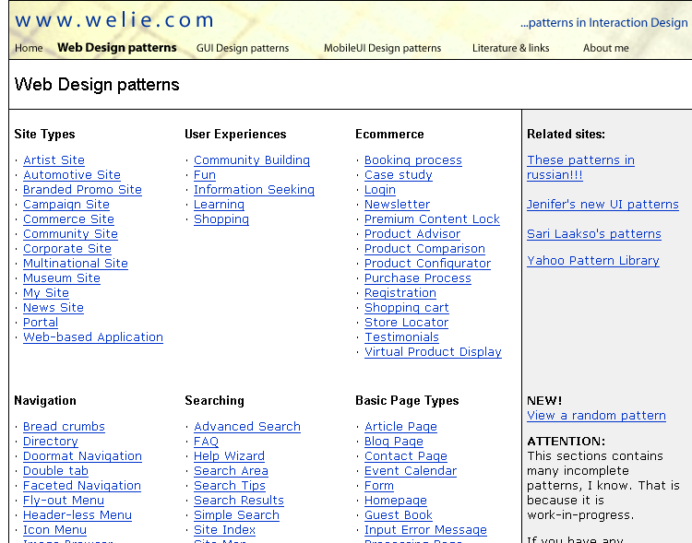
Figure 16: screenshot website about design patterns
[http://www.welie.com]

These design patterns are systematically documented by indicating the relationship between the context, problem and solution. For example:

A design pattern for search results, based on Amazon.com [http://www.welie.com]:
…
Problem: Users need to process a list of search results
Us when: Users have done some form of search, e.g. using a Search Box or Advanced Search or Booking. Now the users need to process the result, most likely by choosing one or more items for further investigation i.e. seeing the page, adding the item to a Shopping Cart, collect items for a Product Comparison.
Solution: Present sorted results with a short description
…

In sum, I believe design patterns are suited most for conventional interfaces and indeed each pattern seems to be working well to improve usability. However, there is always room for improvement towards perfection and depending on the situation there isn't a pattern for everything. They can be best used as indicators for familiar design solutions. Design patterns are abstract solutions, to be implemented by the designers creativity, craft, dealing with the aspects of context and culture.

3.8 Considering feelings of esthetics: the halo effect
Also emotions are important for design, as shown by researchers led by Dr. Gitte Lindgaard at Carleton University in Ontario, Canada. Through empirical study they conclude that:

"web designers have as little as 50 milliseconds to capture the interest of potential customers. Through the halo effect, first impressions can influence subsequent judgments of website credibility and buying decisions." [http://www.websiteoptimization.com/speed/tweak/blink/]

By letting users see websites within a time ranging from 500 msec and 50 msec in order to record their first impression. The first impressions are based on initial emotional reactions that where considered pre-cognitive. The consequences of the first impressions are that of "confirmation bias" or called the "halo effect" [Edward Thorndike, 1920]. The halo effect makes the users search for evidence confirming their first impressions while ignoring contrary evidence. In a word, the first impressions of the visual style of a website immediately determines the judgment of that website and may influence further interaction.

4 Information visualization

4.1 Outline chapter
Purpose
This chapter discusses the different ways to visualize information and, how visualization can be used to navigate in a desktop environment. As shown in figure 17, there are a number of factors that influences how information will be visualized. In the following parts more detail is provided of some of these factors. First, I deal with the visualization of information in general. Then, I give more detail about the influences on information visualization given a developed framework, current implementations of visualizations provided with there strengths and possible weaknesses and how they fit into a user interface as navigational paradigm.

Figure 17: overview factors that influences or play a role by information visualization

Goal
The sub-research question that this chapter tries to answer is:

How to present large amount of highly related information with regard to effective and efficient information retrieval and interpretation?

Focus
The issues that are discussed are:
- Information visualization framework– section 4.2
- Using 2D and/or 3D representations– section 4.3
- Information visualizations applications - section 4.4
- Metaphoric representations – section 4.5

4.2 Dealing with information visualization
Before I discuss different types of information visualization and how to apply them in a user interface, we can ask ourselves the following questions: what is information visualization?, why should we use it?, and, how can we use it?

Information visualization: definition and arguments for use
To answer the first question, information visualization can be defined as:

“the use of 3D graphics to present complex data so it can be explored and manipulated” -Shneiderman (1998)

Shneiderman definition can be considered the general accepted meaning of information visualization. However, I would like to add to view the use of information visualization in a more broader setting, where 2D and 3D are both considered
The last part of the Shneiderman tells us that information visualization is an interactive representation of data. Due to this property, it is well suited to function as a navigational aspect in a user interface. Furthermore, to enhance human information processing, the interaction itself can be accommodated by animation. As discussed in the previous chapter, animation and dynamic representations can be applied to direct attention and therefore: 1) overcome possible attentional problems, 2) control which information and guide how information is processed (dealing with attentional span by creating an attentional space), and, 3) support integration of different views or information spots, in order to reduce cognitive load.
Furthermore, the Sneiderman definition, which answers question two, tells us that information visualization itself reinforces cognition (‘…complex data so it can be explored and manipulated”’). As commonly known and also mentioned in the previous chapter, visually stimuli is considered the most important aspect of perception. Information visualization tend to be supporting pattern and relation detection resulting in accommodating problem solving and decision support.

Information visualization: framework
Let's look at the third question: how can we use information visualization? Well, a lot of research has been conducted related to information visualization [Card S.K et al, 1991, Robertson G.G. et al, 1993, Sebrechts M.M. et al, 1999, Calitiz A.P. et al, 2001, Irani P. et al 2003]. However, besides that they are interesting and useful for the development of information visualization, they are focused on a particular aspect of information visualization, like the presentation of hierarchical structures or just 3D visualizations.
Pfitzner D. et al (2001), claims to have introduced a more broader approach to information visualization. They developed an extensive framework for information visualization by focusing on information retrieval and psychological aspects related to human perceptual capabilities and limitations. As basis for this framework, they used Normans (1999) theories of gulf of execution and evaluation. In short, these theories tells us that a user interacts with the computer to accomplish certain goals which the computer can realize. The first problem the user encounters is "how to formulate my goal(s) to the computer in order to accomplish my task(s)". This requires insight in how the system works and by which operators it communicates. Secondly, when a formulation is executed the user must asses the results on correctness and meaning that leads (hopefully) to satisfaction and new insights.
Given this, I believe that this framework provides rich and full understanding of issues that influences the application of information visualizations. The framework uses for the design of information visualizations five factors that are considered important: data abstraction, task, interactivity, skill level and context. To discuss these factors, I have re-arranged them in a table:

Factor | Sub-factors | Issues | Explanation
Data abstraction  (information that is stored is presented in some kind of abstraction to enhance human information processing) | Relation types | Linear | 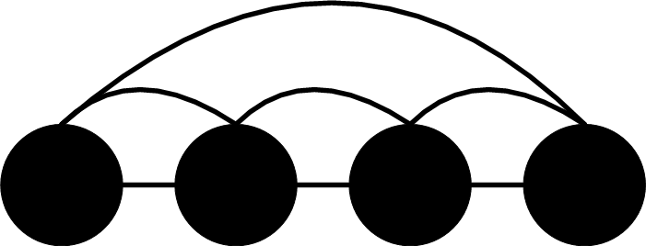 Pfitzner D. et al (2001)
 | Relation types | Ordered tree | 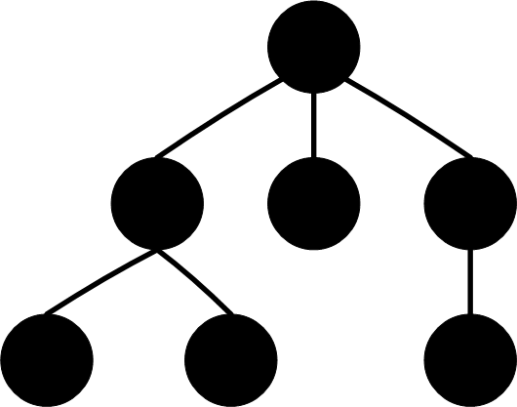 Pfitzner D. et al (2001)
 | Relation types | Un-ordered tree | 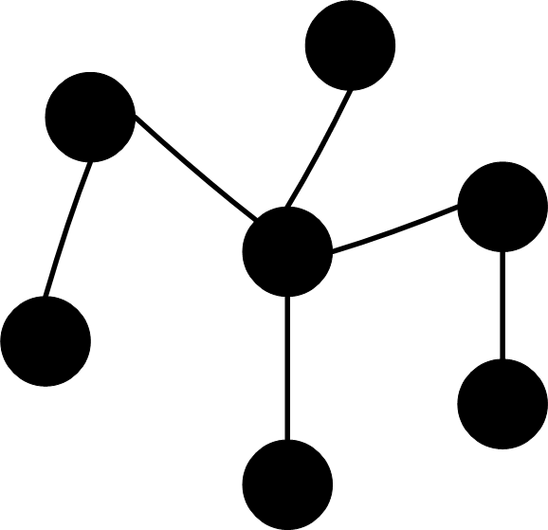 Pfitzner D. et al (2001)
 | Relation types | circular | 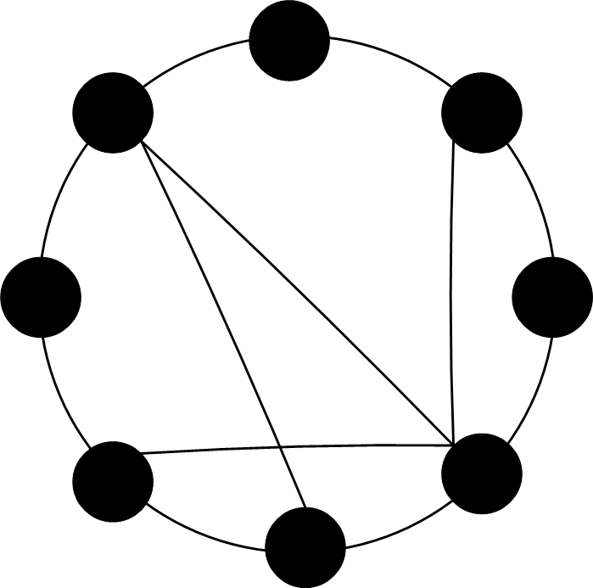 Pfitzner D. et al (2001)
 | Relation types | Lattice (stereo) | 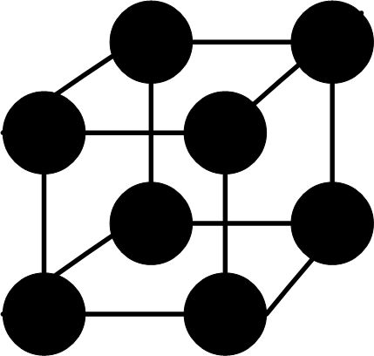 Pfitzner D. et al (2001)
 | Data types | Low data | The availability of and access to objects and attributes
 | Data types | High data | The availability of and access to meta data
Task  (the goal the user wants to accomplish by using low level actions that apply to this accomplishment) | Task types | Overview | The result of viewing all data of a collection
 | Task types | Zoom | The result of viewing a single item like an object or attribute
 | Task types | Filter tree | The result of viewing a subset of data wished for.
 | Task types | Details on demand | The result of viewing details of data.
 | Task types | Relate | The result of viewing relationships between data.
 | Task types | History | The result of viewing previous actions with the aim to undo, replace or refine.
 | Task types | Extract | The result of viewing specific data retrieved from a subset by decompression.
Interactivity  (the possibility and ability of the user to interact with the interface to accomplish a certain goal, a degradation between static and dynamic) | Interaction types  Direct manipulation  Fully automated (indirect manipulation) | Manual | Interaction that requires direct user input and physical effort to perform any action, like dragging an object with the mouse.
 |  | Mechanized | Interaction that uses a tool for focused selection like pull down menus.
 |  | Instructable | Interaction that is controlled by user direction and/or definition, like formulas or user driven guided tours.
 |  | Steerable | Interaction that is commanded by user specification to act in particularly way under specific conditions, like algorithms.
 |  | Automatic | Interaction that is automated and cannot be directed like pre-defined guided tours.
Skill  (the status of user domain knowledge, experiences and interests) | Skill types | Novice | Categorization of knowledge of domain, experience and interest. In this case general and broader information, functionality, actions and visualizations.
 | Skill types | Expert | Categorization of knowledge of domain, experience and interest. In this case certain specific information, functionality, actions and visualizations, functionality, specific actions.
Context  (external influences - with respect to information visualization) | Context types | Life experience | Overall experience and skill to use and operate on information visualization, like computer skills or education.
 | Context types | History | Recordings of previous actions related to the type of use and intensity of use towards the information. For example: <type of use, intensity>
 | Context types | Intend | Registration of what kind of information the user wants to obtain given the available data.
 | Context types | Need | Registration of user needs with regard to accomplishing goals.
 | Context types | Device | Physical device and properties which are used to display information, like size and resolution of computer screens.

Given the framework, I would like to add an extra issue to the factor ‘context’ - last row in the table from the left. This extra issue is an additional context type:

Technology | Considering the limitations and possibilities of certain non-physical 3D technologically, like presentational issues, for example: shading, demand on computer memory use, etc.
Furthermore, I would like to add a new sub-factor to the factor ‘data abstraction’ - first row in the table from the left. This new sub-factors is: ‘environmental types’ and contains two issues:

Environmental types | Information access | Information that is represented for the purpose of interactively viewing data structures and their context.
Environmental types | Information retrieval | Information that is represented for obtaining specific information with regards to its content.

I believe that this addition is necessary to consider the users high level intention for accomplishing a certain goal. In more detail, given the sub-factors different visualizations for each of them can be wished for, focusing on the difference between the purpose of navigation and presentation.

To return to an earlier point, namely the gulf execution and evaluation, as stated above, Pfitzner et al further point out that interactivity determines the success of both. It seems that dynamic user interaction, which requires the system to inform the user about changes with regards to the user interface i.e. immediate feedback, enforces understanding about the context of current and previous information states/actions, like history tracking by animating transition. With other words, being aware of context can help the user in assessing the results on correctness and meaning (gulf of evaluation), and interaction with the system and the feedback given, can lead to determining how the system works and by which operators it communicates (gulf of execution).

Information visualization: aspects of influence
Now that the framework is discussed, we can ask ourselves: In what way does this framework influences the visualization of information? As an overview, figure 18 illustrates the individual framework aspects and their influences.
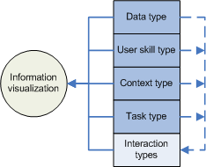
Figure 18: factors related to each other and information visualization
(modified and obtained from Pfitzner D. et al, 2001)

The solid lines indicate direct influences and the dotted lines indirect influences. As shown, the factors: data type, users skills type, context type and task type, indirect influences the interaction type. This means that, interaction type is considered the most import aspect of the Pfitzner D. et al constructed framework. However, they didn’t provide (yet) more detail about the intensity with regards to the factors influences on the factor ‘type of interaction’. And also with what intensity all factors influence information visualization.
Information visualization itself is directly influenced by all of the factors. Thereby it can be further examined according to the following properties which are influenced by the factors:

- Display dimensions - like 2D or 3D, colors, shapes, etc. Influenced by factor data types, user skills, context type, type of task.
- Navigation – like degree of static, dynamic visualizations or animation, automated navigation, conceptual navigation, query based search, spatial navigation, etc. Influenced by interaction style, data type, user skills, type of tasks, context type.
- Feedback from computer to user – like animation or still. Notice that state transitions needs to be animated to give feedback and track results. Influenced by interaction style, task type, data type.

I conclude that the framework provides an extensive initial guideline for the development of information visualization, and, its generic properties allow for exploration and multiple interpretations. Overall, the framework can be used as a future reference for contextual visualized information.

4.3 Display dimensions: 2D or 3D?
The dimensions of information visualization can be either presented to a plane (2D) or by using third dimension of depth (3D). Before discussing the implications of using 2D or 3D information visualizations, we need to briefly define what 2D and 3D is.

Display dimensions: definition 2D and 3D
2D can be defined as: "a structure using two dimensions, horizontal x and vertical y”
3D can be defined as: “a structure using three dimensions, horizontal x- axis, vertical y- axis and z- axis”

Display dimensions: implications 2D and 3D on interaction

A most common 2D interface paradigm is the desktop environment where navigation is based on a WIMP interface. The idea behind the use of a desktop environment, as used in the Windows operating systems, is that it matches a real-life setting: working on a desk with paper in front of you to write on, a file cabinet to store information and a waste basket to throw away your trash, and therefore appears familiar to a user by relating real-live phenomena’s or objects to computer functionality. With various devices such as traditional input like the mouse (moving it in vertical and horizontal direction) and keyboard (entering characters) that accommodates 2D interaction with precision of four degrees of freedom.
In case of 3D interaction, providing six degrees of freedom (translation and rotation in the x, y and z direction), the use of traditional 2D input and output devices may be unsuited for precision and understanding by missing any natural mapping. For example, when examining a 3D computer based representation of a real-life object, intuitive interaction (like encountered in the real-world) and information retrieved (like level of detail on different distances, surface texture) are restricted to the input and output devices traditionally made for 2D interaction. An other example are the 3D spatial environments, as seen in computer entertainment like the so-called “3D shoot ‘em up” games or “first-person” shooter (Doom, Halo, Half-life, etc.), which engages a 3D space but may lead to disorientation or motion sickness. Also virtual museums which mimics a real-life museum and its exhibition in 3D space, often using spatial navigation, may lead to disorientation and inefficient navigation (relative distance of walking).
However, 3D interaction, when applied correctly in the correct situation, can be intuitive, useful and rich to retrieve information. Like said before, 2D input and output limits real-life interaction, but when all 6 degrees of freedom can be used like examination of an object by the user, can provide more information then a 2D representation.

Display dimensions: using 2D or 3D?
Research conducted by Sebrechts et al (1999) compared 2D interfaces (text and visual) and a 3D interface on information retrieval tasks. They found out that depending on user computer experiences and skills and the type of task different visualizations (2D or 3D) where more effective and efficient. They concluded that:

- Computer experience and skills was unimportant for 2D text, relatively important to 2D visuals and of great importance to the 3D interface.
- Experienced users using the 3D interface where able to execute information retrieval tasks slightly faster then 2D.
- Locating a title of a document was easier with the 2D text interface.
- Locating a object in highly related information structures was easier with 2D and 3D visuals.
- Understanding the information structure was easier with 2D and 3D visuals.

From this research I can conclude that there is a relationship between the type of task and the type of interface, and, the user experience. As like Sebrechts et al argues, I believe that we cannot pledge just for 2D or 3D. What to use when can be augmented based on the task objective like considering the intrinsic dimensions of information, execution times, available screen space, user information needs, human information processing properties, etc.
More detail is provided by Nielsen J. (1998) in which he suggest that 3D with regard to information systems should not be used for:

- Abstract information space – where there is no psychical real-life representation is present or needed.
- Navigation through hyperspace – like seen on websites, in 3D this could confuse the user because of remembering what is ‘behind’ you, missing an overview.
- Virtual reality gimmicks – virtual shopping mall or museum where navigation occurs through walking. Usually this adds no value to its intention: informing the user. Virtual spaces should be better then the real-world by exploiting its potential.

4.4 Interactive information visualizations: applications
This section discusses some known information visualizations with regards to presenting context, encountered when visualizing complex inter-related information. Realization of information visualizations can differ according to: the choice of display dimensions (as discussed in the pervious section above), type of interaction and kind of feedback (as stated earlier in section ‘Information visualization: aspects of influences’).

Visualizing detail and context in one view: the fisheye
To visualize information and its context, separate views can be used. Information awareness can be accomplished by switching between views or placing different views next together. However, due to limited screen space, this approach does not allow to see clearly the details while still keeping an overview of the whole structure. Further more, making a view larger tend to shrink the other view causing its content to be distorted or illegible.
A way to solve such a problem is having a view where detail and context are integrated in one. The fisheye views [Furnas G.W., 1986] can be used to visualize information in detail and its context in one view by showing nearby or related information data. As illustrated in figure 19, the right en left edges are made relatively smaller then the middle. In the middle, full details of an object of interest (degree of interest threshold) can be shown and its ‘neighbor’ objects.

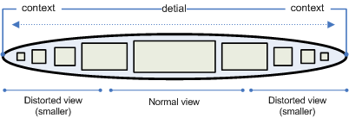
Figure 19: an example of showing detail and context in one view (fisheye view)

Visualizing conceptual structures: concept graph
A way to visualize conceptual structures can be realized by a concept graph. A concept graph can be defined as:

“a visual language that represents information into concepts and its relations to enhance understanding and reduce cognitive load”

Research indicates that certain visual languages like concept graphs act as a working memory extension and enhance direct interpretation of information through pattern detection [Scaife M. and Rogers Y, 1996]. Therefore, the application of concept graphs in education to enhance understanding can be considered effective [Novak J. and Gowin D. B, 1984] and even important. For instance, higher education promotes the use of concept graphs as a way to visualize knowledge [the digital university, http://www.du.nl]
The concept graph as information visualizer is used in applications such as a thesaurus, see figure 20 below.

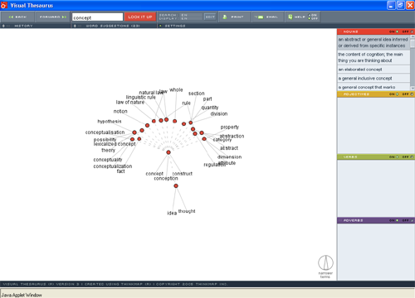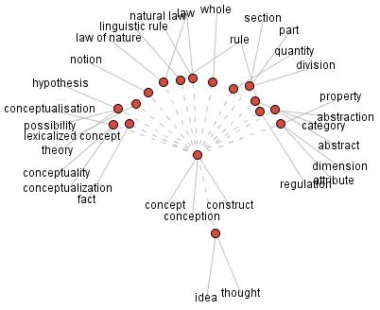
Figure 20: screenshot of the online commercial program visual thesaurus
(http://www.visualthesaurus.com)

By this user-orientated and intuitive form of presentation and navigation, the visual thesaurus visualizes nouns, adjectives, verbs and relations between them, related to a keyword search by the user. The relations between the words can be various like ‘is type of’ and ‘antonym’. An interesting factor of this application is that presentation can be customized by the user to control how information is visually presented by for instance, the customization of display settings (2D or 3D), relationship line colors, overall scale, contrast, font sizes, filtering content, etcetera. Besides visualizing context, details are given by a mouse rollover on presented words.
Also in the field of Artificial Intelligence, concept graphs are used to describe the semantic relationships in complex domains. For example in the domain of semantic web applications where concept graph are used to visualize information i.e. its concepts and their relationships, based on an explicit and formal specification of a conceptualization (ontology). Fluit C. et al (2003) presents a concept graph like visualization technique called the cluster map visualization which is developed by Aduna [Dutch software vendor, http://aduna.biz]. This visualization presents semantic data to user in a simple and instant way without having to deal with often complex structure of the ontology. Figure 21 illustrates this and, as shown, consist of instances (yellow dots representing individual job offers), clusters (grouped instances represented by colored spheres) and classes (rounded rectangles representing categories). As shown, there are two clusters that are connected to more then one class.
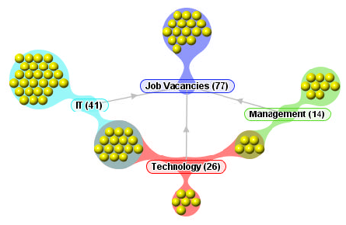
Figure 21: a cluster map visualization of semantic data
(Obtained from: Fluit C. et al, 2003)

In short, I can conclude that the concept has the following advantages:

- Intuitive information visualization for presentation and navigation to represent conceptual information structures.
- Enhances direct interpretation, and therefore understanding of information through pattern detection.

Visualizing linear structures: perspective wall
A way to visualize linear structures can be realized by the perspective wall. The perspective wall has a fisheye view element to present context. Basically, this visualization consist of 2D layout placed on a 3D wall. In the middle of the wall the 2D layout provides normal sized detailed view of data. On the sides, left and right, the presentation is somewhat distorted in such a way it shows context without detail. See figure 22 below for an example.

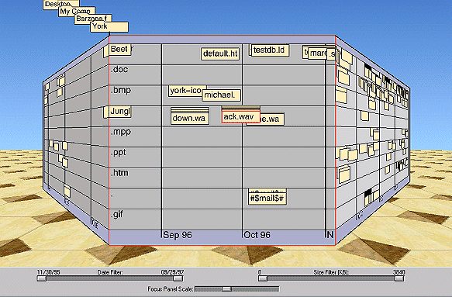
Figure 22: perspective wall representing linear information structures
(obtained from: http://www.fask.uni-mainz.de/user/warth/hypertext/diplom/images/wall2sm.gif)

This visualization provides the following advantages:

- Appropriate use of screen space - by 3D presentation more information can be displayed.
- Showing context and detailed content – fisheye view, distortion of left and right sides while middle is in normal dimensions.
- The 3D metaphor allows for natural transition – by context and detail on linear information structures changes can be smoothly animated that is easily interpreted.

Visualizing hierarchical structures: cone tree
A way to visualize hierarchical structures can be realized by a cone tree. A cone tree visualizes data into a uniformly hierarchy in three dimensions [Robertson G.C. et al, 1991] and be horizontally or vertically displayed. As illustrated in figure 23, the cone tree, developed by Xerox Parc in 1997, consists of 3D transparent cones representing the hierarchical structure of information presented. As shown, the three hierarchical layers are of the same height and each layer contains information related it's upper layer. The highest level of hierarchical information is at the top of the tree. Figure 24 illustrates this in more detail.
This hierarchical visualization of information has got the following advantages:

- Larger screen space - due to the use of three dimensions more information can be placed on the screen.
- Showing context - the transparency of the cones avoids complete obscurity of information. Other and related information is shown in every angle.
- Controlling presentation – the user can rotate the tree by using the mouse to click on an information item. The item clicked will be placed (with its path) in front of the user.
- Fish eye view effect – a selected element appears bigger, brighter, closer to the user then the rest.
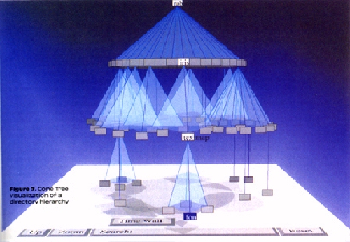
Figure 23: 3D cone tree visualizing hierarchy
(obtained from: http://www.limsi.fr/Individu/jacquemi/IRI-TR/visu-inter2.jpg)

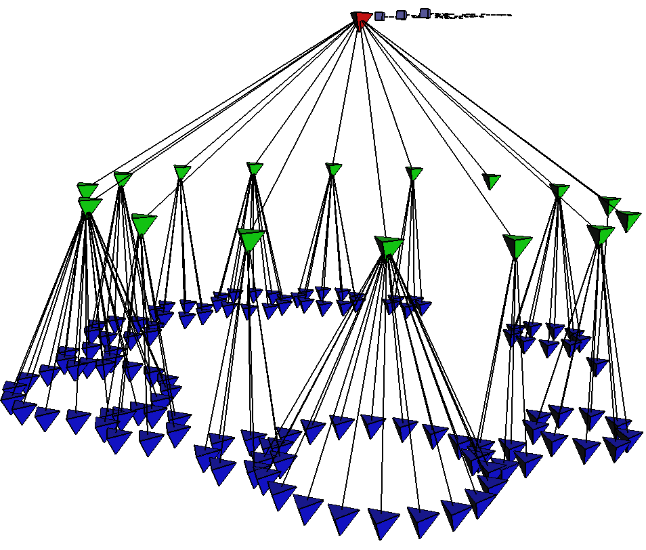
Figure 24: detailed view structure cone tree
(obtained from: http://graphics.stanford.edu/papers/webviz/figs/euc.gif)

4.5 Interactive information visualizations: metaphors
Since information visualization represents information in a certain structure or representing information objects or concepts, the choice of metaphors to convey such information can be considered important. A metaphor can be defined as:

“essential similarity conveyed visually through words and images, or through acoustic or tactile means” ~ [Marcus A., 1998]

Metaphors are used to describe what the user can do with the system by representing the information provided and is an aspect of semiotics – the science of signs. In general, metaphors can assist the user as follows:

- Representation – denote of objects, processes, structures etc.
- Description – define a structure or process, like indicating by presentational properties if the structure is hierarchical or linear.
- Explanation – relate cause and effect, loading bar indicating the effect of loading information.
- Expression - imply concepts or values, the use of known symbols to be applied to indicate suggest action/meaning. Could be in a way that knowledge of a domain can be transferred to another [Marcus A., 1998].

Now we identified the use of metaphors we can take look at the type of metaphors. Hutchins (1989), as cited in Marcus A. (1998) identifies the following types:

- Activity metaphors – are related to the users highest goal i.e. what does the user wants to do? Like learning, communicating, playing games, etc.
- Task metaphors – are related to the users tasks i.e. how to accomplish the goals? Like making use of a spreadsheets, text processing tools, internet browser, etc.
- Mode of interaction metaphors – are related to the user's mental model i.e. how does the user thinks the system works? Like navigational aids or presentation of results.

Marcus A. describes the different types of metaphors based on level:

- Systemic metaphors – indicating general meaning about the overall interface, like the desktop metaphor.
- Individual metaphors – indicating specific meaning for an interface object, like the mouse pointer metaphor.

In addition and in some consistent to this with regards to the creation of metaphors, I believe that metaphors (or any kind or visual presentation) have to be:

- Similarity
  - Using the same aesthetic style and method of indicating meaning (on a contextual level).
- Recognizably
  - Simply, not too many details with respect to information density and the risk of an overload
  - Familiar, known symbols/signs/events/situations to convey meaning to related known knowledge to new situations.
- Regularity
  - Using consistent colors schemes.
  - Using overall consistent dimensions like size and brightness.
  - Re-using existing visuals to indicate relations with visuals belonging to the same group to indicate meaning.

- Distinguishability
  - Using different dimensions in particular situations or information states to indicate context.

5 Looking at digital dossiers in Cultural Heritage

5.1 Outline chapter
Purpose
This chapter discusses several cultural heritage information systems, defined as digital dossiers which focuses on a particular artist and its artworks, with regard to the following aspects: 1) purpose, expectations and influences on presentation, 2) human capabilities and limitations and 3) information visualization. These aspects are translated into an evaluative framework that is used as reference for further discussion. After (and based) on this evaluation, in chapter 6, I will elaborate on the creation of a possible future digital dossier in 2006. Figure 25, depicted below, illustrates this.
Figure 25: evaluation of digital dossiers and speculation on future digital dossier in Cultural Heritage

Goal
This chapter attempts to:

"get insight into how a future digital dossier with a particular information visualization should be created given a qualitive evaluation on pervious digital dossiers on predefined aspects"

Focus
The issues that are discussed are:
- Digital dossiers and evaluation framework – section 5.2
- Evaluation Boezem atelier– section 5.3.1
- Evaluation Marina Abramovic dossier– section 5.3.2
- Evaluation Jeffery Shaw dossier – section 5.3.3

5.2 Digital dossier: background, requirements and applications
Before I proceed to evaluate the digital dossiers, we take a look at what a digital dossier is, what its implications are for Cultural Heritage and identify the different applications.

Background
The introduction of digital dossiers started as a master students project, based on the course Multimedia Casus lectured at the Vrije Universiteit, Amsterdam. In close collaboration with the Netherlands Institute for Cultural Heritage (ICN) - a leading, independent knowledge institute for the preservation and management of so-called moveable cultural heritage -, digital dossiers where created to facilitate the need for accessing 2D and 3D information related to artists, artworks and installations on contemporary art.

Digital dossier can be interpreted generally as:

"a digital archive which presents particular information about a specific topic in a specific way"

As comparison, the digital dossier can be seen as a medical dossier which contains medical related information, presented in different ways, about a patient readily at hand.

User requirements
As for the client of the digital dossier, ICN, a digital archive is needed to combine several sources of information, of different dimension and type, about artists and their artworks in order to preserve and conserve art, and, as a consequence culture. Given this, the following main user requirements where imposed. The digital dossier should:

- Serve as an information source for domain experts,
- Represent highly inter-related information structures,
- Support the possibility to explore inter-related concepts,
- Present rich media recordings, and,
- Provide background information for the interested general public.

Digital dossier applications
Based on these user requirements, students of the annually master course Multimedia Casus developed over a period of three years, three online accessible digital dossiers focussing on a particular artist:

- Boezem atelier (2003) - this digital dossier uses a museum metaphor as visual interface to represent information in 2D and 3D about the expressive artist Marinus Boezem, and navigate in 3D (http://www.cs.vu.nl/~eliens/dossiers/boezem/application/)
- Marina Abramovic dossier (2004) – this digital dossier uses a concept graph as visual interface to represent inter-related information structures related to the contemporary artist Marina Abramovic, her artworks and art-related information, and a 3D visualization gadget to present content (http://www.few.vu.nl/~dossier05)
- Jeffery Shaw dossier (2005) - this digital dossier uses also a concept graph as visual interface to represent inter-related information structures and uses several guided tours (i.e. tool environment) that provide an 3D representation of an artwork ranging from automatic till manual interactive presentations of functional and technical aspects of the artwork (http://www.few.vu.nl/~casus05/)

These three digital dossier applications are created with VRML (Virtual Reality Modelling Language), which allows for creating virtual worlds and present them on the web. The web publication makes it possible for the interested general public to access the digital dossiers worldwide and more easily.

Introduction evaluative framework
The evaluative framework contains several points of interest that are related to four main categories. The chosen categories are: (i) context, (ii) navigation, (iii) presentation and (iv) interaction. These categories correspondent with user interface aspects. For each category, points of interest are defined which are based on the theoretical background by determining if theoretical sections match the categories. For each point of interest, measurements (non experimental) are defined to concretize how to deal with the points of interests.
In short, the evaluative framework looks at digital dossiers by qualitative arguments that are based on the theoretical background. This framework can be considered as a specific heuristic evaluation for the digital dossiers developed, where general principles are setup to guide design decisions or critique a decision already made [Dix A. et al, 2003].

Category of interest | Point of interest | Chapter | Description | Measurements of evaluation  (non controlled, qualitative) | Argumentation
Context | Message of communication | 2 | Looking at the intended goal of the designer | - achievement with respect to the realized application | The intended goal of the designer determines how a system functions, looks like and operates.
Context | User needs, expectations, desires and skills | 2 | Looking at the user requirements | - accomplishment with respect to the realized application | User needs, expectations, desires and skills determine how the application functions, looks like and operates within a defined user domain.
Navigation | Systemic metaphor | 4 | Looking at how information can be retrieved and accessed from a navigational point of view | - efficiency and effectiveness with respect to the context (see above) | Systemic metaphor is used to determine how to work with the system form a general point of view with regard to organization and navigation.
Presentation | Attention | 3 | Looking at how is dealt with human capabilities and limitations with regards to directing, tracking and accommodating attention. | - existence of attentional guidance,  - type of guidance and its effectiveness based on the user task and aspects like information sparsity and clutter, rules for animation, graphical trails, motion cues and sound, and explicitly or implicitly of attention. | Human capabilities and limitations with regard to attention influence how to present information in order to attend to information effectively and efficiently.
Presentation | Perception | 3 | Looking at how is dealt with human capabilities and limitations with regards to visual perception | - use of color and motion,  - limitations of sensory memory and short-term memory,  - accommodation of long term memory(recall and recognition), and,  - first impression (halo effect) | Human capabilities and limitations with regard to perception influence how to present information in order to perceive information effectively and efficiently for interpretation.
Presentation | Systemic metaphor | 4 | Looking at how context and content are visualized. | - efficiency and effectiveness of information processing with respect to object relations | Systemic metaphor is used to determine how information is visualized and organized.
Presentation | Dimension | 4 | Looking at which dimension(s) are chosen and how they are applied. | - existence of (multiple) dimension(s) – 2D 3D  - efficiency and effectiveness of information processing with respect to its application | Dimensional formation influence how information is visualized with regard to information density and retrieval.
Interaction | Design principles | 3 | Looking at design principles to the design with a focus on feedback. | - assessing use of principles directed to learn ability, flexibility and robustness. | Design principles are abstract proven design aspects that can be used for interaction design solutions
Interaction | Affordances and conventions | 3 | Looking at use of affordances and convention in design | - effectiveness of affordances and conventions in a way that clicking on that object is a meaningful, useful action, with a known outcome. | Affordances and conventions can be applied to identify user interaction actions to be meaningful, useful with a known outcome.
Interaction | Individual metaphors | 4 | Looking at individual metaphors based on design rules. | - effectiveness based on aspects: similarity, recognizability, regularity, distinguishability | Individual metaphors can be applied to indicate meaning of interaction actions on objects.
Interaction | Type of interaction | 2 | Looking at the balance and type of interaction between the user and the system. | - existence of the degree of interaction types ranging from manual till automatic. | Type of interaction influence how user and computer interact and communicate.
Evaluative framework

5.3 Dossier Boezem: evaluation

General description
The dossier Boezem provides an interactive virtual museum (i.e. atelier) environment to represent two artworks of Marinus Boezem in 3D and to present related media. It also offers a spatial guided tour by a virtual agent functioning as a museum guide. This digital dossier is not intended to be a finished information system but rather experimental, considered as a proof of concept.
Context
Message of communication | Conclusion
The intended goal of the designer is to provide a demonstrational interactive presentation of media-rich information, that exploits the intrinsic properties of 3D, with the aim to provide added value for the purpose of conservation, preservation and re-installation of contemporary art for a general interested public. When looking at the communication effect model developed by Ladvidge and Steiner (1961) discussed in chapter 2 (page 7), the intended goal can be identified as:  - Cognitive – the realms of knowledge: The digital dossier must provide facts, insights and knowledge in Cultural Heritage.  - Conative – the realms of motives:  - 3D as richer information source: The digital dossier, presented as a 3D interactive multimedia presentation, adds (based on the believes of the designer) value by implying a richer source of information that is more effective and efficient then in 2D in the context of information retrieval. | First, lets look at the cognative part of the intended goal. The Boezem Atelier provides textual and audiovisual information, and 3D representation of two artworks. As stated above, this information is aimed for general interested public and in this perspective cognative part is realized.  The conative part of the intended goal is hard to determine without any quantative data. However, I believe that the integration of presentation and navigation in one environment adds (in this particular case) no extra value to efficient information retrieval to knowledge and insights (like controlling environmental parameters for exhibition purposes), other then amusement. But it does support effective information retrieval, when considering the use of 3D representations to explore objects of interest.
User needs, expectations, desires and skills | Conclusion
Because the Boezem Atelier is considered as a 'proof of concept' the user requirements (as stated in the pervious section) cannot be applied as reference. | However, we can conclude that these two requirements are realized:  - present rich media recordings, and,  - provide background information for the interested general public.
Navigation
Systemic metaphor | Conclusion
The overall interface metaphor used is a virtual atelier. See figure below:  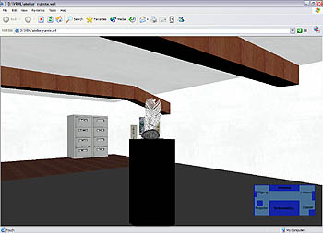  Figure 26: virtual atelier as systemic metaphor | The use of a natural real-life contextual setting (e.g. atelier related to view art, a desk related to view documents) appears familiar to a user by relating real-live phenomena’s or objects to computer functionality. Although it requires, just like in the real-world, for spatial movement to retrieve information. The user can manually move by mouse and keyboard (could lead to disorientation and possible motion sickness), or instantly jump to a location clicking on points in a plain map. In this perspective, this type of navigational paradigm doesn’t support the context of the application (see above), other then amusement, like said before.  When looking at its natural setting, the familiarity can assist the user in knowing where and how to find information. This, I believe, holds true for novice users.
Presentation
Attention | Conclusion
The dossier deals with the following attentional problems:  Focused attentional problems:  - accommodating user attention by (1) a white framework appears when text is shown (2) Zooming in on an artwork resulting in an exploration mode with a plain white background.  Divided attentional problems:  - directing user attention by a spatial guided tour. | - The appearance of the textual information frame leads to high contrast resulting in better readability.  - The white plain background exploration mode avoids any distraction.  - The spatial guided tour guides the user through the available content. Unfortunately, you can not interact with it nor can you pause it or skip a part of the tour.  Given the little amount of content present, that is some text, a video and two artworks, and relatively empty environment - resulting in less distractions and information access, attentional problems are not directly a concern.
Perception | Conclusion
The dossier uses deals with perception by incorporating:  - Colors  - Motions  - Recognition of interaction | - Colors - there is no much abstract information to categorize by visual cues (e.g. applying context). Colors are applied as illustrative expressing a certain mood/experience. (e.g. walls, floor and objects).  - Motions - motions are used to enhance understanding (e.g. a ventilator used in an artwork is animated to simulate blowing wind to indicate its use) and to direct attention (e.g. virtual agent as guided tour).  - Memory - because the digital dossier isn't intended to be a large information archive, the amount of content or operations present doesn't have to be remembered. Also because of the natural familiar metaphors used to convey interaction and content (e.g. file cabinet, video projector) user actions are stimulated, the setting stimulates natural behavior.  - Halo effect (first impression determines acceptance): depends on VRML world speed, not the most advanced visualizations but it (to my opinion) is sufficient enough.
Systemic metaphor | Conclusion
The overall interface metaphor used is a virtual atelier. | The overall interface metaphor, the atelier, is main context within the information is available. The relation between content and context is not explicitly visualized, but implicitly. In other words, no visible relationships between information. There is no need to, due to the little amount of content present, the focus is on the atelier itself and its 3D representations of two artworks.
Dimesions | Conclusion
The navigation through the environment as presentation of content occurs in a 3D environment. | Because of the incorporation of 3D representations and the chosen systemic metaphor of a virtual museum, the need for a 3D environment comes naturally. 3D navigational issues (e.g. disorientation, and possible motion sickness) are not a problem, due to the lack of abstract information, the little amount of information present and relative small environment.
Interaction
Desing principles | Conclusion
Despite the fact that the digital dossier is not intended to be a finished information system, but rather more experimental, some issues of design principles (e.g. Learnabilit, flexitbility, and robustness) can be identified. | Learnability: (i) natural interaction by familiar metaphors of real-life objects supports new users to begin effectively interaction. (ii) cues of change by motion (e.g. opening file cabinet, walking virtual agent)  Flexibility: The interface cannot be changed (no personalization). This could be of interest to exhibitors to experiment with environmental parameters.  Robustness: No operations or calculations are available that dynamically generate user driven results i.e. information is static and cannot be changed or customized. Therefore, the level of support to determine successful achievement and assessment of goals is not of importance.
Affordances and conventions | Conclusion
The dossier contains no perceived affordances, only conventions. These are: different mouse pointers, zooming/in out icons, exit icon, play and stop buttons. | Some objects present in the atelier, that a new user never encountered before like the 3D artworks, don't indicate any affordance i.e. that it would be interactable. Instead, computer based conventions are present, like change of mouse point indicating interaction.  This could be a problem if a user isn't aware of the interaction possibilities of the virtual atelier. Moreover, in this particular case, when a user is aware that object can be clicked on, there is no indication or predication about its meaning, use and outcome.
Individual metaphors | Conclusion
The individual metaphors present in the dossier are: (i) video projector, (ii) file cabinet, (iii) artworks, (iv) agent, and (v) a plain map, as shown in figures below:  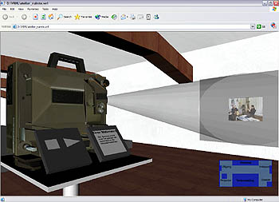  Figure 27: video projector metaphor  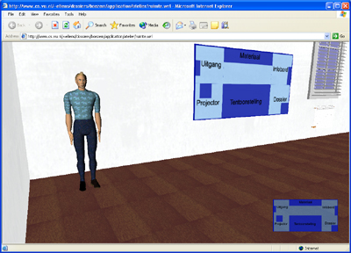  Figure 28: virtual museum guided (agent)  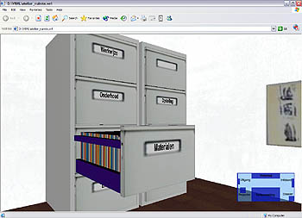  Figure 29: file cabinet metaphor  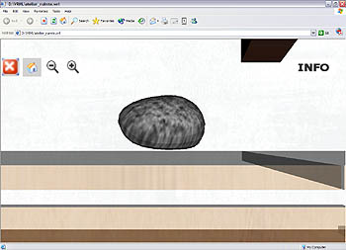  Figure 30: artwork representation: stone | The use of the individual metaphors are familiar in western and computer culture and therefore support natural interaction.  The agent metaphor, as shown in figure 28, which is not a commonly familiar as the others, as for the use as a guided tour, could lead to confusion (prediction of use) or overlooking its function (awareness of existence). This problem could be solved by labeling interaction possibilities (explicitly) or visual cues towards affordance (implicitly).
Type of interaction | Conclusion
The dossier offers automatic guided exploration and manual exploration. In case of automatic guided exploration, a virtual agent functioning as a museum guide can be used to guide the user through the available content. This agent becomes active when clicked on. As alternative, the user can manually navigate by mouse and keyboard or instantly jump to a location clicking on points in a plain map. | The virtual agent present as a guided tour, has suffers from several limitations:  - You can't interact with it by pausing, skipping parts of the tour or define a where the user needs guidance (context driven assistance).

5.3.1 Dossier Boezem: overall conclusion
The digital dossier Boezem has been evaluated according to an evaluative framework based on theoretical research and personal experiences. The dossier offers a 3D virtual atelier where navigation and presentation of information is integrated in the same 3D environment.

In short, the evaluation indicates the following issues for improvement:

- Reconsidering message of communication - given the conative aim of the designer (a 3D dossier would be a richer information source then a 2D counterpart) the integration of navigation and presentation (overlapping) provides no extra value other then entertainment.
- Supporting interaction learnability - There is no indication or predication about the meaning, use and outcome of interactable objects that are not familiar (i.e. affordances) such as the representations of two artworks.
- Allowing for user driven guided exploration - The spatial guided tour doesn’t allow for user interaction or customization.

To close this evaluation, I would like to elaborate on the agent functioning as a museum guide. In developing such spatial guided tours, we should take into account that:

- Agents must avoid distracting the user's attention from information processing tasks, because this will result in irritation and negative emotions [Catrambone R., 2002 and Schaumburg H, 2000].
- Agents should be supporting the user task in a effective way (i.e. relevant) (be it information or entertainment, communication, or composition) and should support rather than obstruct (intelligence) the work process [N. H. Frijda, 1986. p. 494, p.463, p. 455, read it from Hoorn J. et al, 2004].
- Guided tours should support for user interaction and allow for customization to accommodate the flexibility of the interface [see appendix paper 2 for more detail].

5.4 Abramovic dossier: evaluation

General description
The Abramovic dossier serves as a 3D digital archive of the artist Marina Abramovic. The dossier uses a concept graph as navigational mechanism, a 3D content gadget to present related media information and represents an artwork in 3D. Like the dossier Boezem, as discussed above, this digital dossier is not intended to be a finished information system but rather experimental, considered as a proof of concept.
Context
Message of communication | Conclusion
The intended goal of the designer is to provide an interactive presentation of media-rich information, that exploits the intrinsic properties of 3D, with the aim to provide added value for the purpose of conservation, preservation and re-installation of contemporary art for (i) conservators and curators of contemporary art and, secondly (ii) for a general interested public. When looking at the communication effect model developed by Ladvidge and Steiner (1961) discussed in chapter 2 (page 7), the intended goal can be identified as:  - Cognitive – the realms of knowledge: The digital dossier must provide facts, insights and knowledge in Cultural Heritage.  - Conative – the realms of motives:  - 3D as richer information source: The digital dossier, presented as a 3D interactive media-rich presentation, adds value by implying a richer source of information that is more effective then in 2D in the context of exhibition, installation and conservation of art.  - Separate navigation from presentation: Separation of navigation and presentation supports efficiency in greater extent then integration. | The message of communication is somewhat similar to the dossier Boezem, but focuses primarily on providing exhibitors, conservators and curators of contemporary art a source of information. While the dossier Boezem is more general and purely intended for the public. This results in:  - 3D representations of an artwork intended for exploration with regard to exhibition,  - Detailed and inter-related information for domain experts,  - Conceptual information structures, putting content into context.  Future more, the Abramovic dossier takes a different approach to efficiency of information retrieval by a separating of navigation and presentation.  The cognitive part of the intended goal is accommodated by providing access to a inter-related information structure, containing 2D and 3D media.  Once again, the conative part of the intended goal is hard to determine without any quantative data. However, initial user evaluation indicates that:  - The concept graph as navigational mechanism is intuitive to use,  - The concept graph is sometimes confusion and disorientates,  - The 3D content gadget supports effective by showing content simultaneously,  - The 3D representation of artworks is interesting to further work out with regard to manipulation of environmental parameters.  Given these initial results, I can conclude that, in principle, the separation of navigation and presentation when confronted with complex inter-related information supports efficiency of information retrieval.
User needs, expectations, desires and skills | Conclusion
The Netherlands Institute for Cultural Heritage (ICN) imposed the following main user requirements (as mentioned in section 5.2):  The digital dossier should:  - Serve as an information source for domain experts,  - Represent highly inter-related information structures,  - Support the possibility to explore inter-related concepts,  - Present rich media recordings, and,  - Provide background information for the interested general public. | The Abramovic dossier supports the user requirements of by:  - Simultaneous presentation of (multi)media recordings in a 3D content gadget,  - Presentation of inter-related information structures by a concept graph,  - Navigation through conceptual structures by concept graph,  - Presentation of 3D representation of an artwork,  - Allowing for internal linking of concepts (i.e. hypertext),  - Providing specific information for domain experts, and,  - Providing background information for the interested general public.
Navigation
Systemic metaphor | Conclusion
The overall and most important interface metaphor used is a concept graph. See figure below:  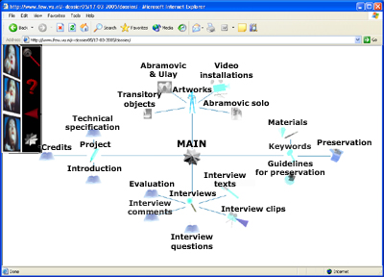  Figure 31: concept graph as systemic metaphor | The concept graph as systemic metaphor visualizes concepts and relations in a star structure to enhance understanding.  As mentioned in part 4.4, research indicate that visual languages like concept graphs act as a working memory extension and enhances direct interpretation of information through pattern detection.  From this point of view, this knowledge representation accommodates the visualization of the complexity of the inter-related information present, and even enhances the information retrieval process, like for navigational tasks.  The concept graph, used as navigational mechanism, allows for browsing the conceptual nodes which causes the concept graph to change accordingly by a smooth transition.
Presentation
Attention | Conclusion
The dossier deals with the following attentional problems:  - The concept graph (navigation environment) deals with:  Focused attentional problems:  - accommodating user attention by showing a three level deep structure.  Selective attentional problems:  - directing user attention by animations of transitions to indicate conceptual changes in the concept graph.  - tracking user attention by content preview when mouse rollover.  - The 3D content gadget (presentation environment) deals with:  Divided attentional problems:  - accommodating user attention by three content windows to display media simultaneously without much visual distortion.  Focused attentional problems:  - accommodating user attention by zoom in/out functionality on content.  - accommodating user attention by placing 3D content gadget on front, while making the concept graph in the background invisible. | - The three level deep conceptual structure, reduces the amount of information presented at once. This could avoid information overload, due that only a subset of information is show.  - The animated transitions of nodes reduce some of the cognitive load associated with deciphering the interface status.  - By explicitly tracking user interaction, that is by mouse, initial information about a certain node can assist the user in information retrieval.  - Displaying media content simultaneously allow the user to divided attention to multiple information sources.  - Showing three content panes at once can lead to an information overflow. To deal with this, the user can focus on a particular content with a zoom option. This functionality avoids distraction from the other content.  - The separation of navigation and presentation accommodates user attention by supporting information retrieval tasks with regard to viewing content and context. In more detail, presenting content or context and as a result, avoiding distraction of one of the two. By still keeping a strong connection between navigation and presentation, despite their separation, the user can focus an actual content while keeping it in context.
Perception | Conclusion
The dossier uses deals with perception by incorporating:  - Colors  - Motions  - Supporting working memory | - Colors - Colored lines in the concept graph are used to indicted properties of concepts.  - Motions - motions are used to enhance understanding (e.g. animation transitions) and accommodates the need to determine what has changed.  - Memory – The concept graph visualizes the complex conceptual structure, representing categories and information objects, and as such acts as a working memory extension (see section 4.4). However, I believe the complexity of the conceptual structure could lead to confusion and disorientation. A possible solution is to support information retrieval by a guided tour.  - Halo effect (first impression determines acceptance): This is difficult to determine and needs some quantative results. However, like the dossier Boezem, I believe initial acceptance depends on VRML world speed. Besides this, I like to navigate with the concept graph myself, seeing the (usually) smooth animations of transition is entertaining and the black background gives it a futuristic and mysterious appearance. My personal experience is that is also attracts the public i.e. the visuals and animations raises immediate curiosity.
Systemic metaphor | Conclusion
The overall interface metaphor used is a concept graph. | Instead of presenting the whole structure, the concept graph shows only a three level deep subset. By lines the user is able to detect relations between nodes, properties and related media content.  When media content is selected for view, a 3D content gadget appears by which the user can select, view and focus on media. As for 3D representations of artworks, they can also be accessed by the conceptual space and are viewed in a plain 3D environment.  Like said before, by still keeping a strong connection between navigation and presentation (i.e. presents of immersion), despite their separation, the user can focus an actual content and keeping it in context.
Dimensions | Conclusion
Due to the use of VRML, the dossier is build in a 3D environment. However, the navigation itself occurs in 2D (only in x and y direction) while presentation of content exploits the properties of 3D. | Users navigate in 2D by a concept graph. By this, less information can be presented at once (missing depth). This could be realized by allowing for 3D visualization and navigation. On the other hand, a possible 3D navigation with the concept graph currently, could lead to confusing the user because of remembering what is ‘behind’ you, missing an overview (see section 4.3 for more details). A in-place 3D navigation where information is not disappearing form the screen, like the 3D cone tree could be a solution.  The 3D content gadget uses the third dimension to present multiple media simultaneously, accommodating user's possible need for divided attentional tasks.
Interaction
Design principles | Conclusion
Despite the fact that the digital dossier is not intended to be a finished information system, but rather more experimental, some issues of design principles (e.g. Learnabilit, flexibility, and robustness) can be identified. | Learnability: By the use of icons in the concept graph, representing concepts and categories, might stimulate recognition of information and support navigation.  Flexibility: The presentation of media in the 3D content gadget can be customized by drag-and-drop functionality. Content can be presented in three windows, located in the 3D content gadget. The user can (i) select which content is shown and (ii) where (in which window) content is shown.  Also, users have some control over how information is presented in the concept graph. The user can determine, by clicking on a concept, if a concept is placed in the center of the screen or positioned as surrounding node of a center node.  Future more, the user can choose between navigating with the concept graph (browsing) or navigation directly based on keyword input (searching).  Besides this, a history trace functionality allows user the return to previous navigational steps.  Robustness: No operations or calculations are available that dynamically generate user driven results i.e. information is static and cannot be changed or customized. However, animations indicate progress of actions. In this perspective, the user can asses the progress of his/her command and detect actual change, like animations of transition of nodes presented by the concept graph.  There could be improvement towards how and which information is presented. We can think of customizing the overall appearance of dossier, personalization of icons, and controlling what information is presented (i.e. selection and filtering of information).
Affordances and conventions | Conclusion
The dossier contains no perceived affordances, only conventions. These are: different mouse pointers, zooming/in out icons, exit icon, play, pause and stop buttons. | Computer based conventions are present, like change of mouse point indicating interaction.  Also explicit telling how to interact with a 3D representations of an artwork is provided.  Moreover, when a user is aware that object can be clicked on, there is some textual indication about its meaning, use and outcome.
Individual metaphors | Conclusion
The individual metaphors present in the dossier are icons used for nodes in the concept graph (see figure 32) and interface icons in the content gadget (see figure 33) and menu (see figure 34).  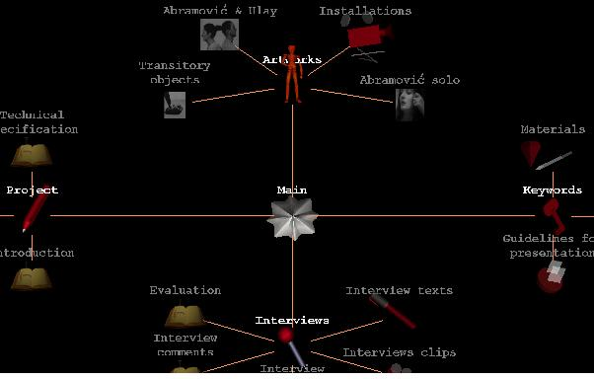  Figure 32: icons for nodes in concept graph  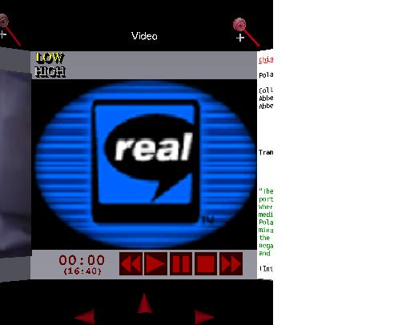  Figure 34: interface icons content gadget  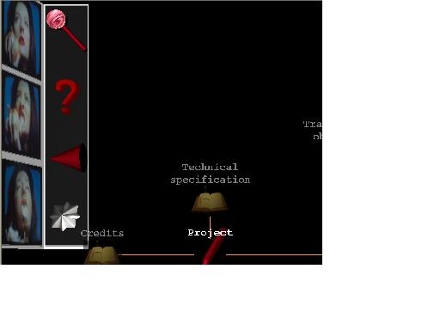  Figure 33: interface icons menu | The icons used in the concept graph and icons used in the menu support regularity (see section 4.5) by:  - Consistent colors schemes.  - Consistent dimensions like size and brightness.  And recognizably (see section 4.5) by:  - Familiar, known symbols/signs/events/situations to convey meaning to related known knowledge to new situations  Also, the icons all have textual information (i.e. labels) supporting understanding.  However, the icons could be enhance by:  - Re-using existing visuals to indicate relations with visuals belonging to the same group to indicate meaning.  The interface icons used in the content gadget miss textual labels to indicate meaning and enhance understanding.
Type of interaction | Conclusion
The dossier offers manual exploration. | Due to the complexity of the conceptual structure and amount of information present, guided tours can be used to assist the user in exploration. Currently, user can find their way by navigation or search. However, especially navigating through the data can disorientate the user or even influence information retrieval negatively (overlook important information). I believe, the use of a conceptual guided tour can prevent these problems and enhance information retrieval efficiently (e.g. reducing exploration time finding information of interest) and effectively (e.g. presenting all relevant information).  Future more, the dossier offers some interaction with 3D representations of artworks. Unfortunately, the interaction possibilities only allow for rotation and zooming in. Given the intended users (exhibitors and conservators), this type of interaction doesn’t support their specific tasks enough like (re)installation and conservation and preservation of art.

5.4.1 Abramovic dossier: overall conclusion
The Abramovic digital dossier has been evaluated according to an evaluative framework based on theoretical research and personal experiences. The dossier offers an archive in 3D space where navigation is separated from presentation. In more detail, for navigation a concept graph is used to represent conceptual knowledge in a three level deep view. By browsing the conceptual nodes, which causes the concept graph to change accordingly by a smooth transition, the user is able to detect relations between nodes an their related media content. When media content is selected for view, a 3D content gadget appears by which the user can select, view and focus on media. As for 3D representations of artworks, can also be accessed by the conceptual space and are viewed in a plain 3D environment.

In short, the evaluation indicates the following issues for improvement:

- Controlling how information is presented - Supporting flexibility by allowing for customization of the overall appearance, allowing for personalization of icons and re-using existing visuals to indicate relations with visuals belonging to the same group to indicate meaning and context.
- Controlling which information is presented - Supporting flexibility by allowing for user driven presentations based on selection and/or filtering of information.
- Expanding interaction possibilities on 3D representations – Supporting domain experts in installation and conservation of artworks by manipulating environmental parameters (e.g. light and texture)
- Guiding the user exploration tasks – by a conceptual guided tour, the dossier can be automatically explored using the concept graph as navigation mechanism to access content. It could enhance information retrieval efficiently (e.g. reducing exploration time finding information of interest) and effectively (e.g. presenting all relevant information).

5.5 Dossier Shaw: evaluation
General description
The dossier Shaw serves as a 3D digital archive of the artist Jeffrey Shaw. The dossier is a follow-up of the Abramovic dossier by which it incorporates the same navigation technique by concept graph to visualize conceptual structures and access content.
As for displaying actual media content, this dossier differs from the Abramovic dossier by using a 2D content viewer instead of a 3D content gadget.
A new feature of this dossier is a tool environment. This tool environment contains a 3D representation of the artwork Revolution that can be explored by several guided tours related to (i) it's re-installation, (ii) manipulating environmental parameters for exhibition and (iii) users can perform a test to install the artwork themselves.
Like the dossier Boezem and Abramovic dossier, as discussed above, this digital dossier is not intended to be a finished information system but rather experimental and in this case evolving based on developed previous dossiers.
Context
Message of communication | Conclusion
The intended goal of the designer is to provide an interactive presentation of media-rich information, that exploits the intrinsic properties of 3D, with the aim to provide added value for the purpose of re-installation of contemporary art for (i) conservators and curators of contemporary art and, secondly (ii) for a general interested public. When looking at the communication effect model developed by Ladvidge and Steiner (1961) discussed in chapter 2 (page 7), the intended goal can be identified as:  - Cognitive – the realms of knowledge: The digital dossier must provide facts, insights and knowledge in Cultural Heritage.  - Conative – the realms of motives:  - 3D guided exploration as richer information source: 3D representations accommodated by guided tours in the context of re-installation, adds value by implying media-rich guided exploration that is more effective then a 2D counterpart.  - Manipulating environmental parameters for efficient and effective insights: A virtual environment extends the possibilities to experiment with the artwork's environment given the artists intentions, exhibition properties and possible constraints, in save environment realized in a relative fast and costless way. | The message of communication is somewhat similar to the Abramovic dossier, but focuses in more detail on exploiting 3D virtual representations to assist Cultural heritage experts with knowledge and insights on re-installation and exhibition. This results in:  - A 3D representation of an artwork intended for re-installation and exhibition.  - Conceptual information structures, putting content into context.  The cognitive part of the intended goal is accommodated by providing access to a inter-related information structure, containing 2D media and giving access to 3D media.  Once again, the conative part of the intended goal is hard to determine without any quantative data. However, initial user evaluation indicates that:  - Guided 3D exploration to re-install an artwork is interesting and considered worthwhile to further develop.  - Manipulating environmental parameters for exhibtional purposes are interesting and considered worthwhile to further develop  Given these initial results, I can conclude that, in principle, use of 3D guided exploration towards re-installation and the manipulation of environmental parameters towards exhibition, looks promising for a richer source of information and effective and efficient insights.
User needs, expectations, desires and skills | Conclusion
The Netherlands Institute for Cultural Heritage the following main user requirements where imposed (as mentioned in section 5.2):  The digital dossier should:  - Serve as an information source for domain experts,  - Represent highly inter-related information structures,  - Support the possibility to explore inter-related concepts,  - Present rich media recordings, and,  - Provide background information for the interested general public. | The dossier Shaw supports the user requirements by:  - Presentation of information structures by a concept graph,  - Navigation through conceptual structures by concept graph,  - Presentation of 3D representation of an artwork,  - Presentation of 2D media,  - Providing specific information for domain experts, and,  - Providing background information for the interested general public.  However, the requirement "support the possibility to explore inter-related concepts" is not realized. It is not possible to 'jump' from information to information (i.e. internal linking) based on inter-relations. Instead, the concept graph must be used to access content.
Navigation
Systemic metaphor | Conclusion
The overall interface metaphors used are (i) the concept graph (ii) 3D exhibition room. See figures below:  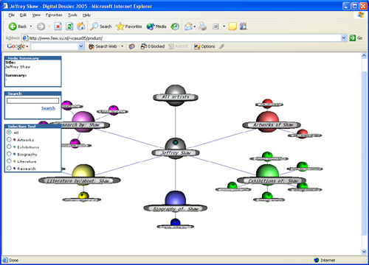  Figure 34: concept graph as systemic metaphor  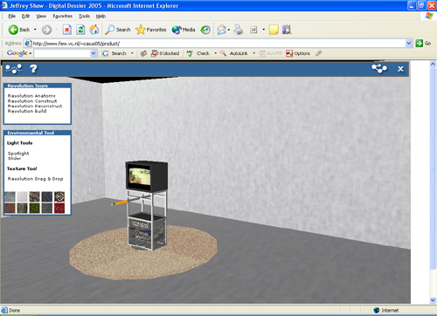  Figure 35: exhibition room as systemic metaphor | Navigation with the concept graph, allows for browsing the conceptual nodes which causes the concept graph to change accordingly by a smooth transition.  When media content is selected for view, a 2D content viewer appears by which the user can select and view media.  The exhibition room metaphor, functions as a tool environment where a 3D representation of the artwork Revolution is used as starting point for several guided tours aiming at re-installation and exhibition.  Although navigation (concept graph) and presentation (exhibition room) are as like in the Abramovic dossier separated, they aren't connected (i.e. mentally immersed) as visually noticeable and functional supported in the Abramovic dossier. Instead, there is a clear ' border' between them concretized by an interaction window where the user can activate the exhibition room. With other words, the user cannot access the exhibition room from the concept graph and visa versa.  This results, to my opinion, in two autonomous environments that are not only functionally unrelated but also mentally. As a consequence, the lack of immersion in navigation and presentation leads to more user effort to put content (presentation of media) into context (concept graph based navigation).
Presentation
Attention | Conclusion
The dossier deals with the following attentional problems:  - The concept graph (navigation environment) deals with:  Focused attentional problems:  - accommodating user attention by showing a three level deep structure.  - accommodating user attention by allowing for filtering of concepts shown.  Selective attentional problems:  - directing user attention by animations of transitions to indicate conceptual changes in the concept graph.  - tracking user attention by textual indication content when mouse rollover.  - The 2D content viewer (presentation media) deals with:  Focused attentional problems:  - accommodating user attention by placing 2D media on front, while making the concept graph in the background invisible.  - The exhibition room (tool environment for presentation 3D media)  Selective attentional problems:  - Directing user attention by a re-installation and a de-installation guided tours. | Functionality inherited from the Abramovic dossier:  - The three level deep conceptual structure, reduces the amount of information presented at once. This could avoid information overload, due that only a subset of information is show.  - By filtering the user can determine what type of information is shown by the concept graph while omitting the rest. This reduces the amount of information presented at once.  - The animated transitions of nodes reduce some of the cognitive load associated with deciphering the interface status.  - By explicitly tracking user interaction, that is by mouse, initial information about a certain node can assist the user in information retrieval.  - The user can focus on a particular content by putting it on the front making the background obscured. This functionality avoids distraction from the other content.  - The exhibition room contains guided tours by which domain experts get insight in how to install and de-install the artwork Revolution in a save environment. These guided tours direct user attention to enhance information retrieval.  Unfortunately, this dossier have omitted accommodating textual information with visual information about nodes when mouse rollover. This feature was present in the Abramovic dossier and provides more richer information what to expect.
Perception | Conclusion
The dossier uses deals with perception by incorporating:  - Colors  - Motions  - Supporting working memory | - Colors - (i) Colored lines in the concept graph are used to indicted properties of concepts. (ii) colored spheres in the concept graph indicated categorized information groups.  - Motions - motions are used to enhance understanding (e.g. animation transitions) and accommodates the need to determine what has changed.  - Memory – The concept graph visualizes the complex conceptual structure, representing categories and information objects, and as such acts as a working memory extension (see section 4.4). However, again, I believe the complexity of the conceptual structure could lead to confusion and disorientation. A possible solution is to support information retrieval by a conceptual guided tour.  - Halo effect (first impression determines acceptance): This is difficult to determine and needs some quantative results. However, like the dossier Boezem and Abramovic dossier, I believe initial acceptance depends on VRML world speed.  From a more personal view, the exhibition room containing the 3D representation looks realistic resulting in to support the functional intention of providing insights in re-installation and exhibition purposes.
Systemic metaphor | Conclusion
The overall interface metaphor used is (i) the concept graph (ii) 3D exhibition room. | As said in the evaluation of the Abramovic dossier, the concept graph as systemic metaphor accommodates the visualization of the complexity of the inter-related information present, and even enhances the information retrieval process.  Instead of presenting the whole structure, only a three level deep subset is shown. The user is able to detect relations between nodes, properties and related media content.  As for 3D representations of the artwork Revolution, it cannot be accessed by the conceptual space, only by activating the 3D exhibition environment.  To avoid the any external influence on context of Revolution other then the intention of the artist, the exhibition room allows for multiple visualizations of the environment. By manipulating environmental parameters like the use of light and textures, one fixed environment is avoided.
Dimensions | Conclusion
Due to the use of VRML, the dossier is build in a 3D environment. However, the navigation itself occurs in 2D (only in x and y direction), and 2D media is also presented in a flat environment. Only the 3D representation of the artwork Revolution in the exhibition room exploits the properties of 3D. | Like said in the Abramovic dossier, users navigate in 2D by a concept graph. By this, less information can be presented at once (missing depth). This could be realized by allowing for 3D visualization and navigation. On the other hand, a possible 3D navigation with the concept graph currently, could lead to confusing the user because of remembering what is ‘behind’ you, missing an overview (see section 4.3 for more details). A in-place 3D navigation where information is not disappearing form the screen, like the 3D cone tree could be a solution.  Unlike the 3D content gadget used in the Abramovic dossier it is not possible to view multiple media simultaneously. This dossier uses a 2D content viewer and could be a problem if an user requires this in need to accomplish his task. However, this is not stated in the user requirements.  The 3D exhibition environment uses the third dimension to represent the artwork Revolution in all its dimensions to provide a rich view about its parts and how they are connected into a construction. This is of use for the understanding how the artwork is installed.
Interaction
Design principles | Conclusion
Despite the fact that the digital dossier is not intended to be a finished information system, but rather more experimental, some issues of design principles (e.g. Learnabilit, flexibility, and robustness) can be identified. | Learnability: By the use of colored spheres in the concept graph, representing concepts and categories, might stimulate recognition of information and support navigation.  Flexibility: The users have some control over how information is presented in the concept graph. The user can determine, by clicking on a concept, if a concept is placed in the center of the screen or positioned as surrounding node of a center node.  Also the total information space can be personalized by filtering options. The user can filter information to be shown based on type.  Future more, the user can choose between navigating with the concept graph (browsing) or navigation directly based on keyword input (searching).  Besides this, a history trace functionality allows user the return to previous navigational steps.  Robustness: No operations or calculations are available that dynamically generate user driven results i.e. information is static and cannot be changed or customized. However, animations indicate progress of actions. In this perspective, the user can asses the progress of his/her command and detect actual change, like animations of transition of nodes presented by the concept graph.
Affordances and conventions | Conclusion
The dossier contains no perceived affordances, only conventions. These are: different mouse pointers, exit icon, play, pause and stop buttons. | Computer based conventions are present, like change of mouse point indicating interaction.  Also explicit telling how to interact with a 3D representations of an artwork is provided.  Moreover, when a user is aware that object can be clicked on, there is some textual indication about its meaning, use and outcome.
Individual metaphors | Conclusion
The individual metaphors present in the dossier are icons used for nodes in the concept graph (see figure 32) and interface icons in the content viewer (see figure 33) and icons used in the upper menu (see figure 34).  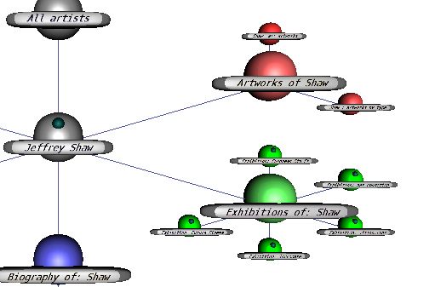  Figure 36: icons for nodes in concept graph  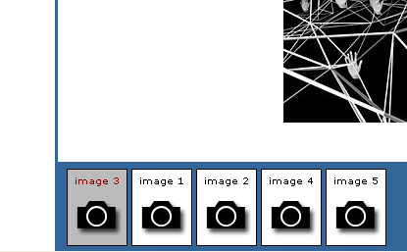  Figure 37: interface icons content viewer  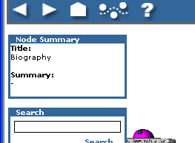  Figure 38: interface icons menu | An interesting issue is the use of only colors and size in the concept graph to indicate meaning of nodes. In the Abramovic dossier, icons of different shape are used to represent known symbols or real-life objects to indicate meaning. This dossier, uses one shape (i.e. sphere shape) and different colors and size to indicate meaning.  The spheres icons support regularity by(see section 4.5):  - Consistent colors schemes.  - Consistent dimensions of shape.  Similarity (see section 4.5) is supported by:  - Using the same aesthetic style (i.e. spheres).  Also, the icons all have textual information (i.e. labels) supporting understanding.  To return the issue of one shaped icons or multiple shaped icons. In my perspective, a downfall of using one shape (sphere shape) for all icons in the concept graph is that the user depends on the textual explanation to identify meaning. There is no identification possible with regard to recognition of a certain shape.  On the other hand, an advantage might be that it supports regularity in shape that results in simplifying the visual appearance of the concept graph i.e. easier for the eye. This could lead to less distraction of different shapes (i.e. chaos) and enhance information retrieval.
Type of interaction | Conclusion
The dossier offers manual and guided exploration. | Manual exploration by concept graph occurs by the following ways:  - Navigation through whole conceptual information structure,  - Keyword search, and,  - Filtering on information types.  By the addition of filtering on information types, the complexity of the conceptual information structure is reduced.  However, especially navigating through the data can disorientate the user or even influence information retrieval negatively (overlook important information). I believe, the use of a conceptual guided tour can prevent these problems and enhance information retrieval efficiently (e.g. reducing exploration time finding information of interest) and effectively (e.g. presenting all relevant information).  Future more, the dossier offers some guided exploration on a 3D representation of the artwork Revolution. These guided tours support specific tasks for domain experts on re-installation and exhibition of art. In more detail, a (i) anatomy, (ii) construction, (iii) deconstruction tours and the (iv) manual construction test are developed aiming to provide interactive or fully automated guidance.

5.5.1 Dossier Shaw: overall conclusion
The digital dossier Shaw has been evaluated according to an evaluative framework based on theoretical research and personal experiences. The dossier is a follow-up project of the Abramovic dossier by which uses the conceptual navigational mechanism by concept graph to locate information of interest and to access media content, and extended it with filtering options for personalization's.
As for displaying actual media content, this dossier differs from the Abramovic dossier by using a 2D content viewer instead of a 3D content gadget.
Besides this, a 3D tool environment is available focusing on the artwork Revolution of the contemporary artist Jeffery Shaw. This tool environment (i.e. 3D exhibition room) contains a 3D representation of the artwork itself and aims to provide exhibitors insight about how to install the artwork and how environmental parameters influences exhibition.

The issues of the Abramovic dossier that have been addressed by the dossier Shaw are:

- Controlling which information is presented - Supporting flexibility by allowing for user driven presentations based on selection and/or filtering of information.
- Expanding interaction possibilities on 3D representations – Supporting domain experts in installation and conservation of artworks by manipulating environmental parameters (e.g. light and texture)

Unfortunately, some issues that the Abramovic dossier addresses are not incorporated by the dossier Shaw. I believe that these (omitted) issues are important to incorporate. In short, the evaluation indicates the following issues for improvement:

- Internal linking – allow the user to explore inter-related information based on hypertext technique to control information retrieval.
- Mental immersion – a close functional and visual connection between navigation by concept graph (showing concepts and context) and presentation of content.

Sherman W.R et al. (2003) says about mental immersion:

“state of being deeply engaged; suspension of disbelief; involvement”

Given this definition, we can argue that the user when immersed isn’t distracted by noticeable non-immersive properties of the interface: resulting in being aware of the mechanics and medium used instead of using that mental activity for the task at hand.

- Proving richer preview information - accommodating textual information with visual information to support efficient information retrieval.

Other issues that still need to be addressed:

- Controlling how information is presented - Supporting flexibility by allowing for customization of the overall appearance, allowing for personalization of icons and re-using existing visuals to indicate relations with visuals belonging to the same group to indicate meaning and context.
- Guiding the user exploration tasks – a conceptual guided tour could enhance information retrieval efficiently (e.g. reducing exploration time finding information of interest) and effectively (e.g. presenting all relevant information).

5.6 Conclusion on analysis

The digital dossiers of 2003, 2004 and 2005 (chronological developed as follow-ups of the previous one) have evolved from a 3D environmental system where navigation and presentation where combined (Boezem dossier, 2003) to a 3D media-rich information space that separates navigation though context and presentation of content (Abramovic dossier, 2004 and dossier Shaw, 2005).
The results of the analysis on the three digital dossiers showed us that the next digital dossiers on Cultural Heritage should inherit or deal with:

- User driven guided exploration – Allowing the user to create, customize and interact with a guided exploration that presents information by automation and guides the user in information retrieval, interaction and communication. Based on the information type and user task a suited form of guided presentation should be applied. For example, abstract information by a conceptual guided tours, 3D representations of real-life objects by a tool environment that supports manipulation of environmental parameters, scrutiny of objects, etcetera.
- Separation or combination of navigation and presentation with regards to information types – e.g. navigation through abstract information by a concept map and separated presentation media content in content gadget, navigation in 3D virtual environment and combined presentation 3D objects in the same environment.
- Mental and functional immersion – the visual connection between context and content, functional environments and inter-related information.
- User controllable presentation – how and which information is presented depending on user selections, filtering, search and/or parameters.
- Rich preview information – providing users textual information with visual information of information objects to support efficient information retrieval.
- Exploitation of 3D representations to accommodate user tasks - to further exploit and use 3D representations of artworks to the benefit of Cultural Heritage purposes, like the conservation and preservation of art, we could think about time based manipulation like simulating and analyzing influences on art decay.

6 Elaborating on next generation digital dossiers in Cultural Heritage

6.1 Outline chapter
Purpose
This chapter starts towards the creation of a next generation digital dossier. The results of the analysis on digital dossiers of 2003, 2004 and 2005, as described in chapter 5, will be used to define general design aspects for future development of digital dossiers.

Goal
The goal of this chapter is to provide a general concept of a next generation digital dossier in Cultural Heritage. The question this chapter tries to answer is:

How can one present and access media-rich highly related information with regard to Cultural Heritage so that the cost of information retrieval and interpretation is minimized?

Focus
The issues that are discussed are:
- Design aspects in the development of the digital dossier – section 6.2
- A concept of the future digital dossier– section 6.3

6.2 Defining the design aspects
Given the analysis of the digital dossier, by which we looked at the evolution of digital dossiers in a period of three years, design aspects for the next generation dossiers are identified. By a selection process of "best of breeds", which the most promising and best received design aspects of the analysis that support Cultural Heritage issues (e.g. conservation, installation, exhibition, etcetera) where selected to accommodate the initial user requirements imposed by Netherlands Institute for Cultural Heritage (ICN). In the table below, the selected design aspects are defined for the future development of the digital dossier.

Related to | Design aspects | Comments
Initial user requirements  (see also section 5.2) | Serve as an information source for domain experts | Dossier must contain user specific information.
Initial user requirements  (see also section 5.2) | Represent highly inter-related information structures | Dossier must represent abstract information.
Initial user requirements  (see also section 5.2) | Support the possibility to explore inter-related concepts | Dossier must allow for hypertextual exploration.
Initial user requirements  (see also section 5.2) | Present rich media recordings. | Dossier must present media content.
Initial user requirements  (see also section 5.2) | Provide background information for the interested general public | Dossier must be accessible and interesting to the public.
Additional points of interest | Aim for immersion | Dossier must ensure the user is immersed in navigation and presentation reducing effort to put content (presentation of media) into context (navigation).
Additional points of interest | Present content in context | Dossier must allow to access the context of content and visa versa.
Additional points of interest | Provide guided exploration of information | Dossier must assist user exploration that suits user needs and interest.
Additional points of interest | Allow for personalization of presentation | Dossier must provide means of controlling how and which information is presented.
Additional points of interest | Allow for manipulation environmental parameters | Dossier must provide means to produce insights in exhibition, conservation and preservation of art.
Additional points of interest | Exploit the intrinsic properties of 3D | Dossier must provide means to produce insights in re-installation conservation and preservation of art.
Additional points of interest | Allow for rich preview information | Dossier must provide rich preview information on abstract data to support efficient information retrieval.

The digital dossiers constructed so-far are not focused on usability primarily but on experimenting with design concepts.
When deployed in the real world, usability aspects are important. Thus, besides these defined design aspects, general human computer interaction issues like design principles, the use of affordances and conventions, accommodating user attention and perception, etc. must be dealt with in any interface design. Evaluations on usability needs to conducted to enhance the design e.g. evaluation based on models (e.g. GOMS), cognitive walkthrough and quantative results on effective and efficient information retrieval.

6.3 Concept next generation digital dossier
Information retrieval approach: artwork centralization
For the development of the next generation digital dossier we should elaborate on a different approach to start information retrieval.
In the most recent digital dossiers (Abramovic and Shaw), the user can access content by using the concept graph as a starting point. By navigating or searching the user locates information of interest, which causes the concept graph to visualize the related conceptual structure, content can be accessed by activating the node that contains content. By the incorporation of hypertextual way to navigate from content to content, it is also possible to navigate (in some particular situations) without using the concept graph. See figure 39 for an illustration.
The digital dossier so-far created are based on a particular artist focusing an a particular artwork. The dossier provides, in the point of view of Cultural Heritage, information that aims to produce new insights with regard to the re-installation, exhibition, conservation or preservation of the artwork concerned. As such, to support the Cultural Heritage tasks of domain experts towards the artwork, the dossier must centralize the artwork more explicitly. In more detail, instead of using the concept graph showing at start high level node of the information present, a 3D representation of the artwork itself should be applied to start as the navigational paradigm, as illustrated in figure 40. Furthermore, to support immersion it is interesting to 'get rid off' explicit interface features and focus more implicit use of interface features by stimulating interaction less mechanical and more in a natural setting.

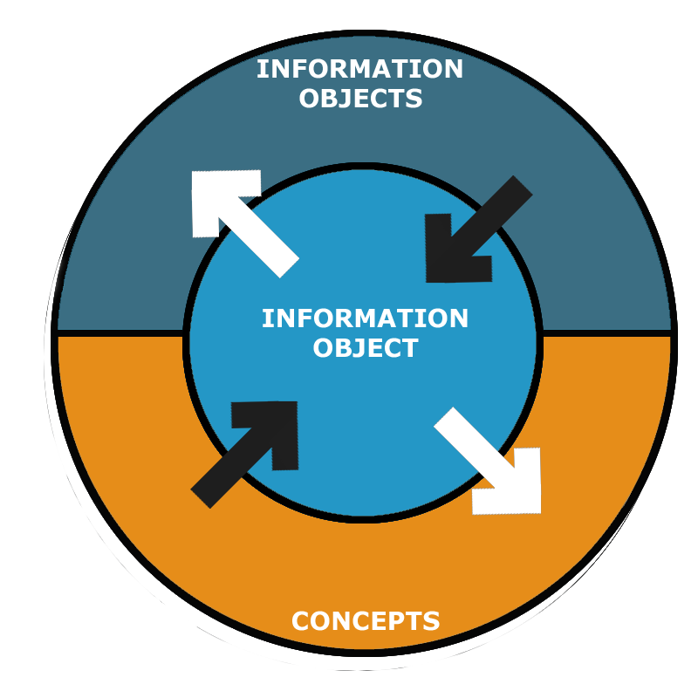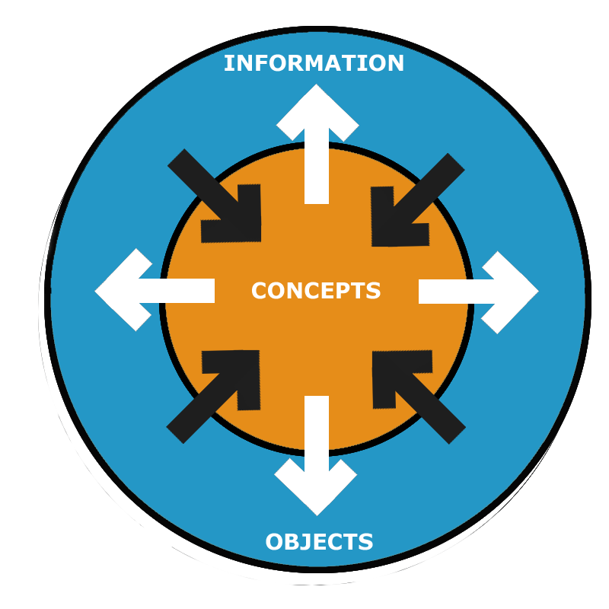
Figure 39: information access digital dossiers 2004/5. Figure 40: information access next generation digital dossier

First attempt concept next generation digital dossier
Given the concept of artwork centralization as mentioned above, we sketch a first impression in design. This sketch incorporates the design aspects stated in section 6.2 based on the analysis in chapter 5 and user requirements imposed by Netherlands Institute for Cultural Heritage (ICN).

General shell dossier

The centralization of the artwork itself as information access mechanism, allows the user to select a part of, or the whole artwork to access related information as shown in figure 41. As illustrated in figure 42, a part (leaf) of the artwork (plant) has been selected allowing the user to chose between several options.

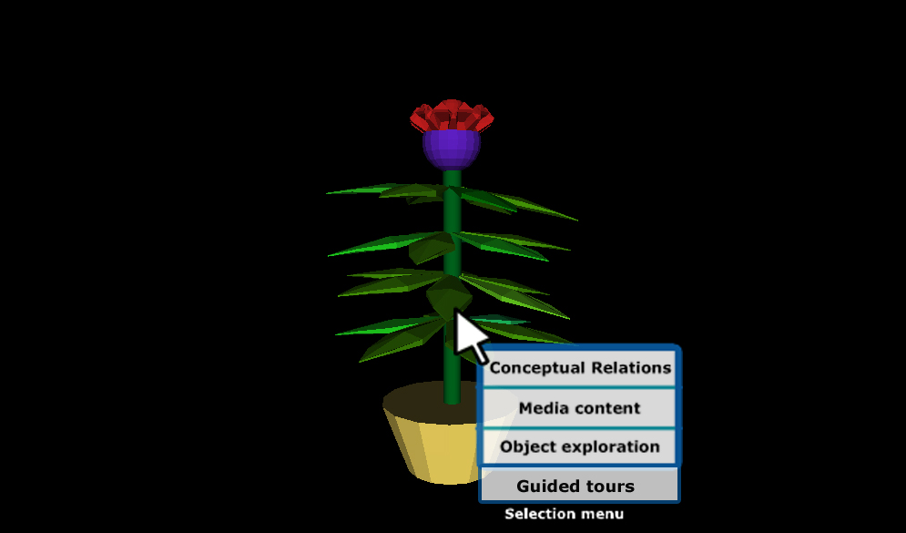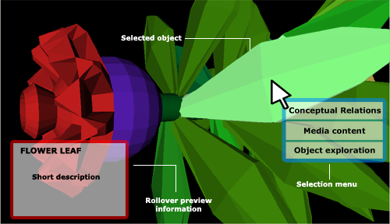
Figure 41: whole plant is selected for specific functionality figure 42: leaf is selected for additional functionality

Design aspects

I elaborate on how this concept can realize the design aspects defined in section 6.2 above.

- Serve as an information source for domain experts

This requirements can relate to (1) the type and amount of content present and (2) interaction possibilities or functionality to retrieve the information. Because this requirements can be interpreted as the general need that I will provide details by next requirements.

- Represent highly inter-related information structures

To represent the highly inter-related information structures a concept map or graph can be used. As like the Abramovic dossier and Shaw dossiers, this seems to be supporting information retrieval and analysis. Also research conducted towards the use of concept maps and in more general visual languages support these assumptions (as mentioned in section 4.4).
The concept graph visualization technique can be used from the previous dossiers, as illustrated in figure 43 below.

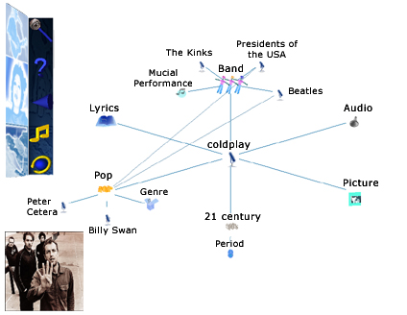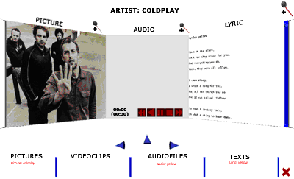
Figure 43: concept graph visualizes information structure Figure 44: content gadget presenting media

- Support the possibility to explore inter-related concepts

The concept graph (see figure 43) used in the previous dossiers can also be used as a navigational mechanism to explore inter-related concepts.
When dealing with highly inter-related information structures in information systems, the notion of the concept map or graph as a simple and intuitive visual form of knowledge representation has potential as user interface mechanism: interactively displaying structural relationships and context.
As discussed in section 4.4, different visualizations have already been proposed to navigate hierarchical information structures. The most known example of 3D information visualization is the 3D cone tree (see section 4.4). The 3D cone tree visualizes hierarchical structures and consists of cone objects.
The concept graph used as shown in figure 43 can also be in 3D. The motivation of using 3D over 2D is that 3D visualizations make optimal use of screen space and provides the opportunity to visualize larger structures. However, like said in the evaluation of Jeffery Shaw dossier (see: dimensions), we must avoid confusing the user by remembering what is ‘behind you’. A in-place 3D navigation where information is not disappearing form the screen, like the 3D cone tree could be a solution.

- Present rich media recordings

For the presentation of media, the 3D content gadget can be appropriate. By the use of 3 windows which are positioned in a certain way that allows for simultaneous presentation without much visual distortion, the user can combine different media type into view to accommodates his need for information (see figure 44 above). We could argue for the need to compare or merge of information.

- Present content in context

The use of the concept graph (showing relations) and the placement of the artwork in an environment for exhibitional purposes (user experience and artist intention) contributes to present content in context.

- Provide guided exploration of information

To assist the user in information retrieval efficiently (e.g. reducing exploration time finding information of interest) and effectively (e.g. presenting all relevant information) the dossier provides guided exploration on:

- Navigation and presentation - with regard to artwork to access information in combination with the concept graph (see figure 45) and presentation of content.
- Specific user tasks – with regard to the use of 3D to support information analysis on re-installation, conservation, preservation and exhibition of art. As mentioned in the evaluation, this is implemented in the dossier Shaw by offering guided tours with regard to the re-installation process of the artwork Revolution.

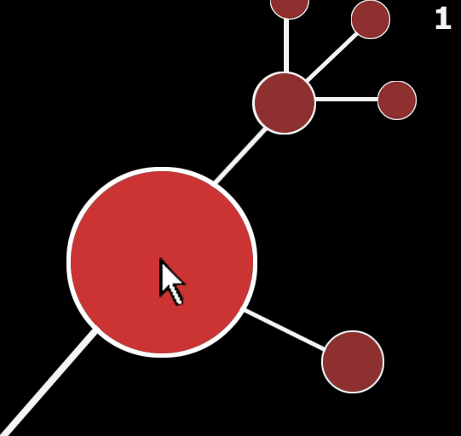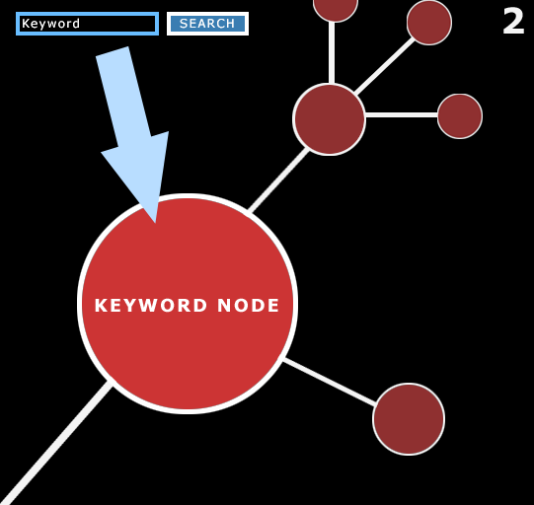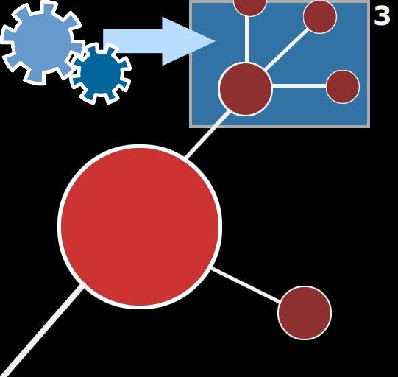
Figure 45: showing manual navigation, to keyword search to automatic guidance

- Allow for personalization of presentation

To support personalization of information the next generation dossier incorporates the following functionality from the Abramovic and Shaw dossier:

- Possibility to focus on one window by a zoom function - Abramovic dossier
- Possibility to chose which content is shown on what window - Abramovic dossier
- Filtering of information shown by the concept graph – dossier Shaw

And as a new addition, the overall size of the content gadget can be manipulated to allow for more presentational control. This way the user can minimize, maximize and manipulate size of windows to divide or focus attention (like used in WIMP interfaces). See figure 46 and 47 for an example.

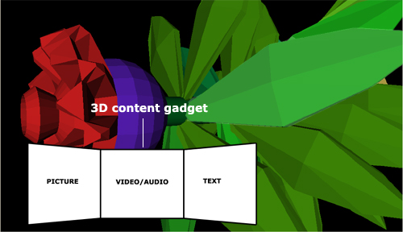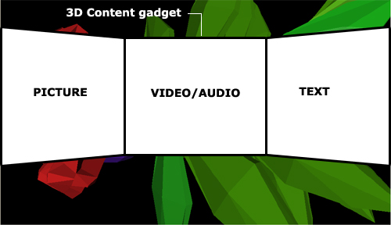
Figure 46: smaller sized content gadget Figure 47: larger sized content gadget

- Allow for manipulation environmental parameters

To support domain experts of Cultural Heritage with the exhibition of art, the next generation dossier must allow for manipulation of environmental parameters. The use of virtual space, and in particular 3D representations of the artwork and its context (the environment where it is exhibited), provides exhibitors insight in how the artwork should be exhibited (the position of it in space) and which factors influence the exhibition (environmental parameters). This insights can be useful when considering the limitations on a real-life exhibition room (size and shape) and the experience of that on the audience with regard to the artist intention of that experience. See figures 48 and 49 as example.
In the dossier Shaw, a 3D exhibition room was developed that offers exhibitors some manipulation of environmental parameters (e.g. light, textures) to indicate the effect it has on the exhibition. This could be extended by providing a tool environment by which the exhibitor can manipulate the exhibition room itself (size and shape), environmental parameters (light and texture) and the position of the artwork in space. This approach makes the analysis of effect of exhibition on the artwork more safe (virtual environment) especially when confronted with delicate material parts that are hard to replace or cannot be replaced when broken, more easy and faster to realize (the cost of time to manipulate environmental parameters and properties exhibition room). Even more, this information could be used as input for a virtual simulation of the exhibition in time by incorporating virtual agents acting as audience to indicate the effect it has on a real-life exhibition.
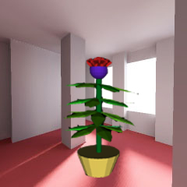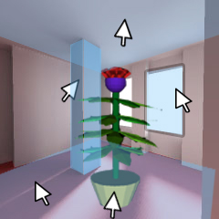
Figure 48: artwork positioned in example exhibition room Figure 49: manipulation exhibition room properties.

- Exploit the intrinsic properties of 3D

The use 3D representations of real-life objects allows for a rich information retrieval. Parts of representations of the whole could be examined in six degrees of freedom (rotation and movement in x, y and z direction). This can provide more level of detail on objects then a 2D counterpart. See figure 50 as example.
As developed in the dossier Jeffrey Shaw, the use of 3D can also be applied to match real-life actions. In particular, the re-installation of artworks can be guided or manually realized in 3D, see figure x as illustration. The aim is to offer exhibitors a way to get familiar with the construction process in a virtual environment, see figure 51. The re-installation in real-life can be realized based on skill and knowledge of the exhibitor gained by the digital dossier. This virtual practice is based on the use of flight simulators for airplane pilots.

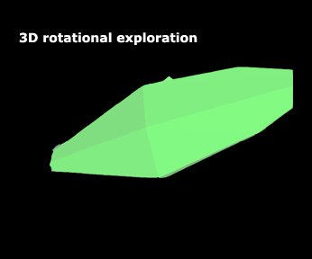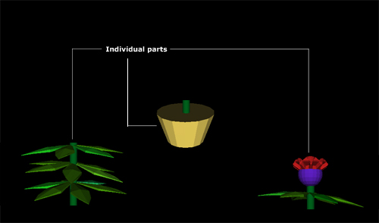
Figure 50: leaf of plant picked out of detailed examination Figure 51: re-installation of parts of an artwork

- Allow for rich preview information

As shown in figure 42, by tracking user attention explicitly (i.e. mouse pointer location) preview information about the attended information can be displayed. This allows the user to get a more accurate view about the information to retrieve. This could lead to effective and efficient decision making and as a result information retrieval. The preview information shown must be as complete as possible meaning that it contains of multiple media to provide accurate preview of the information.

7 Conclusions

This thesis began with the research question: how can one present and access media-rich highly related information with regard to Cultural Heritage so that the cost of information retrieval and interpretation is minimized?

This study has uncovered issues on design that influence the creation of a next generation user interface by providing an adequate answer on the research question mentioned above. In more detail, I investigated and discussed the issues with regard to underlying premises of presenting information, user interface design with respect to Human Computer Interaction and ways of how information can be visualized.

I evaluated three developed applications of digital dossiers in the domain of Cultural Heritage. By a evaluative framework, which can be considered as a specific heuristic evaluation where general principles are setup to guide design decisions or critique a decision already made, I have analysed the dossiers. The evaluative framework consist of four categories: (i) context, (ii) navigation, (iii) presentation and (iv) interaction. These categories correspondent with general user interface aspects. For each category, points of interest are defined which are based on the theoretical background by determining if theoretical sections match the categories. For each point of interest, measurements (non experimental) are defined to concretize how to deal with the points of interests.

The results of the analysis on the digital dossiers of 2003, 2004 and 2005 (chronological developed as follow-ups of the previous one), showed us that the digital dossier has evolved from a 3D environmental system where navigation and presentation where combined (Boezem dossier, 2003) to a 3D media-rich information space that separates navigation though context and presentation of content (Abramovic dossier, 2004 and dossier Shaw, 2005).
The results of the analysis on the three digital dossiers showed us that the next digital dossiers on Cultural Heritage should inherit or deal with: user driven guided exploration, separation or combination of navigation and presentation with regards to information types, mental and functional immersion, user controllable presentation, rich preview information and exploitation of 3D representations to accommodate user tasks.

As a result I have introduced a ‘framework of design aspects’ for the development of the next generation digital dossier in Cultural Heritage. This framework consists of initial user requirements and design aspects that where identified as positive on the analysis of the digital dossiers and my experience on their development. Based on a new way to start information retrieval i.e. shifting from abstract conceptual information towards centralization of the artwork itself contributing to a more natural real-life setting, I elaborated on this based on the application of the framework of design aspects.

Because this study cannot of course be viewed as conclusive, evaluations focused on quantative results with regard to usability needs to be conducted to get a more accurate view. In more detail, evaluations on usability needs to conducted to enhance the design e.g. evaluation based on models (e.g. GOMS), cognitive walkthrough and quantative results on effective and efficient information retrieval.

For the future development of digital dossier in general, I believe that the introduced artwork centralization approach as a concept and the framework of design aspects, contributes to the user requirements on Cultural Heritage tasks.

Conference paper 1

Accepted for Concept Mapping Conference, Costa Rica – San Jose, 5-7th September, 2006.

CONCEPT MAP AS VISUAL INTERFACE IN 3D DIGITAL DOSSIERS: IMPLEMENTATION
AND REALIZATION OF THE MUSIC DOSSIER

van Riel C., Wang Y. , and Eliëns A., Vrije Universiteit Amsterdam, the Netherlands

Abstract. This paper describes the implementation and realization of 3D digital dossiers, based on several case studies, which uses a concept map as navigation and visualization paradigm. The aims of these 3D digital dossiers are to provide intuitive navigation, efficient and effective search and detection of relational information structures, imposing immersive presentation of content and content related information by making use of 3D space and concept visualization. Altogether, the dossiers serve as a digital archive for domain experts and interested parties. The digital dossiers indicate that using a concept map to visualize and navigate through relational information structures is intuitive and effective.

Category: Full Paper

Introduction

The increasing interest in accessing multimedia information and related 3D representation of information objects into an application has heightened the need for digital dossiers. The introduction of digital dossiers to accommodate such interest started as a master students project, based on the course Multimedia Casus lectured at the Vrije Universiteit, Amsterdam. In close collaboration with the Netherlands Institute for Cultural Heritage (ICN) - a leading, independent knowledge institute for the preservation and management of so-called moveable cultural heritage -, digital dossiers where created to facilitate the need for accessing 2D and 3D information related to artists, artworks and installations on contemporary art.

It should be stressed that the digital dossier, according to our interpretation, can be seen as a digital archive which presents particular information about a specific topic in a specific way. We chose for the phrase digital dossier, and not for archive or library, to stress that our focus lies on presentational aspects.

Generally, the digital dossier consists of two main functional environments to allow for navigation and presentation of content. For navigation a concept map was developed that allows for detecting and choosing inter-related concepts, concept-related information, media recordings and 3D representations in a unified intuitive fashion. The concept map developed is considered purely as a proof of concept acting as navigational mechanism, and as a consequence of this focus, it is currently implemented as a concept graph. Relations shown between nodes in the concept map are not named but are intended to be directional, and can be regarded to be implicitly derived depending on the context of its destination node.

For the presentation of content, the advantages of 3D are used to allow for parallel presentation of text, audio, picture and video and to incorporate and present interactive 3D representations of information objects. Although both environments are visually and functionally different, it’s aimed to be perceived as strongly related by the use of visual cues.

The aim of this paper is to provide experimental results that benefit research on using concept maps in user interfaces. In the following parts, we give more detailed explanation about our work: First, section 2 focuses on using concept maps in user interfaces and describes the different applications of the digital dossier. In section 3 requirements on the digital dossier are discussed, followed by section 4 where more detail is given about the implementation and realization process. Next, section 5 deals with the use of guided tours to present information and finally, in section 6, conclusions and future discussion are provided.

Background

Using visual languages in communication to enhance understanding and to reduce cognitive load is well-known. Research indicates that certain visual languages like concept maps act as a working memory extension and enhances direct interpretation of information through pattern detection [Scaife et al., 1996]. Such findings have led to using concept maps in knowledge representation in general.

The application of concept maps in education to enhance understanding can be considered effective [Novak et al., 1984] and even important. On the web for example, higher education promotes the use of concept maps as a way to visualize knowledge. The digital university, founded by Dutch universities, provides online information, examples and exercises for students to learn and use concept maps. Also in the field of Artificial Intelligence, concept maps where used to describe the semantic relationships in complex domains. As a navigation mechanism it is, for example used in the Visual Thesaurus.

When dealing with highly inter-related information structures in information systems, the notion of the concept map as a simple and intuitive visual form of knowledge representation has potential as user interface paradigm: interactively displaying structural relationships and context. Different visualizations have already been proposed to navigate hierarchical information structures [Schonhage et al., 2000]. A well-known example of 3D information visualization is the 3D cone tree [Robertson et al., 1991]. The 3D cone tree visualizes hierarchical structures and consists of cone objects. The motivation of using 3D over 2D cone trees is that 3D visualizations make optimal use of screen space and provides the opportunity to visualize larger hierarchical structures.

Requirements on the digital dossier

Due to the creation of the digital dossiers for and in collaboration with the Netherlands Institute for Cultural Heritage (as mentioned in the introduction), the following main user requirements where imposed:

The digital dossier should:

- Serve as an information source for domain experts,
- Represent highly inter-related information structures,
- Support the possibility to explore inter-related concepts,
- Present rich media recordings, and,
- Provide background information for the interested general public.

Applications and implementation of the digital dossier

Based on the requirements with regard to the digital dossier, three applications for different domains where created and recently deployed:

- the Marina Abramovic dossier,
- the music dossier, and,
- the Jeffery Shaw dossier.

These three digital dossier applications are created with VRML (Virtual Reality Modeling Language), which allows for creating virtual worlds and present them on the web. The web publication makes it possible for the interested general public to access the digital dossiers worldwide and more easily.

The first digital dossier that used the concept map as information visualizer and navigational mechanism, is the abramovic dossier. This dossier has been presented at cultural events and institutes like the Institute for Time-based Arts - Montevideo as a prototype.

With regard to conceptual domains, the Marina Abramovic and the Jeffery Shaw dossier focus on the artist, their artworks and artwork-related information. The music dossier contains information related to the domain of music. In the following parts, the music dossier will be used as a representative of the general functionality for all dossiers.

Visual navigation by concept map

In order to represent and support exploration of highly inter-related information, a concept map was created that visualizes the information into hierarchical structures which serves as a user interface for navigation. In more detail, the concept map has the following properties:
- Parent-Child and non-taxonomical relationships visualized as a star structure: The concept map is implemented as a star-structured-hierarchy diagram that allows detecting relations between concepts and search for information. By star-structured we mean that relations between concepts are visualized by lines by showing a centered concept surrounded by related concepts (see figure 1).
Figure 1: concept map visualizing hierarchy. Figure 2: Content gadget with 3 panes visualizing media content

- A three level deep view: The use of hierarchical structures can be compared with the 3D cone tree[7], however, unlike the 3D cone tree, where the complete hierarchy is shown, only a subset of the hierarchy is visible - three levels deep - to avoid screen clutter. This view allows the user to browse through a large amount of data while displaying a limited number of items at a time.
- Dynamically generated structure: A selected concept will be translated to the center of the screen, involving movement in the X and Y direction. It then becomes a parent node showing its children around it. So, the structure presented is determined by the user’s choice.
- 3D icons representing information types: Concepts shown in the concept map are represented by 3D icons. These 3D icons visualize a certain type of information. We distinguish between two main information types: categories and content. The content information type itself consists of different media types - text, pictures, audio and video - which are represented by different 3D icons.

- To compensate for the lack of an overview where all information is shown at once, caused by the three level deep view, as noted above, the user can also use keyword search instead of concept map navigation.

Presentation of media content

To present media content in the dossier, a content gadget was developed which is activated when media in the concept map is selected for view, and has the following properties:
Three content windows: By making use of 3D space, media content can be presented simultaneously by using three content windows which can be selected to present text, pictures, audio and video. In our experience, the use of these three windows at the same time doesn’t cause much visual distortion (see figure 2).

- Focusing on particular content: Showing three content windows at once can lead to an information overflow. To deal with this, the user can focus on a particular window with a zoom option. This allows avoiding distraction from the other content windows.
- Dynamic content display: By a drag-and-drop function, the user can customize his/her presentation view. This choice gives the user more freedom instead of being bounded to a fixed position of media presentation.
- Internal linking: By selecting concepts represented by hyperlinks in text, the user is able to view their conceptual relations in the concept map.
- Scroll-bar pane selection: Under the content windows are scroll-bar panes present which can contain more categorized media content to select for view.

Incorporation of 3D representations

Due to the use of the 3D technology VRML, 3D representations of real-world objects could be easily incorporated and presented in the digital dossier (see figure 3). The 3D environment demonstrates the interactive exploration of real-world objects which could benefit domain experts. By manipulating position and/or angle of objects, the user can get insight into which parts the object consists off.
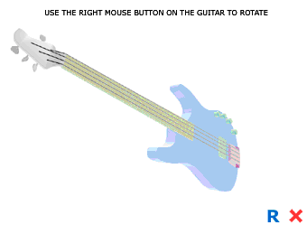
Figure 3: 3D representation of an electric guitar

At this point, we can only speculate how useful, in the perspective of Cultural Heritage, such a reconstruction can be as a tool for the conservator responsible for the re-installation, to play around with the presentation parameters, the positioning in space, the overall size, light and ambient effects.

Guided tours for automatic and focused presentations

When browsing through inter-related structures like in hypertexts, the end-user can experience some problems [Nielsen, 1990], like disorientation and quality of information retrieval. Directing the user’s focus of attention, especially in complex inter-related structures, like the dossier where navigation is non-linear may prevent the user from becoming lost or confused. In this perceptive, guided tours can be used to automate user interaction and function as a narrative story telling facility.

Several types of guided tours have been implemented in the dossier to facilitate automatic and focused presentation of information:

Conceptual guided tour - automatic and focused presentation of conceptual information by concept map.
Technical and space related guided tours - automatic presentation of functional and/or technical aspects of real-world objects, allowing for manipulation of environmental parameters for exhibition purposes.

The realization of the conceptual guided tour will be discussed in more detail in section 5.3

Requirements on the digital dossier

In short, the technical realization of the digital dossiers with regard to the concept map concerned two main parts: 1) the data structures, and, 2) visualization and animation of the concept map.

Data structures

To structure and categorize data into concepts and specify attributes (which outcomes are used by the concept map), a fixed number of record-like structures where created:

Video information node – to display video fragments.
Audio information node – to cast audio fragments.
Picture information node – to show images
Text information node – to present text
Group node – to present a category

As stated above, these record-like structures are used by the concept map and contain attributes which includes common values like a unique identifier, a short –and a long name, the location of a 3D icon, connected unique identifiers from related nodes and a description. For some structures, like video, audio and text nodes, additional attributes are added: location of the source file, location of a preview image and height and width of the output presented. These nodes give access to the actual content.

The group node is used to create categories in the concept map where to nodes can be related. Below, an example of the structure is given:

GroupNode {
ID "BILLYSWAN"
shortName "Billy Swan"
urlIcon "models/solo_artist.wrl"
connectedNodesIDs ["AudioBilly", “TextBilly”, “VideoBilly”, “PopGenre”, “InstrumentGuitar”]
}
Audio {
ID "AudioBilly"
shortName "let me help"
urlContent "audio/BillySwan.mp3"
description [""]
connectedNodesIDs ["BILLYSWAN"]
}
Picture {
ID "PictureBilly"
shortName "Picture: let me help"
urlContent "images/BillySwan/billy.jpg"
width 312
height 312
urlPreviewImage "BillySwan/billyswan.jpg"
heightPreviewImage 296
widthPreviewImage 296
description [""]
connectedNodesIDs ["BILLYSWAN"]
}

This piece of code illustrates the node connections as defined by the attribute ‘conncetedNodesID’s’. As shown, the group node is also connected to other nodes as well, which can be group nodes themselves or end nodes like audio or picture. Further more, the picture node contains some additional attributes that define width and height of the content itself and its preview image, as with video:

Video {
ID ”VideoBilly”
shortName ”Live performance clip”
urlContent ”clips/billySwan.avi”
width 320
height 360
urlPreviewImage ”images/previewImages/billy.jpg”
widthPreviewImage 220
heightPreviewImage 140
description [””]
connectedNodesIDs [”BILLYSWAN”, ”videoClips”]
}

Visualizing and animating the concept map

Each navigational action, whether by mouse clicks, filtering or keyword search, causes the concept map to change into a new state. This process of change includes determining the center node (which is the concept selected and placed in the center of the screen) and its related nodes (which are its related concepts), visualizing them star-structured wise and animating their transitions to a final position.

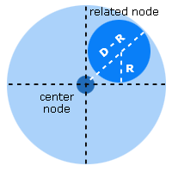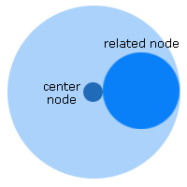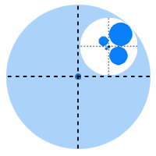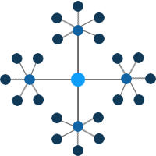
Figure 4: radius related node figure 5: minimum distance Figure 6: indirect-related nodes figure 7: three level deep view

Drawing the node structure

When the center node and related nodes are determined, the new concept map state is computed as positions on a 2D plane. The process can be described in 5 steps:

- Step 1 – centralization center node: First the center node is placed in the center of the available space. This node represents the information the user is focusing on.
- Step 2 - available radius center node: Next, the available radius for the center node is set. This radius must be larger than the space taken in by the center node itself otherwise there is no room for drawing the related nodes.
- Step 3 – available radius related nodes: In this step, the radius that is available for each related node (direct related) of the center node is computed. First, the circle around the center node, as computed in step 2, is divided into sectors. The number of sectors used is equal to the amount of related nodes. The space available for a related node is the circle that fits inside a sector, as shown in figure 4. However, the circle around the related node may not intersect with the center node; this puts a minimum on the distance from the center node to the related node. If this is the case, the circle available for the related node is decreased to not intersect with the center node (i.e. the radius is derived from the minimum distance and the available space (radius) of the center node), as shown in figure 5.
- Step 4 – actual radius related nodes: The three level deep view, as implemented into the concept map, allows the related nodes to have related nodes themselves. This leads, from the center node perspective, to indirect-related nodes. In this step, the actual radius used by the related node will be computed based on the number of nodes it is related to. For each of the indirect-related nodes, the distance it will be placed from the related node is computed. These nodes must not intersect each other, so they are arranged around the related node, as depicted in figure 6. The distance to the related node is equal for each surrounding node and has equal sector size to be drawn in. The distance between an indirect-related node and the related node is taken as small as possible such that the indirect-related node just hits the borders of the sector. In case the related node and indirect-related node would intersect, they will be put next to each other. If the required radius of the related node exceeds the available radius, the available radius is taken as the required radius. Also the related node and the indirect-related nodes will be scaled down to fit inside its available radius.
- Step 5 – position nodes in concept map: In this last step, the position of all the nodes in the concept map are realized as computed in the pervious steps. Figure 7 illustrates an arrangement of the nodes implemented as a star-structured concept map.

Animating state transitions
When a node (other then the center node) in the concept map is selected, the concept map goes to a different state: the selected node becomes the new center node and is placed in the center of the space. This change is animated and shows the transition of the old to the new state. Nodes that are also needed in the new state, move by interpolation to their new locations. Nodes that are no longer needed disappear from the screen with a fade-out effect, where new nodes that are needed appear with a fade-in effect.

Further details
Because of the inter-related data present in the dossier, multiple occurrences of the same nodes in the concept map are possible. This happens, for example, when in a particular state a concept is an indirect-related node of two or more related nodes. In such cases, the indirect-related node is only drawn once by the following rule: if a node is already drawn for its related node, the other possible locations will be left open. As mentioned earlier, the center node is drawn first, then the related nodes and at last the indirect-related nodes. As a result, most open locations will be around the related nodes.

To indicate relationships, lines are drawn between the nodes. If a node has a relation to a node that is direct, an apparent colored line is drawn, if the node is indirect related, a non-apparent colored line is drawn; because the node was already elsewhere drawn.

Automatic conceptual navigation by a guided tour
Due to the amount of relational data and complexity of the conceptual structure, a conceptual guided tour was developed that assist the user in informational retrieval by directing focus of attention (see section 4.4).

This guidance - automating user interaction by a time-based sequence of events that activates navigational functions - uses the concept map as a narrative story facility to present information of interest. This allows the user to explore conceptual relations and related media or 3D representations by automation in a defined conceptual context. It is believed to have the following advantages:

First, it can support information retrieval:

- Effectively - presenting all relevant information in a narrative order given a its conceptual context, and,
- Efficiently - avoiding time consuming manual navigation finding objects of interest (without getting lost or confused).

And secondly, an interesting possible feature can be to support information analysis by presenting how to interact with real-life objects.

As concerns the implementation, the guided tour program consists of several input and output channels by which it communicates with functions present in the digital dossier. In order to automate user interaction, the guided tour program fires events with specific values at specific pre-defined times to activate functions by the input and output channels. By calculating the current time of when the guided tour is activated, it is determined based on a set of rules when (at which time after activation of the guided tour) an event is allowed to be fired. In the standard interaction these events are fired by user mouse clicks or key strokes.

Conclusion

This paper began with the premise that using a concept map as a visual interface may provide intuitive navigation when dealing with highly inter-related information structures. In practice, digital dossiers where created that use a concept map - implemented as a star-structured diagram where the presentation of the structure is dynamic - as a visual interface where the presentation of content is separated from navigation but still indicating a strong relation between them. In addition, to assist the user in navigation and search, several guided tours where created to enhance information retrieval and analysis. So far, initial user feedback on the digital dossiers looks very promising for using the concept map as a navigation paradigm. Because this study cannot of course be viewed as conclusive, evaluations focused on quantative results needs to be conducted to get a more accurate view. Also deploying the digital dossiers in other applications for the real world may reveal further issues for research.

Acknowledgements
We gratefully acknowledge the contribution of the following people to the development of the digital dossier:

- Vrije Universiteit Amsterdam: Tim Verweij, Olaf van Zon, Eric de Boer, Pascal Snijders Blok,
- Universiteit van Amsterdam: Abeer Mahdi, Jina Menke, Michela Negrini,
- Technische Universiteit Delft: Jurgen Koster,
- The Netherlands Institute for Cultural Heritage: Tatja Scholte and Ijsbrand Hummelen, and,
- Montevideo: Bart Rutten and Gaby Wijers.

References

Nielsen, J. Hypertext and Hypermedia, Academic Press, San Diego, Calif., 1990. pertext programming system.
Novak J. and Gowin D. B., Learning How To Learn. Cambridge, UK: Cambridge University Press, 1984.

Robertson G.G. and MacKinlay J.D. (1991), Cone trees: animated 3D visualizations of hierarchical information, Proc. of the SIGCHI Conference on Human factors in computing systems: Reaching through technology, 189 194, New Orleans, Louisiana, United States, March 1991.

Scaife M. and Rogers Y., External cognition: how do graphical representations work?, International Journal of Human-Computer Studies, Volume 45 Issue 2, august 1996.

Schonhage, B., van Ballegooij, A., Eliens, A. (2000), 3D gadgets for business process visualizations, Proc. of the fifth symposium on Virtual reality modeling language (Web3D-VRML), 131 - 138, Monterey, California, United States, February 2000.

Conference paper 2
Accepted for: International Conference on Multidisciplinary Information sciences & Technologies, Spain – Mérdia, Oktober 25-28th, 2006.

Exploration and guidance in media-rich information spaces: the implementation and realization of guided tours in digital dossiers

van Riel C, Eliëns A. and Wang Y.
Vrije Universiteit, Intelligent Multimedia Group, Faculty of Sciences, Amsterdam Netherlands

Confronted with media-rich information spaces involves interfaces that are usually designed to facilitate personal exploration to locate information of interest. Navigating such media-rich information spaces, where information structures can be complex, may result in disorientation and demotivation. The need of suited approaches able to support the exploration of such media-rich archives has motivated the development of several types of guided tours. The aims of these guided tours are to support information retrieval, like locating objects of interest in a logical sequential order, and analysis, like learning how to interact with real-life objects or detecting relationship structures, in a dense information environment. This paper, discusses the application and realization of these guided tours in digital dossiers in the domain of Cultural Heritage. Based on the results, we discuss the implications on future development of media-rich environments with regard to information exploration and guidance.

Keywords: Guided tours, Digital Dossiers, Media-rich environments, Cultural Heritage.

Introduction

In recent years, media-rich environments evolve with more complexity and possibilities due to technological developments in computational speed, the Internet and 3D graphics hardware. In the area of cultural Heritage, these developments allow for new opportunities towards cultural communication. The virtual museum of Canada, for example, enables Internet users to access cultural content and related features of several Canadian museums and galleries. This online media-rich environment contains tens of virtual exhibits of cultural content and a collection of more than a thousand images of art.

The guided tours discussed in this paper are implemented to function in 3D digital dossiers within the domain of Cultural Heritage. A digital dossier can be interpreted as a digital media-rich archive in a 3D environment that represents particular information about a specific topic in a specific way. In more detail, it can represent architectural knowledge visually and facilitates the presentation of 2D and 3D media. The 3D digital dossier applications are created with VRML (Virtual Reality Modeling Language), which allows for creating virtual worlds and present them on the web. The web publication makes it possible for the interested general public to access the digital dossiers worldwide and more easily.

The introduction of digital dossiers and the related guided tours started as a master multimedia student's project, based on the course Multimedia Casus lectured at the Vrije Universiteit Amsterdam, in close collaboration with the Netherlands Institute for Cultural Heritage (ICN) - a leading, independent knowledge institute for the preservation and management of so-called moveable cultural Heritage. The increasing interest in accessing multimedia information and related 3D representation of information objects in an application, desired by the Cultural Heritage institutes, has heightened the need for digital dossiers. In this perspective, and in a broader sense of Cultural Heritage, the digital dossier should serve as an information source for domain experts with regard to preservation, conservation and reinstallation of artworks. Because of the complexity of conceptual structures and related media, guided tours can be used to assist the user in navigation and search for information within a defined conceptual space. The aim of this paper is to provide experimental results that benefit research on using guided tours for information navigation and retrieval in media-rich applications.

In the following sections, we give a more detailed explanation about our work: First, section 2 discusses the types of guided tours that are developed for the different applications of the digital dossier. In section 3 the use of the conceptual guided tour is discussed, followed by section 4 where we discuss the use of the environmental guided tour, and as last, in section 5 we discuss the use of the object centered guided tour. Next, section 6 gives an overview about the technical realization of guided tours within 3D digital dossiers, and finally, in section 7, conclusions and future research are provided.

Guided tours for automatic and focused presentations

Personal exploration of media-rich environments becomes more extensive and time consuming with respect to quantity and quality of the information present, and the awareness of information locations. In such cases, locations of the collection of information to be accessed may be too large to remember and or the location of information is not known, forcing the information to be retrieved based on its content, its attributes or its relationships to information whose location is known [1], i.e. navigating through hyperspace. Navigation as such, due to the non-linear communication structure as found in media-rich environments, can cause some problems, like disorientation and quality loss in information retrieval [2]. Also, when confronted with high quality information, such as 3D representations that imposes greater information richness by six dimensional explorations, can affect the user in extensive and time consuming exploration i.e. the extent and awareness of 3D interaction possibilities.

By directing the user's focus of attention by automation, in situations where navigation is non-linear may prevent the user from becoming lost or confused and enables the designer to control which information in what order is processed, and as a consequence influence the quality of information retrieval. Also exploration of information rich objects can be accommodated in this way. From this perspective, guided tours can be used to automate user navigation and interaction, and function as a narrative story telling facility. Consistent with this assumption, an experiment was conducted where participants used dynamically planning guided tours to navigate through hyperspace. The results indicate that the guided tours overcome problems of getting lost, and accommodate information retrieval and information processing [3].

The types of guided tours developed and discussed in this paper are focused on, first of all, navigation and presentation:

- conceptual guided tour - automatic and focused presentation of conceptual information spaces and related media, and,
- spatial guided tour - automatic spatial guidance where objects are strongly related with the environment; allowing for manipulation of environmental parameters.

And secondly, we will look at object exploration:

Object focused guided tour - automatic presentation of functional and/or technical aspects of real-world objects.

Guided tour(s) 1: guidance in conceptual space
The creation of the conceptual guided tour is based on the abramovic digital dossier [4]. This digital dossier uses a concept graph as navigation paradigm to represent conceptual knowledge in a three level deep view, as shown in figure 1.

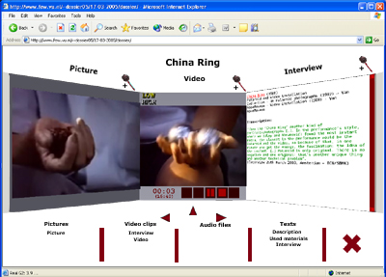
Fig. 1. Concept graph visualizing information structures Fig. 2. Content gadget with 3 panes visualizing media

By browsing the conceptual nodes, which causes the concept graph to change accordingly by a smooth transition, the user is able to detect relations between nodes and their related media content. When media content is selected for view, a 3D content gadget appears by which the user can select, view and focus on media, as shown in figure 2. As for 3D representations of artworks, can also be accessed by the conceptual space and are viewed in a plain 3D environment.

Due to the amount of relational data and complexity of the conceptual structure, a conceptual guided tour was developed that assists the user in information retrieval by directing focus of attention. This guidance - automating user interaction by a time-based sequence of events that activates navigational functions - uses the concept graph as a starting point to act as a narrative story facility to present information of interest. Media information is presented by activation of media related nodes visualized by the concept graph which changes by navigation. This allows the user to explore conceptual relations and related media or 3D representations by automation in a defined conceptual context more effectively (presenting all relevant information in a narrative order given its conceptual context) and efficiently (avoiding time consuming manual navigation finding objects of interest) without getting lost or confused.

A remaining issue is to instantly respond to user exploration interactively. With the current conceptual guided tour facility it is feasible to create or activate a guided tour based on user selection or on predefined topics. In the future, an autonomous dynamically generated guided tour that responds to user interaction should be desirable.

Guided tour(s) 2: guidance in spatial navigation

The second guided tour aims to assist the user in locating information of interest and orientation in a spatial environment. The dossier Marinus Boezem [6] uses a virtual atelier to represent two artworks of the artist Marinus Boezem, by a 3D representation of which one is interactive and the other animated, and related media. The aim of these representations is to inform the interested public about its use and presentation in an actual exhibition. Related 2D media content is accessed by real-life metaphors, like a file cabinet for text and a video projector for video, as shown in figure 3.

Fig. 3. Video projector showing audiovisual media Fig. 4. Virtual agent acting as museum guide

In this digital dossier the navigational metaphor is not abstract, as opposed to the abramovic dossier as discussed in the previous section, but realistic. Dealing with spatial environments as such requires to deal with spatial movement (limitations input devices and possible motion sickness) and orientation (being lost by lack of overview). Given this, the Boezem dossier uses an animated character (i.e. agent) that acts as a real-life museum guide (e.g. guiding, answering questions), as shown in figure 4. This guided tour operates by changing the user’s viewpoint according to the position and transitions made by the virtual guide. To give the user more control over the environment a plane map of the virtual atelier can be used to click on a choice of continuations (e.g. instant narrative jumps) to support efficiency of information retrieval.

Currently, this guided tour suffers from several limitations. First of all, it is desired that the agent must be interactively responding on user focus of interest and/or attention as opposed to predefined actions. Secondly, with regard to interactive artwork installations, such guided tours could be extended with simulating interaction on artwork installations for the public, giving exhibitors insight in the use of the artwork and its environment, and based on this experiment with virtual environment parameters.

Guided tour(s) 3: guidance in object focused exploration

The dossier Jeffery Shaw uses the conceptual navigational paradigm of the abramovic dossier to locate information of interest and to access media content (see section 3), and extended it with filtering options for personalization's, see [5] for more details.

Besides this, a 3D tool environment is available focusing on the artwork Revolution of the contemporary artist Jeffery Shaw. This tool environment contains a 3D representation of the artwork itself (see figure 5) and aims to provide exhibitors insight about how to install the artwork Revolution and how to influence its presentation by offering the following options:

- Anatomy tour,
- Construction tour,
- Deconstruction tour,
- Manual construction test, and,
- Manipulation of environmental parameters.

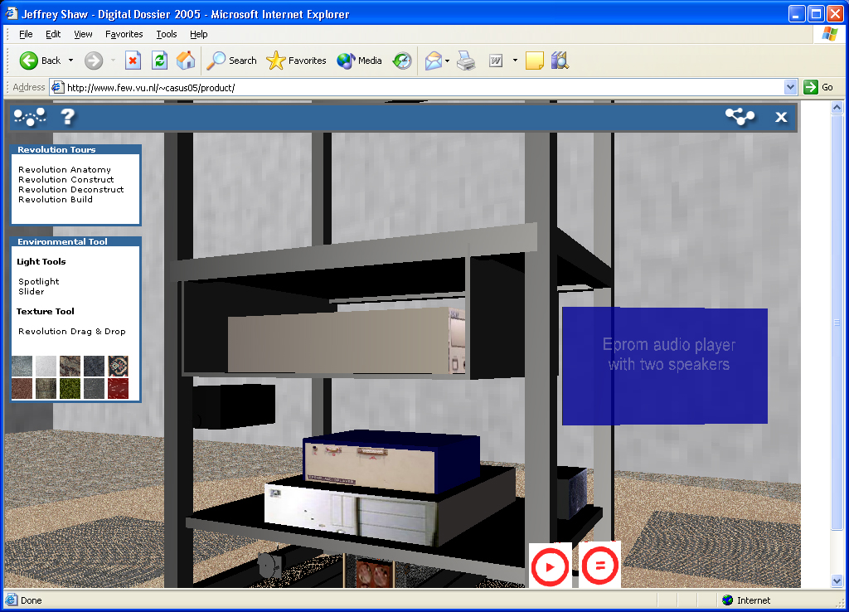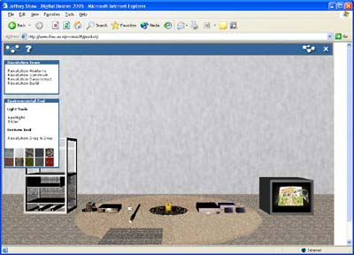
Fig. 5. Detailed view artwork Revolution Fig. 6. Individual components artwork Revolution

The (i) anatomy, (ii) construction, (iii) deconstruction tours and the (iv) manual construction test are developed aiming to provide interactive or fully automated guidance, and as such, can be interpreted as guided tours. When activated they present aspects of the construction and deconstruction process of the Revolution artwork in detail by 3D representations of each part of the artwork.

In short, the anatomy tour provides an automated exploration of the parts of the artwork, their material, position, connection and use. The construction tour provides an automated exploration of how the individual parts are installed, and the deconstruction tour represents the de-intallation process.

The manual construction test, allows for more user interactivity. The general concept of this tour has emerged from the IKEA (the Swedish home furnishing retailer) product blue-prints. The aim was to offer exhibitors a way to get familiar with the construction process of the artwork Revolution in a safe (i.e. virtual) environment. Especially when confronted with delicate material parts that are hard to replace or cannot be replaced when broken. This tour guides the user through the process of construction by giving textual and visual feedback when manually constructing the artwork by its parts.

The tool environment also offers some manipulation of environmental parameters (e.g. light, textures) to indicate the effect it has on the exhibition, and as a consequence its experience, and can be related to the intent of the artist. See [5] for more detail.

In the future, a tool environment as discussed could be improved by focusing on the artwork and its environment, which is part of the experience, allowing to extend the amount and degree of manipulating environmental parameters.

The realization of guided tours

As mentioned in the introduction, the 3D technology VRML was used to develop the digital dossiers. The technical properties of VRML - with regard to the internal communication structure - allows for the creation of guided tours which communicate with the digital dossiers to mimic user interaction. In more detail, VRML environments consist of input and output channels that are used to send or receive events (i.e. internal commands). These events are used to activate functions present in the digital dossier.

In order to mimic user interaction, the guided tours operate by a sequence of events, that communicate with functions with regard to user interaction (e.g. mouse clicks or key strokes), with specific pre-defined values and fired at specific pre-defined times.

A more sophisticated approach is to create a strategy of sequence for events. This can be realized by dealing with selection and filtering, as done in the dossier Jeffery Shaw where only specific types of content can be shown, or based on attributes and properties for the creation of guided tours.

Conclusions

This paper began with the premise that using guided tours in media-rich environments support information retrieval and analysis. This study has uncovered several applications of guided tours in digital dossiers for the domain of Cultural Heritage.

In more detail, we introduced a conceptual and spatial orientated guided tour, and a tool environment which offers automated and interactive tours to access 3D artwork representations and related media. In summary, depending on the metaphoric environment and needed information to complete user tasks, the use of guided tours for effective and efficient exploration and guidance in media-rich information spaces looks promising. However, because this study cannot of course be viewed as conclusive, evaluations focused on quantative results needs to be conducted to get a more accurate view.

For the future development of guided tours, we believe that guidance in media-rich information must be applied implicitly - switching from exploration to guidance based on the preferences and information-need of the actual user.

Acknowledgements

We whish to express our appreciation of the contribution of the following people to the development of the guided tours and digital dossiers:

- Participants Multimedia Casus 2003,
- Participants Multimedia Casus 2004, see [4] for more detail,
- Participants Multimedia Casus 2005,
- The Netherlands Institute for Cultural Heritage, in particular Tatja Scholte,
- Montevideo/Time Based Arts

References

Agosti 1996 Maristella Agosti and Alan F. Smeaton (editors). Hypertext and Information Retrieval. Lower, Boston, 1996.

Nielsen, J. Hypertext and Hypermedia, Academic Press, San Diego, Calif., 1990. Pretext programming system.

Catherine Guinan , Alan F. Smeaton, Information retrieval from hypertext using dynamically planned guided tours, Proceedings of the ACM conference on Hypertext, p.122-130, November 30-December 04, 1992, Milan, Italy.

Eliëns A, van Riel C., Wang Y., Navigating media-rich information spaces using concept graphs - the abramovic dossier, accepted for: International Conference on Multidisciplinary Information Sciences and Technologies (InSciT2006) October, 25-28th 2006, Mérida, Spain

Wang Y., Eliëns A., van Riel C., Content-oriented presentation and personalized interface of cultural Heritage in digital dossiers, accepted for: International Conference on Multidisciplinary Information Sciences and Technologies (InSciT2006) October, 25-28th 2006, Mérida, Spain

Hoorn J., Eliëns A., Huang Z., van Vugt H.C., Konijn E.A., Visser C.T. (2004), Agents with character: Evaluation of empathic agents in digital dossiers, Emphatic Agents, AAMAS 2004 New York 19 July - 23 July, 2004.

References

Antoniou G., van Harmelen F., A Semantic Web Primer, Vrije Universiteit Amsterdam, 2004.

Averbukh V.L., Visualization Metaphors, Programming and Computer Software, Vol. 27, No. 5, 2001, pp. 227–237. 2001

Baecker, R. and Small, I. Animation at the Interface. In Laurel, B. (Ed.), The Art of Human-Computer Interface Design, Addison-Wesley, 251-267, 1990.

Baecker, R., Small, I. and Mander, R. Bringing icons to life, In Proceedings of ACM CHI’91, pp. 1-6, 1991.

Bartram L., Perceptual and Interpretative Properties of Motion for Information Visualization, NPJV 1997, Vegas Nevad USA.

Beun R.J. and van Eijk R M., Conceptual Discrepancies and Feedback in Human Computer Interaction, ACM International Conference Proceeding Series; Vol. 65, Proceedings of the conference on Dutch directions in HCI table, Amsterdam, Holland, 2004.

Biederman, I. (1995). Visual object recognition. In S. F. Kosslyn and D. N. Osherson (Eds.). An Invitation to Cognitive Science, 2nd edition, Volume 2., Visual Cognition. MIT Press. Chapter 4, pp. 121-165.

Bongers B., Human-Computer Interaction: Notes on Physical Interfaces, http://www.xs4all.nl/~bertbon.

Calitz A.P., Munro D., Representation of hierarchical structures in 3D space, Afrigraph, capetown south Africa, 2001.

Carroll J.M., Olson J., Mental models in human computer interaction: Research issues about what the user of software knows, Washington, DC, National Academy Press, 1987.

Catrambone R. Anthropomorphic agents as a user inter-face paradigm: Experimental findings and a framework for research. In Proceedings of the 24th Annual Conference of the Cognitive Science Society, pages 166–171, 2002.

Chang D., Dooley L. and Tuovinen J. E., Gestalt Theory in Visual Screen Design – A New Look at an Old Subject, Seventh World Conference on Computers in Education, Copenhagen, July 29—August 3, 2001.

Chang B.W. and Ungar, D. (1995) Animation: from cartoons to the user interface, In Proceedings of ACM UIST 1995, pp 45-55.

Connor Dickie, Roel Vertegaal, Changuk Sohn and Daniel Cheng. eyeLook: Using Attention to Facilitate Mobile Media Consumption. ACM UIST 2005. Seattle, Washington, OR: ACM Press, 2005.

Deng Z, Yildirim S., Bulut M., Lee C. M., Kazemzadeh A., Lee S., Neumann U., Narayanan S. - Analysis of Emotion Recognition using Facial Expressions, Speech and Multimodal Information - ICMI’04, October 13–15, 2004, State College, Pennsylvania, USA.

Dix A, Finaly J, Abowd G, Beale R, Human Computer Interaction, second edition, 2001.

Douglas J. Gillan, The Psychology of Multimedia: Principles of Perception and Cognition, ACM, CHI 98 l 18-23 APRIL 1998.

Eliëns A., introduction multimedia, syllabus, http://www.cs.vu.nl/~eliens/onderwijs/research/multimedia/imm/college/doc.pdf.

Fisher, M. and Smith–Gratto K., Gestalt theory: a foundation for instructional screen design. Journal of Educational Technology Systems 27(4): 361–371.

Fluit C., Sabou M. and Harmelen, van, F., Ontology-based Information Visualization: Towards Semantic Web Applications, http://www.cs.vu.nl/~frankh/postscript/VSW05.pdf, 2003.

Frijda N. H., The Emotions. Cambridge University Press, 1986.

Furnas G.W., Generalized fisheye views, in proceedings of SIGCHI’86, 1986, pp. 16-23.

George G. Robertson , Jock D. Mackinlay , Stuart K. Card, Cone Trees: animated 3D visualizations of hierarchical information, Proceedings of the SIGCHI conference on Human factors in computing systems: Reaching through technology, p.189-194, April 27-May 02, 1991, New Orleans, Louisiana, United States.

Gregory R.L., Seeing and thinking. Giornale Italiano di Psicologia, 1993, 20, 749-769.

Grunig, J. E. & Hunt, T., Managing public relations. New York: Holt,Rinehart and Winston, 1984.

Hoorn J., Eliëns A., Huang Z., van Vugt H.C., Konijn E.A., Visser C.T. (2004), Agents with character: Evaluation of empathic agents in digital dossiers, Emphatic Agents, AAMAS 2004 New York 19 July - 23 July, 2004.

Horvitz E., Kadie C., Paek T., and Hovel D., Models of attention in Computing and Principles to applications Communication, Communications of the ACM March 2003/Vol. 46, No. 3

Irani P., Ware C., diagramming information structures using 3D perceptual primitives, ACm transactions on Computer-human interaction, vol. 10, no. 1, march 2003, pages 1-19.

Jacob, R. J. K. The use of eye movements in human-computer interaction techniques: What you look at is what you get. ACM Trans.Inf. Syst. 9, 3 (April), 152–169, 1991.

Khaled Hammouda, An Ecological Perspective of Visual Information Density in Interface Design, Department of Systems Design Engineering, University of Waterloo, Ontario, Canada N2L 3G1, 2000.

Khan A., Matejka J., Fitzmaurice G., Kurtenbach G., Spotlight: Directing Users’ Attention on Large Displays, CHI 2005, April 2–7, Portland, Oregon, USA, 2005.

Marcus A., Metaphor Design in User Interfaces, Journal of Computer Documentation, Vol. 22, No. 2, may 1998.

Martin B. VirHKey: A VIRtual Hyperbolic KEYboard with Gesture Interaction and Visual Feedback for Mobile Devices, MobileHCI'05, September 19–22, 2005, Salzburg, Austria.

Mastoropoulou G., Debattista K., Chalmers A. and Troscianko T., The Influence of Sound Effects on the Perceived Smoothness of Rendered Animations, ACM International Conference Proceeding Series; Vol. 95, A Coroña, Spain, 2003.

Micheals C.F, Carello C., Direct perception, Prentic hall inc, engelwood clifs, New Jersey, 1981.

Nakatsu R., Nicholson J. and Tosa N. - Emotion Recognition and Its Application to Computer Agents with Spontaneous Interactive Capabilities, ACM Multimedia ‘99 10199 Orlando, FL USA

Nielsen J. , 2D is Better Than 3D, November 15, 1998, http://www.useit.com/alertbox/981115.html.

- Norman, D. A., Affordance Conventions, and Design. Interactions 6, ACM, 38–43, 1999.

Norman D.A., Emotional Design, New York: Basic Books, 2004.

Norman, D. A., The Psychology of Everyday Actions. In The Design of Everyday Things. New York: Doubleday/Currency, 1990.

Novak J. and Gowin D. B., Learning How To Learn. Cambridge, UK: Cambridge University Press, 1984.

Oviatt S., Coulston R., Tomko S., Xiao B., Lunsford R., Wesson M., Carmichael L., Toward a Theory of Organized Multimodal Integration Patterns during Human-Computer Interaction, ICMI’03, November 5–7, 2003, Vancouver, British Columbia, Canada.

Reeves B. and Nass C. - Perceptual bandwidth, communication of the ACM, March 2000/Vol. 43, No. 3.

Reidsma D., op den Akker R., Rienks R., Poppe R., Nijholt A., Heylen D. & Zwiers J. Virtual Meeting Rooms: From Observation to Simulation. AI & Society, The Journal of Human-Centred Systems. Springer-Verlag London Ltd, 2007, http://wwwhome.cs.utwente.nl/~anijholt/artikelen/sid2005.pdf.

Robertson G.G., Mackinlay J.D., Card S.K., cone trees: animated 3D visualizations of hierarchical information, ACM, 1991.

Ruspini, D.C., Kolarov, K., and Khatib, O., The Haptic Display of Complex Graphical Environments. In Proceedings of SIGGRAPH 97, ACM Press / ACM SIGGRAPH/ Addison-Wesley Publishing Co, Computer Graphics Proceedings, Annual Conference Series, ACM, 345-352, 1997.

Scaife M. and Rogers Y., External cognition: how do graphical representations work?, International Journal of Human-Computer Studies, Volume 45 Issue 2, august 1996.

Schaumburg H.. Computers as tools or as social actors? The users’ perspective on anthropomorphic agents. International Journal of Cooperative Information Systems, 10(1-2):217–234, 2001.

Sebrechts M.M., Vasilakis J., Miller M. S., Cugini J.V., Laskowski S.J., visualization of search results: a comparative evaluation of text, 2D, and 3D interfaces, Berkley CA USA, 1999.

Severin W.J., Tankard jr J.W., communication theories: origins, methods, and Uses in Mass Media, fifth ediction, 2001.

Sharon Oviatt, Ten Myths of Multimodal Interaction, communication of the ACM, November, Vol. 42, No. 11, 1999.

Sherman W.R., Craig A.B., Understanding Virtual Reality – interface, application and design, 2003.

Shneiderman, B., Designing the UserInterface, Addison-Wesley Publishing Company, USA, 1998.

Shubin, Falck and Johnson, Exploring COLOR in Interface Design, interactions july august 1996.

Studer, R., Benjamins, V. R., and Fensel, D., Knowledge engineering: Principles and methods. Data Knowledge Engineering, 25(1-2):161—197, 1998.

Tomko S., Harris T. K. , Toth A., Sanders J., Rudnicky A., and Rosenfeld R., Towards Efficient Human Machine Speech Communication: The Speech Graffiti Project, ACM Transactions on Speech and Language Processing, Vol. 2, No. 1, February 2005.

Treisman, A. M., Features and objects in visual processing. Scientific American, 255 (5), 114B-126, November, 1986.

Trumbo J., Spatial Memory and Design: a conceptual approach to the creation of navigational space in Multimedia design, Interactions, July-August, 1998.

Wickens C. D., Hollands J. G, Engineering Psychology and Human Performance, third edition, Prentice Hall Inc, 2000.

Vertegaal R., Attentive user interfaces: Introduction, Communications of the ACM, March, Vol. 46, No. 3, 2003.

Zellweger, P.T., Mackinlay, J.D., Good, L., Stefik, M., Baudisch, P., City Lights: Contextual views in minimal space, In Proceedings of CHI 2003, pp. 838-839, 2003.

Zhai S., What’s in the EYES for Attentive Input, Vol. 46, No. 3 COMMUNICATIONS OF THE ACM. March 2003.

1 Technical University, Eindhoven, the Netherlands, ywang@few.vu.nl
dr A. Eliëns, Vrije Universiteit, FEW/CS, De Boelelaan 1081, 1081 HV Amsterdam, eliens@cs.vu.nl
http://www.few.vu.nl
http://www.icn.nl
http://www.du.nl
http://www.visualthesaurus.com
http://www.few.vu.nl/~dossier05
http://www.few.vu.nl/~cvriel/casus05/mindossier
http://www.few.vu.nl/~casus05
http://www.montevideo.nl

