1: Game Mechanics
-Turn-based
-25 turns / 4 years per turn (100 years total)

Before the game starts:
-Generic intro movie
-Choose an area (=scenario)
-Choose climate sensitivity (moeilijkheidsgraad), to be chosen before you start the game
-Specific intro movie for the scenario + narrative
-Tutorial (possibility to skip), told by advisors

Game started:

Specification of a turn:
-You see your local environment
-Specific intro movie for the scenario + narrative at key game moments.
-Event-phase
-Decision-phase

Onscreen parameters:
-People
-Planet
-Climber 2.0 model
-Profit
-Alex Halsema’s model

Decisions on the shortlist directly influence values of underlying models.

2. Game events

2.1 Description of game events:

Game event: Narrative element
Cause trigger: End turn, parameter change
Information: Storyline, additional info on how the player is functioning
Player Options: Sit back und watchen das blinkenlight.
Visuals: Video, newspaper, news-item

Game event: Global event
Cause trigger: End turn

Information: State of the world

Player Options: Clicking the globe to go to world map

Visuals: Flashing globe

Game event: Handle global disasters

Cause trigger: Clicking on the globe

Information: Shows location of disasters and extent of disasters

Player Options: - Clicking on disasters to handle them
- After handling disasters, possibility to click on an icon of the local map to go back to it

Visuals: - Global map visible
- Animated disasters moving over map
- When chosen pop up screen with information on type, effect and cause of disasters.

Game event: Disaster mini-game

Cause trigger: Clicking on a disaster to handle it

Information: Give description of disaster, the mini-game and how to play it

Player Options: Play mini-game
Skip mini-game
Additional information request

Visuals: Intro screen for disaster game
The mini-game visuals

Game event: Disaster video

Cause trigger: Clicking on a disaster to handle it

Information: Give description of disaster and show video

Player options: Additional information request

Visuals: Video of specific disaster
Pop up information screen.

Game event: Additional information request

Cause trigger: Clicking on the information request

Information: Give description of disaster, extent and effects

Player options: Close screen with additional information

Visuals: Text, image

Game event: Go to local area

Cause trigger: After handling global disasters you return to the local area

Information: World status (Globe)
Local Status
Advisors
Parameters
Toolkit

Shortlist

Player options: Possibility to click world map (globe)

Possibility to click on events to react (obligatory)

Use toolkit
Edit shortlist
Consult Advisors
Take knowledge test
Visuals:
Local map of your chosen area/country
Shows location of events, Effects of events on local level
Backdrop for the game
Advisors
Toolkit

Game event: Use toolkit

Cause trigger: When toolkit is used

Information: Based on the 6 climate star topics the player can choose an area to make a decision

Player options:

First choose a topic:
-Climate strategies
-Feedbacks
-Energy
-Regional developments
-Adaptation
-Governance
After you choose a topic, you choose a decision from the specific topic.

Visuals: Star-shaped toolkit
Representation for decisions (icons, videos)

Game event: Short list

Cause trigger: A decision is chosen

Information: A list of chosen decisions, with a maximum length of 3

Player options: Remove decision from list

Visuals: Note in the corner of your screen

Game event: Meet world leaders
Cause trigger: Recurring item on time basis
Information: State of the world
CO2 emission rights
Players status in the world
Player options: Talk to world leaders
Leave meeting
Visuals: Interactive video of world leaders in circular line up
Player’s avatar(?)

Game event: End game
Cause trigger: -100 yrs have passed
-Threshold in the models in reached triggering an end –event.
Information: Video selection of the player’s actions
Player Score (Decision making score & Mini-game score)
Player options: Go to post-game evaluation
Visuals:
Video
Screen with player score

Game event: Post-game evaluation
Cause trigger: End game event
Information: Statistics (People, planet, profit, graphs & miscellaneous other stats)
Hall of fame (high score list)
Link to Clima Futura website
Player options: Play again
End game
Go to website of Clima Futura
Visuals:

-hall of fame
-evaluation report
-people
-profit
-planet
-Ending screen
-Rewind movie of player actions when “play again”

3. Key Game Events
“What is a key game event: a video and editorial, coupled with for instance a minigame. “

3.1 Types of game events

3.2. Game event ‘Turn’
- Name: Turn
- Contents:
  - Score
  - Feedback
    - Individual
    - Global
    - Local

- Game Options:
  - Minigame
  - Video
  - Editorial/ Testing
- Visuals:
  - Video/Text/Game
- Follow up: Dependent on the turn.

3.3. ‘Warning’ game event
- Name: Warning
- Contents:
  - Info from Climber model leading to threshold breach
  - Pre-emptive measure
- Game options: Accept or ignore warning
- Visuals:
  - Pop up screen
  - Video
- Follow up: Continuation of the game, followed by event when player chose to ignore warning.

3.4. ‘Reflection’ game event
- Name: Reflection moment
  - At fixed points in the game
- Contents:
  - Cause – effect relation in comparison with timeline
  - Feedback
    - Individual
    - Global
    - Local

- Game Options:
  - Clicking world to see the condition of the world
  - Links to read on cause – effect relations between disciplines.
  - Editorial/ Testing

- Visuals:
  - Video/Text/Game
  - Globe plus extent of changes
  - Timeline, showing cause – effect relation
  - Links
- Follow up: Dependent on the turn

3.5. Minigames

- Name: Token Hunt
- Contents: Collect knowledge on CO2 in all areas of the climate star.
- Game Criteria: Collect six knowledge elements
- Testing: Via six quizzes.
- Reward: Compensation for CO2 emission
- Follow-up:

- Name: BreakThrough!
- Contents: Save the land from the charging water. Make sure the men keep sticking their finger in the dike.
- Game Criteria: 1- 2min game time, ‘point and click’ game.
- Testing: Keeping the water out = success.
- Reward: Gained score, gained knowledge
- Follow-up: Editorial on real water control mechanisms

- Name: Polar bear Special Ops!
- Contents: Polar bear jumping ice sheets whilst collecting tokens.
- Game Criteria: Polar bear has to jump from ice sheet to ice sheet, meanwhile collecting tokens to represent CO2 reduction. The better the player does, the more the ice sheets grow, thus recovering the icecaps.
Platform game, player controls the polar bear moves.
- Testing: Upon completion of restoration icecaps the players succeeds.
- Reward: Compensation for CO2 emission
- Follow-up:
4. Storyboard

A short story along the lines of the IPCC report, where the player is told that the climate is changing, and that this will have impact on our luxurious lives. The player is told that he can change this for his country.

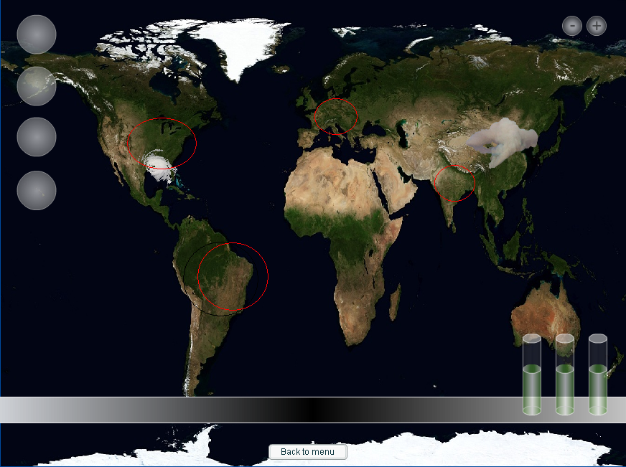
- Choose area
The general statistics of the country chose can be specified. Meaning: industry load/technology level, population en the condition/sensitive parts of the country chosen. The player must be able to discern between difficult and easy countries to play (in terms of level of difficulty)

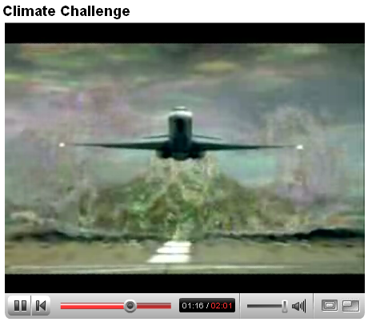
- Starting film.
In this game moment the introduction is made.
This can be done by several ways, such as the climate challenge game of the BBC. If an introductory film is made for this game, this can also be a good way for PR possibilities.

Figure 1: http://www.youtube.com/watch?v=_H3Jgp5Byoo

- Explanation Phase

In this phase the player should be allowed to learn the controls of the game, this can be achieved by letting the game option to pass by while different advisors tell what the function and influence is of this specific feature. The reason the advisors are included in this part of the game is to familiarize the player with these characters. The player should be able to skip this phase.

- Game phase
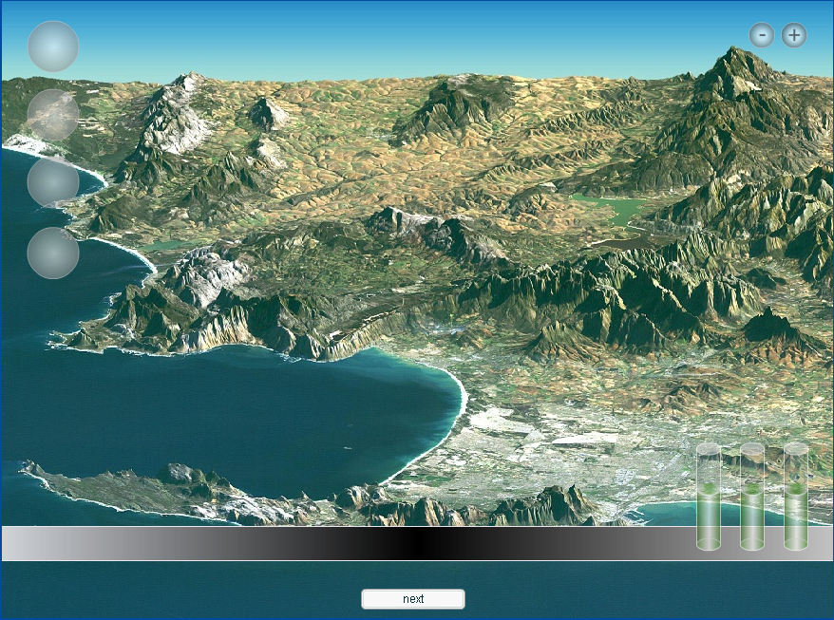
Name: Local Area
Show the main screen for the players. This visual has the player’s country, and its progression, state and condition.

Visuals:
- For example, if the country is subject to a flooding, this image should visualize this event.
- Furthermore the image should have an image of the players cities, the amount of cropland still present (i.e. visualization of the land-sea mask of climber model).
- The screen should show a miniature spinning globe which acts as an optional key to go to the world map.
- The screen should show a miniature model of the VU climate star, which is the player’s navigational tool.
- The player should see miniaturized visuals of his or her advisors.

Key features:
- Acquiring and devoting of the players resources. For the game play in this phase the key features are focused on the. This is subject of the VU climate star.
- Access world map
- Advisors
- Vu Climate start toolkit
- Gain bonuses

- Game Phase ¾ & 4/4
This is basically the phase in which the computer calculates and implements the changes. The player does not actively contribute to this phase and should not notice it in game time.

- End turn
5.0 One turn.

Player progression through screen:
- The player starts with the screen. An optional event should be when one of the parameters is changed below a certain level. This leads to either ‘narrative element’ or ‘Global event’. When these elements pop up, the player is obliged to handle these before proceeding in the game. The player can access the extra level via the globe icon.
- The player is on the global level. Here the player is presented with all the problems in the world, visualized on the screen.
The player can be offered either one of three things, or all three things per event.
  - Minigame
  - Disaster Video
  - Additional information request
- After handling global disasters the player can return to his local area. Before this screen returns, the game should have modeled eventual changes. (I.e. stopping a flood, extra gained bonuses.)

Player options Elaborate:

- VU climate star toolkit:
Every area has a certain amount of decisions which the player can choose for his or her short list, and these are implemented by putting them on the short list. This list is representative of the settings the player chooses (editing shortlist).

The choices on the climate star are per area:

1. Climate Strategies;
  - Reducing emissions
  - Reducing risks
2. Feedbacks;
  - Monitor feedback
  - Research investment
  - Prediction of climate response
3. Energy;
  - Invest in efficiency
  - Invest in Green Technologies
  - Implement government policies for emission for compagnies
4. Regional Developments;
  - Raise awareness
  - Implement ‘home-isolation’ campaign
5. Adaptation to Climate Change;
  - Spatial analysis
  - Water households
  - Land use
6. Governance.
  - CO2 emission market
  - Invest in sustainability
  - National and international press conference

- Consulting advisors
The player is able to consult his or her advisors in order to get advice on which areas to focus on when editing the shortlist.
The intricate part here is that the game has to implement which advisor is dominant, dependant upon the players prior decisions.
One nice way of bringing the advisors is by implementing the ‘cause-effect’ screen in this part. Where the player can see the connections between actions taken prior in the game, and what they have caused. An added visual in this screen can be the graphs showing the players different parameters, as the game progresses.

- Obtain Bonuses
The player can actively try to gain bonuses.
This can be done by playing extra mini games, take knowledge tests at a local level, or by accessing the global level and play added features here.

6.0 Start scenario’s

Storyboard

Netherlands.

The start is a prognosis of the IPCC report. Netherlands will have to deal with a rising sea level, but it is not the only country which is influenced by this rising sea level. World wide 634 million people suffer this same fate.

The game starts with a fictive dike breakthrough in Zeeland, pointing to the changing conditions in the Netherlands. There could also be mention of the possibility of the development of floating communities. (Edit – this is actually being done, research is conducted in this field, especially in the architectural sector).
The player is pressurized further on a political level, where Brussels is implementing governance that by 2014 all factories must be equipped with CO2 capturing filters and be able to sequestrate this underground. This requires the player to start investing in the usage of green technology.

Further areas which can be used as storyboard items are the need for importation of food, when/if the Netherlands flood.

More over, the land remaining is being over run by environmental refugees. (for more info: check the paper by N. van Egmond ). Other stress factors are: an ominous presence of the Greenland icesheet, which is reflected in the game around 2037 (edit – game moment states a collapse or non collapse of the Greenland icesheet, depending on the rate of the meltwaterflux in the model. Hence: go or no go).

Key Game elements:

People elements:
- North Pole broadcast by Dutch DJ
- Pressure from London to reduce Europe’s emissions by 60% (effect on economy)
- Less death due to warm weather, leading to expanding population
- People’s demand to follow up after Island which shifted to green energy
- Political vs. Industry: latter claiming that climate change is not evident.
- Frustrated farmers
- Smog causes health problems
- Settlement problems
- Alliance of Small Island pressure
- European Union pressure
Planet elements:
- Animal migration because of changing climate
- Barrier reef heating up ( provide cooling )
- Drought and flooding
- Start knows cooling elements, natural cycles manifest more than human impact
- Increasing CO2 levels does not provide enough nutrition for crops to grow.
- Land species, both plant and animal are going extinct.
- Bread Basket of Europe is not producing enough yields.
- Vast boreal forest is under stress
- Increased pests and diseases.
- Dropping lake levels
- Threshold Amazon rainforest from sink to source ( 550ppm)

Profit elements
- Investing in green tech:
- lines of giant wind turbines
- Wave power generators
- Centralized power stations with zero co2 emission
- Insulated home technologies
- Geothermal city heating
- Solar energy, Solar-thermal power plants
- Zero emission cars
- Demand vs. Population growth.
- Efficiency vs. Cost
- World BNP
- Fossil fuel Industries waging “war on reality”
- Increase in costs to implement green tech in later phases of the game
- Vulnerability of the Netherlands for rising sea level via costs
- Evacuation of people
- Reconstruction of buildings

Key game Dates:

2014
- Forced implementation of green tech
2037
- Greenland Icecap Scenario (if rise is above 3 degrees).
- Ratification of Kyoto protocol by Russia, Australia (edit- this could be in order instead all at once)
2050
- One third of the world population is lacking water. This leads to revolutions, environmental refugees and war. Shortages are worst in Asia and South America.
- Drought scorches the South of Africa, Australia and the Mediterranean Basin.
- We see the first summer with no ice on the Arctic, increasing trade routes.
- Polar bears and walruses are nearly extinct.
- Dependent on the 2037 scenario, Netherlands consist of floating communities, heavily dependent op trade for survival.
- Tropics have shortened growth season

2075

7.0 Narrative Examples:

Starting movie
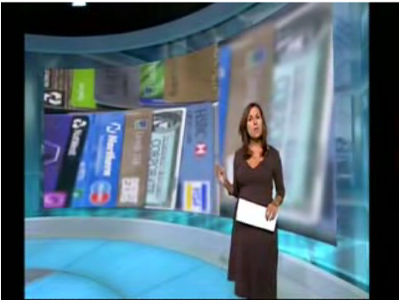
Newsflash:
Reporter in the evening news:
” The climate report a proposed by the IPCC has stated that mankind most likely has a discernable influence on the climate. The report states, among other things that can be linked to climate change, that the Netherlands could well expect a maximum of 1.1 meters of sea level rise. The Dutch government has not denied these allegations and has decided to stimulate further investigations as…..(fade out)”

Scientist in conversation with another scientist, behind computer:
Sc1: “This cannot be right…. You mean to tell me that it could be possible that the entire southeast sheet of Greenland goes?
Sc2: “Well sir, it’s all dependent on the rates of which this change actually occurs, but if this model is right, there is certifiable cause for concern..”
Sc1:”Well then, this proves it, those fools have been meddling long enough, it would seem that it’s getting out of control…
(Introduction character 1: Scientist, old – respected in the community, highly concerned with the interference of man with climate. He has always dedicated his research to understanding the workings of climate and now feels that man does have serious reason for concern, representative of one of two advisors in the game, area PLANET).

Return to
Reporter in the evening news:
” While the vast majority of the scientific world is shared behind the conclusions of the IPCC that the humans have made significant contributions to climate change over the last few decades, there are still some for whom doubts remain…(fade out)

Industrial kingpin sits behind the desk in front of him, several people are being addressed.
“You cannot stand here and tell me that we have to cut off our deal with china because we have to invest in soot filters! I refuse to let Brussels tell me how to run this company! I have run this company for 25 long years, and I’m not about to change my ways because of some pencilneck in Brussels!! Soot filters!

(Character two: the industrial representative who believes that his lifetime achievement is more important than the changing climate. He can be used as a representative for the conservative side in the area of PROFIT. )
Return to
Reporter in the evening news:
“The latest IPCC report estimates that worldwide 634 million people are in danger of flooding in the near future. It is estimated that around 180 countries are likely to be endangered by flooding, among which the Netherlands. The scientists are divided in the countermeasures, but are warning that adaptations to this rise in sea level will be a costly and tiring ordeal….(fade out)”

Man and woman sitting in a luxurious house. Then news is playing on the television. The man and woman, one of which could possibly be the players chosen avatar, are talking about the news.
Man:” It does not make my work any easier you know. Now I’ve got this hot breath of Brussels breathing in my one ear, and the industries blowing in the other. And to make matters worse, there’s international concern as well. I mean: it sure makes my term challenging, but …you know.”
Woman: “It would seem that the challenge involves a lot of decisions…”
Man: “And a lot of choices need to be made…yes.

