The Decision-Making Model

for the

Conservation and Restoration

of

Modern and Contemporary Art

Foundation for the Conservation of Modern Art 1997/99

The Decision-making Model

for the

Conservation and Restoration

of

Modern and Contemporary Art

A. Why a decision-making model? …………………..p. 1 - 4

B. Explanation of the ‘steps’ in the model……………p. 5 - 15

© 1999, Foundation for the Conservation of Modern Art/

Netherlands Institute for Cultural Heritage. No part of this model may be reproduced in any form, by print, photoprint, microfilm or any other means without mentioning the source.

A. Why a decision-making model?

During the discussions concerning the desired treatment of the pilot objects in the initial phase of the Conservation of Modern Art project, it soon became apparent that it was necessary to develop a structure. In the first discussions it was clear how many differing and disparate arguments could play a role in establishing a decision-making model. It was evident that the problems arising in the conservation and restoration of modern and contemporary art are complex. The present model originated from new and improved attempts to steer the discussions of the theoretical working group into proper channels.
Once a consensus has been reached concerning the terminology, the model appears to function well: it affords a structure for leading a discussion; it organises the decision making; it affords possibilities for checking an existing decision in the light of consequences that may have been less clear when determining the problems; it helps to formulate issues of the justification of the decision making; and it guarantees insight into the justification so that it may later also be consulted by others.

The model presented here builds upon a model for decision making in conservation issues developed earlier by Ernst van de Wetering.C This model took into account an important aspect of such decisions, namely that they always represent a compromise between various kinds of considerations. These considerations can sometimes conflict. Moreover, comparable considerations may weigh differently depending on the individual cases. Each case requires a new evaluation of whether preservation of the appearance is more or less important than preservation of the authentic material or possible functioning of the object.
The pros and cons of each individual case have to be weighed and guide the final decision in various paths. The final result will always prevail over one or even more of the various considerations. This process is illustrated as a circle with the factors to be considered as arrows facing inward which, in accordance with the value attached to the various considerations, guide the process in a certain given direction with more or less force. The final decision, thus, is both a compromise and a reflection of the relevant factors.

Ernst van de Wetering’s model was initially developed with the conservation problems associated with ‘traditional’ art in mind. In order to apply it to ‘contemporary’ art, it had to be expanded. With
regard to ‘traditional’ art, the meaning of the object in a material sense is generally unambiguous. Material and technique serve the meaning, which is largely determined by the representation. This
means that as long as the representation is preserved, intervention with regard to the material characteristics of the work do not have to take place at the expense of the work’s meaning, to the extent that this is determined by the representation. Naturally, they can take
place at the expense of other elements of the meaning that are
determined by technique and material, such as the transparency and depth of the colour, or of other values, such as authenticity. In
addition, with traditional art there is usually greater agreement as to the meaning of a given work of art: the meanings it can embody are generally shared. With regard to ‘non-traditional’ objects of modern and contemporary art, the relationship between material and meaning is usually ambiguous. Meanings are mostly specific to the artist in question or even the object in question. Materials and techniques.
moreover, also carry their own meaning. The array of materials and techniques is thereby so expanded that in principle anything and everything can be used.
A concomitant factor is that the less traditional the material used is, the more it contributes to the meaning of the work. A consequence of this is that a change in the material characteristics of a contemporary art work often directly alters its meaning. Along these lines, active conservation procedures which directly intervene with the material identity of the art work can also have repercussions for the meaning.

With respect to non-traditional objects of contemporary art, two moments can be distinguished in the decision-making process as to their conservation in which the role a particular material characteristic plays with regard to meaning must be investigated. The first moment in the model is when the consequences of a change in the material condition of a work for its meaning have to be established. Is there a discrepancy between the physical condition of the art work and its meaning?

Not every change in the condition of the material is equally problematic: a scratch in a floor plate by Carl André can confirm its meaning, while a similar scratch in a metal object by Donald Judd would negate its meaning. Sometimes the meaning can denote decay: namely, if the transience of an object is consciously produced by the maker and is part of the content of the work. In that case, conservation implies an intervention affecting the intended meaning.

Should a conscious discrepancy be established between the physical condition of the work and its meaning and treatment proposals have been formulated, a second moment arises when the significance of material characteristics for meaning must be investigated. At this point, the consequences of various possible active conservation interventions – which entail just as many changes in the material characteristics of the work – must be investigated.

Thus, there are two moments when the relationship of the material characteristics to the meaning of the art work must be investigated: when the question is posed as to whether condition and meaning can be united and whether intervention and meaning can be united. These considerations led to an expansion of Ernst van de Wetering’s original model and now we speak of two circles: one in which the central issue is whether in the present case there is a discrepancy between physical condition and meaning; and a circle in which certain conservation options and their consequences are considered. For

both of these moments various considerations can guide the decision to be made in various directions. For both moments, moreover, the considerations that lead to an answer are not predetermined, but originate from the problem at hand.

The questions formulated in the instructions indicate only a direction. The questions are grouped around various aspects of the object: aesthetic considerations, authenticity, historicity and functionality. Moreover, the questions can be answered from various perspectives: that of the artist (or of his/her surviving relatives and studio assistants), that of a forum of authoritative art critics and art historians, and that of those responsible for making a decision (the curator and/or conservator).
The answers will rarely agree, and it cannot be stated a priori which perspective should prevail.

The model presented here suggests a decision-making trajectory. It addresses the condition phenomenon; whether this phenomenon is a problem; and if so of what nature; it proposes various solutions; weighs the consequences of these solutions; and proposes a definitive conservation plan. The model is not intended to give a description of the manner in which decisions are made in reality. The model is not descriptive, but normative: it describes how a decision should be taken in an ideal case. It serves as a guideline for the manner in which the decision should be made, as an aid to explicating and thereby controlling the considerations which in practice are often implicit, and finally as an instrument to check and provide an insight into the decisions ultimately taken.

6
6
Consideration

4

Discrepancy

?

Data registration
1
1

,cx

Condition 2

3 Meaning
5
Conservation options
7
Proposed treatment
Diagram: Decision-making Model for the Conservation and Restoration of Modern Art
© Foundation for the Conservation of Modern Art

Explanation of the ‘steps’ in the model

- Data registration

Knowledge of the object, including information on the materials used, the way it was made and the intentions of the artist is crucial for the conservation of contemporary objects. The gathering and registration of this knowledge forms the basis for a responsible decision as to conservation.

Experience has taught the Conservation of Modern Art project that some basic information is necessary for the conservation of contemporary objects. This was only sporadically available from the museums involved in the project. In some instances the implicit knowledge of a curator, conservator or another outside expert could be tapped. In a number of instances, the necessary information could no longer be recovered.

A model for data registration was developed during the Conservation of Modern Art project that can be used as a guideline in gathering and registering the necessary information.


Instructions:

Register the following information, preferably using the model for data registration.

· Information about (and from) the artist about the actual production of the object, its meaning and particularly the meaning of the material (possibly through an interview with the artist).
· Visual material of the original condition and/or intermediate condition, registration of motion, sound, installation.
· Literature on the artist.
· Information on the composition of materials, brand names, production processes, information from assistants and producers.

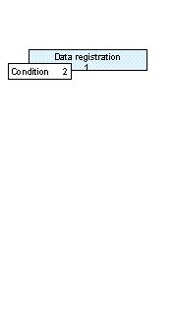
- Condition

In determining the condition of a work, first the composition and ageing of the materials must be scientifically (chemically, biological, physically) investigated. This is followed by an analysis of the mechanical ageing (for example through use) and of reactions to the environment (pollution). In the event of damage to the object, the damage and consequent changes must be precisely documented.

In establishing the condition of the object, questions can also be formulated about the future ageing behaviour of a specific material. In a number of cases it will be difficult to predict the future ageing behaviour and the conditions under which this will arise.

A problem in describing the condition of contemporary objects is that the composition of many of the materials used is not known and moreover the ageing behaviour of many materials has not been investigated. This holds true primarily for the ‘new materials’, such as plastics, but also for parts of equipment, such as transistors and cathode-ray tubes (screens).
The more information we have concerning the materials used and their composition, the better their condition can be determined.
The condition report is made on a regular basis, when checking the condition of the object or when there is a concrete reason for doing so, for example when the object is being lent or has been damaged. Each new condition report is then appended to the data registration. The model for condition regristration was developed in the course of the Conservation of Modern Art project.

Instructions:

- Make a condition report of the work using the model for a condition report. The most appropriate expert for making such a report is a conservator. If necessary, he/she will consult other experts.

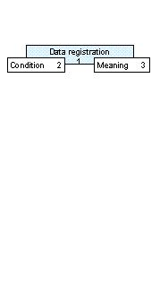
3. Meaning

Determining the meaning of the work prior to conservation is the foundation for responsible decision making in the conservation of modern art. The meaning of a work, however, is layered and certainly not unambiguous. One can speak of meaning imparted by the artist, but also by a context (criticism, group, style, time), by a place (collection, country, ‘site-specific’), or event (performance). In addition, the choice of material and working method has consequences for the meaning of the work. Finally there are also ideological (political, philosophical and religious) layers of meaning.
In the case of modern art, materials and working methods acquire a highly specific significance so that conservation research must be conducted per artist and per work.
Because conservation in most cases constitutes an intervention in the materiality of the work, research into this layer of meaning before a conservation method is established is particularly important.

The meaning of the work is determined on the basis of available data gathered in the course of the investigation. The gathering of data that could influence the meaning of the work – with an emphasis on the use of material and working method – is thus one of the first activities to be undertaken in the conservation of modern art. The curator/conservator determines the meaning.

Following specific research for the sake of conservation, information related to the meaning is amplified and refined.

Instructions:

Determine the general meaning of the object on the basis of the following questions:

· What is the subject or theme of the work (whether or not this can be gauged from the title)?
· What is the importance of the perceptible appearance for the meaning of the work? The perceptible appearance can be visual, but also auditive, kinetic, etcetera.
· What is the importance of the various materials used for the meaning of the work?
· What is the importance of production processes for the meaning of the work?
· In what lies the expressiveness of the work?
· What are other important associations?

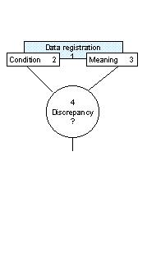
- Discrepancy?

Correct diagnosis of the conservation problem is extremely important for the decision making concerning the method of conservation. In the Conservation of Modern Art project it appeared that a conservation problem was engendered by a discrepancy between the condition and the meaning of a work.
A discrepancy, therefore, can only be determined with extensive knowledge of the meaning of the work on the one hand, and investigation of the physical condition of the work on the other hand.

Whether there is a discrepancy between condition and meaning of the work can be determined by answering the following question:
Does the meaning of the work change as a result of the ageing, damage or decay it has sustained such that intervention must be considered?

It cannot be stated beforehand whether a certain ageing or damage, indeed, constitute a problem.
As mentioned in the introduction, a scratch can reinforce the meaning of one work of art (for example in a floor plate by Carl André) while negating it in another (a metal object by Donald Judd). Therefore, designating a potential discrepancy is not a linear process: one can speak of various kinds of considerations and factors. Determining whether a discrepancy can be identified in each individual case will differ in each case. Moreover it is possible that in a later phase of the research (namely in weighing the conservation options), new information will come to light that will also influence the assessment of the discrepancy.
The factors to be weighed in determining a discrepancy (aesthetic factors, authenticity, historicity and functionality) can be presented as arrows pointing inward in a circle that will guide the decision in a certain direction with more or less force according to the value attached to these considerations.
The final determination of the discrepancy is thus the outcome of a process of deliberation involving a number of factors, and therefore a compromise.

Instructions:

- Determine whether there is a discrepancy and define the conservation problem. This can be done with the help of the following checklist. The factors to be weighed can be applied in the circle.

Checklist for determining a discrepancy between the physical condition and the meaning of a work

Central question:
Does the meaning of the work change as a result of the ageing, damage or decay it has sustained to such an extent that intervention must be considered?

4a. Aesthetic and artistic factors
— Does the ageing, damage or decay influence the subject or theme of the work?
What subjects or themes does the work explicitly refer to?
Does the work evoke associations or reactions that are important for its meaning?
— What importance do the changes in the perceptible appearance of the work have as a result of ageing, damage or decay to the meaning of the work?
What importance does the perceptible appearance have for the meaning of the work?
— Does the meaning of the materials used change as a result of the ageing, damage or decay?
What importance do the various materials used have for the meaning of the work?
What importance do the various materials used have in relation to the (cultural-historical) context? What materials were used by the artist’s contemporaries?
What materials does/did the artist use in the rest of his oeuvre?
— Is the expressiveness of the work affected as a result of the ageing, damage or decay?
In what lies the expressiveness of the work?

4b. Authenticity
— What importance does the deviation from the original appearance (generated by damage, ageing and decay) have for the meaning of the work?
What importance does the perceptible appearance have for the meaning of the work?
— Is the production process important in assessing whether the change in appearance influenced the meaning?
Can one speak of a single implementation or of an edition?
To what extent is the ‘hand of the artist’ in the production process important for the meaning?

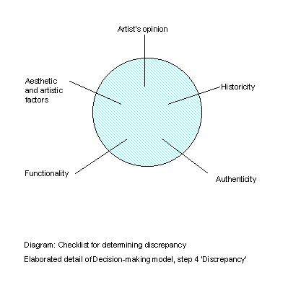
Does the work have parts that were made, whether or not on commission, by third parties? What is the meaning of these parts in the work?
— What relation does the ageing, damage or decay have to the importance of the original creation for the meaning of the work?
Does the work have parts of which the originality is not important for its meaning and that can be regularly changed without problems? For example a palm rather than the palm provided by Broodthaers.
Can arguments be found in favour of or against a possible re-making of the work or parts thereof?

4c. Historicity
- Are there traces of ageing that contribute to the meaning of the work? To what extent is the established ageing and decay part of the work?

4d. Functionality
— Does ageing, damage or decay affect the functionality in a way that is important to the meaning of the work?

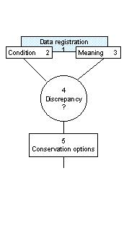
Instructions:

- Formulate various options for passive and active conservation that could contribute to the termination or lessening of the discrepancy or of the conservation
problem.

- Weighing conservation options

The possibilities for conservation and restoration are weighed in light of the consequences and risks that the treatment would entail for the meaning of the work. The following question is central: In what sense will the meaning of the work alter as a result of the proposed conservation option?

The factors related to the object when considering the options (authenticity, aesthetic factors, functionality and historicity) are important in answering this question. In addition, external limitations (legal aspects, economic limitations and possibilities: see also the checklist in this chapter) that play a role when weighing the various options for conservation must also be considered.

The various conservation and/or restoration options are considered within a framework of risks, meaning and limitations. In this way, technical possibilities might yield to ethical or economic considerations, or a treatment might be abandoned in the light of ideological priorities.
As when determining a discrepancy, an important feature when weighing conservation options is that various considerations steer the decision on conservation in various directions. Consequently, a decision always has the character of a compromise. Here, too, the weighing factors are illustrated as arrows pointing inward in a circle which, in accordance with the value attached to the various considerations, guide the decision in a certain direction with more or less force. Thus, the final decision is a compromise and the outcome of a weighing of factors.

Instructions:

- Balance the conservation options against the consequences and risks that the treatment would have for the meaning of the work with the aid of the following checklist.
- The weighing factors can be applied in the circle on page 14.

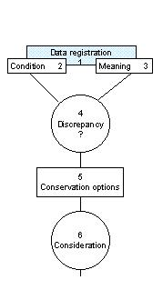
5. Conservation options

Should a discrepancy be established between the condition and the meaning of the work, the technical possibilities for conservation and restoration are then explored. This is done by a conservator, who gathers the relevant information from specialists (material experts and scientists).

Checklist for weighing the options for conservation

Central question:
In what sense will the meaning of the work be altered as a result of the proposed conservation options?

6a. Aesthetic and artistic factors
— Will the theme or subject of the work be influenced by the proposed conservation? What subjects or themes does the work explicitly refer to?
Does the work evoke associations or reactions that are important for its meaning?
— What importance do the changes in the perceptible appearance as a result of the proposed conservation have for the meaning of this work?
— Will the meaning of the materials used be altered as a result of the proposed treatment?
What importance do the various materials used have for the meaning of the work?
What importance do the various materials used have in relation to the context? What materials does/did the artist use in the rest of his oeuvre?
What importance does the perceptible appearance have for the meaning of this work?
— In what sense is the expressiveness of the work affected by the proposed conservation? In what lies the expressiveness of the work?

6b. Authenticity
— Following the proposed conservation, what is the impact of an intervention in the original appearance of a work on its meaning?
What importance does the perceptible appearance have for the meaning of the work?
— Will traces of the production process be influenced by the proposed conservation such that the meaning of the work changes?
What is the importance of the production process for the meaning of the work?
To what extent is the ‘hand of the artist’ in the production process important for the meaning?
Can one speak of a single implementation or of an edition?
Does the work have parts that were made, whether or not on commission, by third parties? What is the meaning of these parts in the work?

— Will the proposed conservation affect the original creation to such an extent that the meaning of the work changes?
Does the work have parts of which the originality is not important or its meaning and that can be regularly changed without problems? For example a palm rather than the palm provided by Broodthaers.
Can arguments be forwarded in favour of or against a possible re-making of the work or parts thereof?

6c. Historicity
— Will the proposed conservation affect the traces of ageing and does this influence the meaning of the work?
— Will the proposed conservation eliminate other traces of ageing, which should be preserved not for artistic but for historical reasons?

6d. Functionality
— Does the proposed conservation affect the functionality of the work in any way that is important to the meaning of the work?

Which are the preconditions in the decision-making process on conservation and to what extend do they influence the process?

6e. Relative importance of the art work
— What role does the work in question play within the oeuvre of the artist, artistic movement, museum collection, or national collection in the decision about conservation?
— Can one speak of an edition or a single work and is this work part of a series or is it an individual work of art? What are the consequences of this for the decision regarding the proposed conservation?

6f. Financial limitations and possibilities
— What are the financial limitations and possibilities for the proposed conservation options?
What is the maximum available budget for the conservation of the object?
Does the financial value of the object justify the costs of the conservation or are there other reasons for justifying the expense of conservation?

6g. Legal aspects
— What legal consequences can be anticipated as a result of the proposed conservation?

6h. Artist’s opinion of the intervention
— What is the opinion of the artist concerning the proposed restorations and how does this fit in with earlier statements by the artist concerning the work?

6i. Technical limitations and possibilities
— What are the technical limitations and possibilities of the
proposed conservation?

6j. Restoration ethics
— Is the integrity of the work sufficiently guaranteed after treatment?
— Are the answers to the previous questions sufficient for treatment to be initiated?
— Can the proposed methods be reversed? If not, are there decisive reasons for using them nonetheless?
— Is the professionalism of the implementation guaranteed?
— Will the treatment be documented?

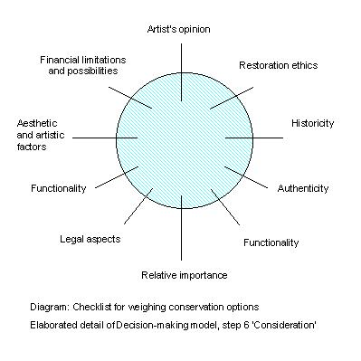

7. Proposed treatment

The result of the previous steps in the model is a definitive treatment proposal with a well-founded motivation. This treatment plan contains proposals for preventive conservation, for active conservation and for restoration.

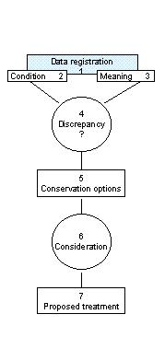

Instructions:

Draught the treatment plan and make sure that the motivation for the decision making is stored with the data registration.

The decision-making model was conceived under the supervision of the working group Decision-making model in the project 'Conservation of Modern Art'.

The working group comprised:
Wilma van Asseldonk curator De Pont Foundation, Tilburg
Marja Bosma curator Centraal Museum, Utrecht
Marianne Brouwer curator Kröller-Müller Museum, Otterlo
IJsbrand Hummelen coordinator Netherlands Institute for Cultural Heritage
conservation research Amsterdam
Dionne Sillé project manager Foundation for the Conservation of Modern Art
Renée van de Vall philosopher & lecturer Faculty of Art and Culture, Maastricht University
Rik van Wegen curator Bonnefantenmuseum, Maastricht

