Exhibition history

“IMAGO, Fin de siècle in Dutch contemporary art” (1990) was a travelling exhibition with the theme of contemporary art and technology. Because of the specific character of the exhibition, it was a co-production by the Netherlands Office for Fine Arts (now Netherlands Institute for Cultural Heritage, ICN) and the Netherlands Media Art Institute Montevideo/TBA. Montevideo created the exhibition concept and selected the artists. All the installations made especially for this exhibition were purchased by ICN. Between 1990 and 1994 the exhibition made an intensive tour, visiting various cities such as Amsterdam, Bratislava, Barcelona and Gunma (Japan) under the supervision of Montevideo staff.

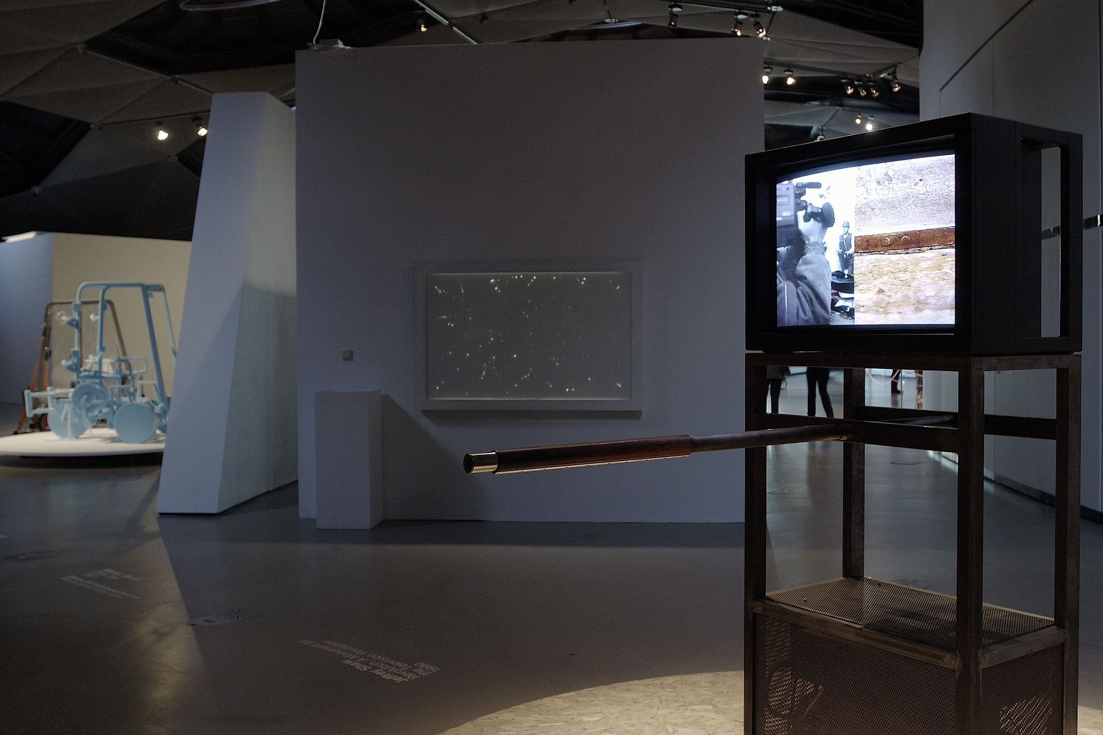
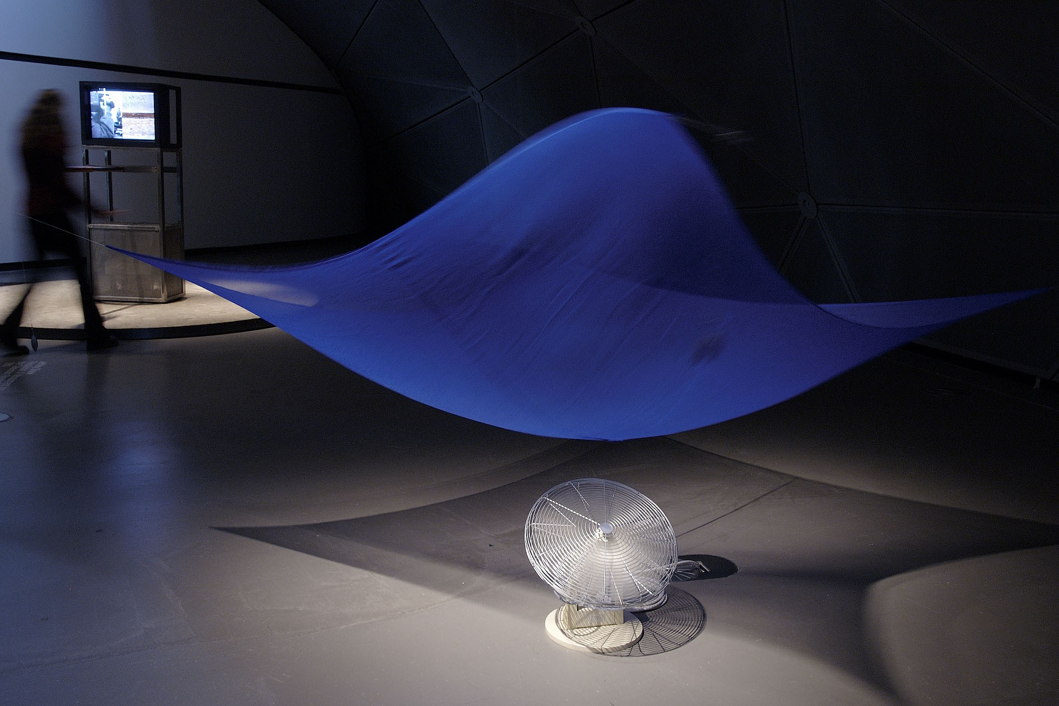
Jeffrey Shaw, ‘Revolution’ at ‘Moveable Parts: Forms of the Kinetic’, Museum Tinguely, Basel, Switzerland (March 6 – June 26, 2005).
© LMJ, Foto: Niki Lackner
Jeffrey Shaw, ‘Revolution’ at ‘Moveable Parts: Forms of the Kinetic’, Museum Tinguely, Basel, Switzerland (March 6 – June 26, 2005).
© LMJ, Foto: Niki Lackner

